Maths Predicted Paper
Higher Paper 2 Calculator

Q1. Circle the decimal that is closest in value to

0.6 0.66 0.667 0.67
(Total 1 mark)
Q2. Increase 4200 by 38%
_______________________________________________________________________
_______________________________________________________________________
_______________________________________________________________________
Answer _________________________________________
(Total 2 marks)
Q3.

A solid cuboid is made from centimetre cubes.
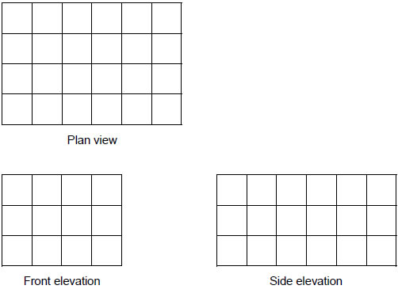
How many centimetre cubes were used to make the cuboid?
_______________________________________________________________________
_______________________________________________________________________
Answer _________________________________________
(Total 2 marks)
Q4.

Here is
a rectangle
and
a T-shape made from two rectangles.
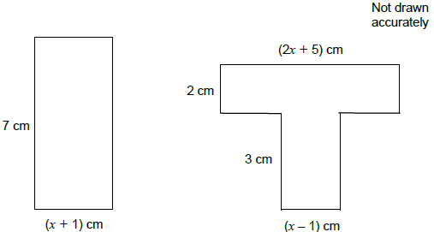
Show that the rectangle and the T-shape have the same area.
_______________________________________________________________________
_______________________________________________________________________
_______________________________________________________________________
_______________________________________________________________________
_______________________________________________________________________
_______________________________________________________________________
_______________________________________________________________________
_______________________________________________________________________
_______________________________________________________________________
_______________________________________________________________________
_______________________________________________________________________
_______________________________________________________________________
_______________________________________________________________________
(Total 4 marks)

Q5. Here is a quadratic graph.
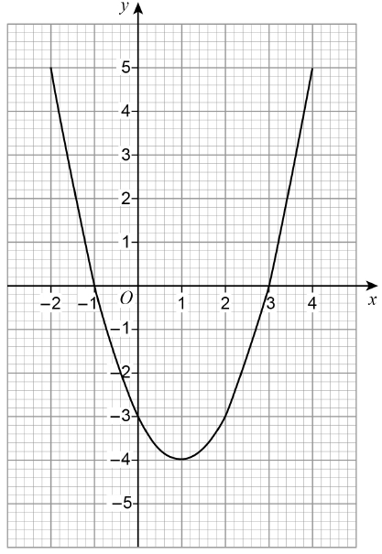
Circle the x-coordinate of the turning point of the graph.
–4 –1 1 3 (Total 1 mark)

Q6.
(a) Line M has the equation 3x + 2y = 7 Circle the gradient of line M.
(1)
(b) Line N has the equation
Circle the gradient of a line that is perpendicular to line N.
(1)
(Total 2 marks)
Q7. The equation of a curve is y = (x + 3)² + 5 Circle the coordinates of the turning point.
(5, 3) (5, −3) (3, 5) (−3, 5)
(Total 1 mark)
Q8.
(a) Factorise x² + 10x + 24
___________________________________________________________________
___________________________________________________________________
Answer _________________________________________
(2)
(b) Hence or otherwise, solve x² + 10x + 24 = 0
___________________________________________________________________
Answer _________________________________________
(1)
(Total 3 marks)
Q9. A biased coin is thrown 250 times.
The relative frequency of Heads is worked out after every 50 throws.

Total number of throws | 50 | 100 | 150 | 200 | 250
Relative frequency | 0.4 | 0.29 | 0.4 | 0.32 | 0.3
Circle the best estimate of the probability of Heads.
0.3 0.32 0.342 0.4 (Total 1 mark)
Q10.
Circle the value of the reciprocal of 0.2
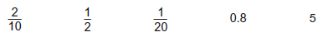
(Total 1 mark)
Q11.

Circle the inequality shown by the diagram.
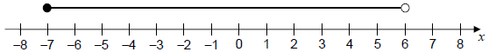
−7 < x < 6 −7 ≤ x < 6 −7 < x ≤ 6 −7 ≤ x ≤ 6
(Total 1 mark)

Q12. The diagram shows a rectangle.
(a) Write down an expression for the area of the rectangle. Simplify your answer.
___________________________________________________________________
Answer _________________________________________ (2)
(b) You are given that a and b are prime numbers. The area of the rectangle is 315 cm²
Work out the values of a and b.
Answer __________________ cm and __________________ cm (2)
(Total 4 marks)

Q13.
The dimensions of a rectangular floor are to the nearest 0.1 metres.
A force of 345 Newtons is applied to the floor. The force is to the nearest 5 Newtons.

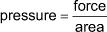
Work out the upper bound of the pressure. Give your answer to 4 significant figures.
You must show your working.
_______________________________________________________________________
_______________________________________________________________________
_______________________________________________________________________
_______________________________________________________________________
_______________________________________________________________________
_______________________________________________________________________
Answer _____________________________ N/m² (Total 5 marks)
Q14.

The square of x is 7
Circle the value of x³
343 117 649
(Total 1 mark)

Q15.

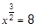 where x > 0 and 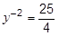 where y > 0
Work out the value of .

_______________________________________________________________________
_______________________________________________________________________
_______________________________________________________________________
_______________________________________________________________________
_______________________________________________________________________
_______________________________________________________________________
_______________________________________________________________________
= _________________________________________
(Total 5 marks)

Q16. The diagram shows a square with area 100 cm²
Not drawn accurately
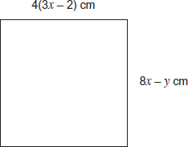
Work out the values of x and y.
_______________________________________________________________________
_______________________________________________________________________
_______________________________________________________________________
_______________________________________________________________________
_______________________________________________________________________
_______________________________________________________________________
_______________________________________________________________________
_______________________________________________________________________
x = ____________________
y = __________________ (Total 6 marks)
Q17. Solve the following equations. Do not use trial and improvement.
(a) + 2 = x
___________________________________________________________________
___________________________________________________________________
___________________________________________________________________
x = ______________________________________
(3)

(b)
___________________________________________________________________
___________________________________________________________________
___________________________________________________________________
___________________________________________________________________
___________________________________________________________________
___________________________________________________________________
y = ______________________________________
(4)
(Total 7 marks)
Q18. The diagram shows rectangle ABDE and right-angled triangle ABC.
AC = 17 cm BC = 8 cm
Not drawn accurately
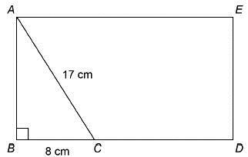
BC : CD = 1 : 2
Work out the area of rectangle ABDE.
_______________________________________________________________________
_______________________________________________________________________
_______________________________________________________________________
_______________________________________________________________________
_______________________________________________________________________
_______________________________________________________________________
_______________________________________________________________________
Answer _________________________________________ cm² (Total 4 marks)
Q19.
Rana sells 192 cakes in the ratio small : medium : large = 7 : 6 : 11
The profit for one medium cake is twice the profit for one small cake.
The profit for one large cake is three times the profit for one small cake.
Her total profit is £532.48
Work out the profit for one small cake.
_______________________________________________________________________
_______________________________________________________________________
_______________________________________________________________________
_______________________________________________________________________
_______________________________________________________________________
_______________________________________________________________________
_______________________________________________________________________
_______________________________________________________________________
Answer £ _________________________________________
(Total 5 marks)
Q20.

f(x) = 3x
Circle the expression for f^{–1}(x)
(Total 1 mark)

Q21.
ABCD and AEFG are identical squares.
CD = EF = 10 cm
Angle BAG = 45°
Not drawn accurately
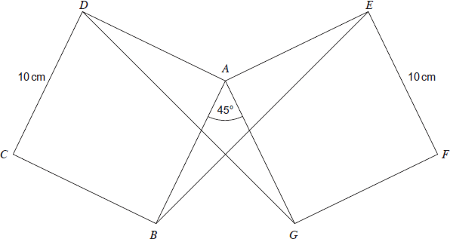
Prove that triangles AGD and ABE are congruent.
_______________________________________________________________________
_______________________________________________________________________
_______________________________________________________________________
_______________________________________________________________________
_______________________________________________________________________
_______________________________________________________________________
_______________________________________________________________________
_______________________________________________________________________
_______________________________________________________________________
(Total 4 marks)

Q22.
A fishing lake contains thousands of fish.
The fish are Carp, Bream or Roach.
10 fish are caught.
The table shows some of the results.

 | Carp | Bream | Roach
Frequency | 4
Relative frequency |  | 0.1
(a) Complete the table.
(3)
(b) The owner uses the results to estimate the proportion of Carp in the lake.
How can she make her estimate more reliable?
___________________________________________________________________
___________________________________________________________________
(1)
(Total 4 marks)
Q23.
Solids X and Y are similar.
X has volume 64 cm³
Y has volume 343 cm³
The surface area of X is 176 cm²
Work out the surface area of Y.
_______________________________________________________________________
_______________________________________________________________________
_______________________________________________________________________
_______________________________________________________________________
_______________________________________________________________________
_______________________________________________________________________
_______________________________________________________________________
_______________________________________________________________________
Answer = _________________________________________ cm²
(Total 3 marks)

Q24. (3x + 1)(x − 2) + ax + b ≡ 3x² + 8x − 5
Work out the values of a and b.
_______________________________________________________________________
_______________________________________________________________________
_______________________________________________________________________
_______________________________________________________________________
_______________________________________________________________________
_______________________________________________________________________
_______________________________________________________________________
_______________________________________________________________________
a =....................................................................
b =....................................................................
(Total 4 marks)
Q25.
(a) Factorise 3n² + 7n + 4
___________________________________________________________________
___________________________________________________________________
___________________________________________________________________
___________________________________________________________________
Answer _________________________________________
(2)
(b) Hence, or otherwise, write 374 as the product of its prime factors.
___________________________________________________________________
___________________________________________________________________
___________________________________________________________________
___________________________________________________________________
___________________________________________________________________
___________________________________________________________________
Answer _________________________________________
(2)
(Total 4 marks)
Q26.

The diagram shows a sphere, radius 6 cm, and a solid hemisphere, radius 9 cm
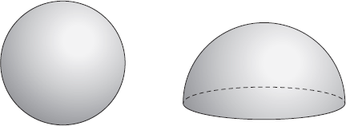
Work out the ratio
surface area of the sphere : total surface area of the hemisphere
Give your answer in its simplest form.
_______________________________________________________________________
_______________________________________________________________________
_______________________________________________________________________
_______________________________________________________________________
_______________________________________________________________________
_______________________________________________________________________
_______________________________________________________________________
_______________________________________________________________________
_______________________________________________________________________
_______________________________________________________________________
Answer _______ : _______
(Total 5 marks)

Q27.
(a) What is the equation of a circle with centre (0, 0) and diameter 6 units?
Circle your answer.
x² + y² = 3 x² + y² = 6 x² + y² = 9 x² + y² = 36
(1)
(b) Which of these points lie on the circumference of the circle x² + y² = 25?
Circle your answer.
(−3, 4) (6.25, 6.25) (9, 16) (−1, 12)
(1)
(c) Circle True (T) or False (F) for each statement.

 | The centre of the circle x² + y² = 25 is (0, 0) |  | T | F
 | The equation of the tangent to the circle x² + y² = 25 at the point (5, 0) is y = 5 |  | T | F
 | The equation of a circle and the equation of a straight line can have 0, 1 or 2 solutions if solved simultaneously |  | T | F

(2)
(Total 4 marks)

Q28.
(a) Write x(3x – 9) = 4 in the form ax² + bx + c = 0 where a, b and c are integers.
___________________________________________________________________
___________________________________________________________________
Answer_________________________________________
(1)
(b) Solve x(3x – 9) = 4
Give your answers to 2 decimal places.
___________________________________________________________________
___________________________________________________________________
___________________________________________________________________
___________________________________________________________________
___________________________________________________________________
___________________________________________________________________
___________________________________________________________________
___________________________________________________________________
Answer_________________________________________
(2)
(Total 3 marks)

