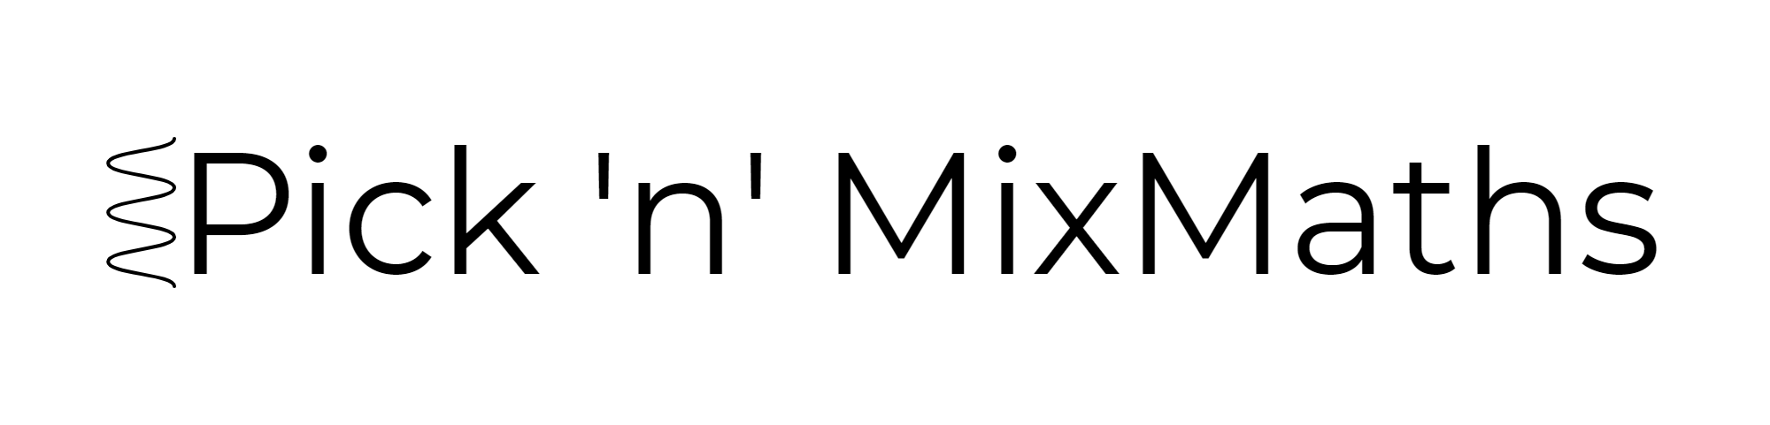
HIGHER: PROOF – This is a selection of the types of question that you need to be able to solve.
Q1.
Prove that (n – 1)² + n² + (n + 1)² = 3n² + 2

(Total for Question is 2 marks)

Q2.
Prove that
(2n + 3)² – (2n – 3)² is a multiple of 8 for all positive integer values of n.

(Total for Question is 3 marks)

Q3.
Prove algebraically that the difference between the squares of any two consecutive integers is equal to the sum of these two integers.

(Total for Question is 4 marks)
Q4.
The product of two consecutive positive integers is added to the larger of the two integers.
Prove that the result is always a square number.

(Total for question = 3 marks)
Q5.
n is an integer.
Prove algebraically that the sum of is always a square number.

(Total for question = 2 marks)
Q6.
Prove that the sum of the squares of any three consecutive odd numbers is always 11 more than a multiple of 12

(Total for question = 3 marks)
Q7.
For any three consecutive whole numbers, prove algebraically that the largest number and the smallest number are factors of the number that is one less than the square of the middle number.

(Total for question = 3 marks)
Q8.
a, b, c are positive integers such that a > b > c
N is the largest three digit number that has the digits a, b and c.
K is the smallest three digit number that has the digits a, b and c.
(a) Use algebra to show that the difference between N and K is always a multiple of 99

(3)
(b) If a > b and b = c will the difference between N and K still be a multiple of 99?
Justify your answer.

(1)
(Total for question = 4 marks)
Mark Scheme
Q1.
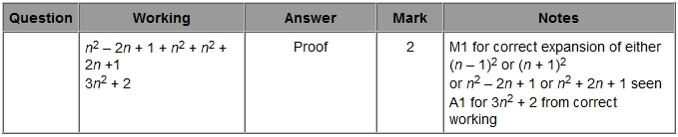
Q2.
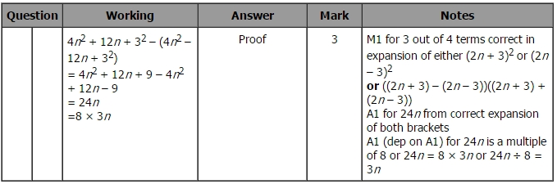
Q3.
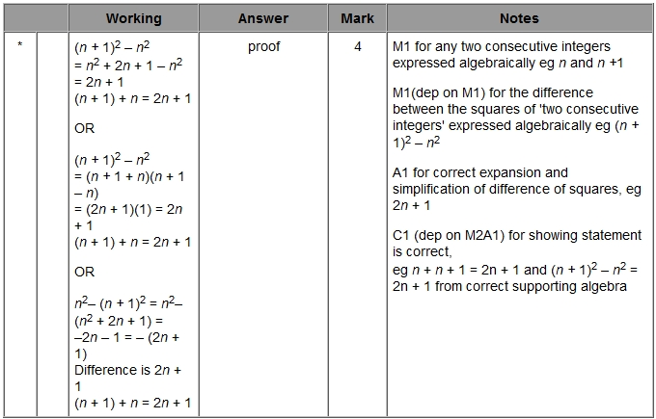

Q4.
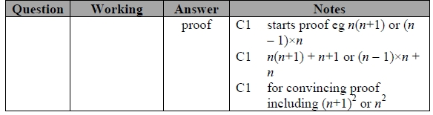
Q5.
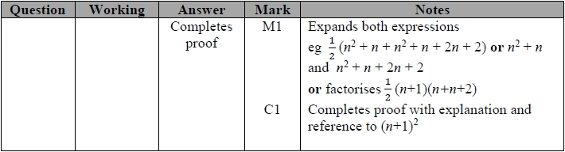
Q6.
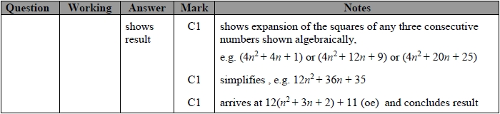
Q7.
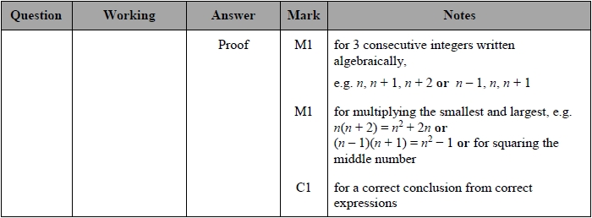
Q8.