HIGHER: LINEAR GRAPHS – This is a selection of the types of question that you need to be able solve.
Q1.
Here are the equations of four straight lines.
Line A y = 2x + 4
Line B 2y = x + 4
Line C 2x + 2y = 4
Line D 2x − y = 4
Two of these lines are parallel.
Write down the two parallel lines?
Line ................................ and line ................................
(Total for question is 1 mark)
Q2.
Here are the graphs of 6 straight lines.
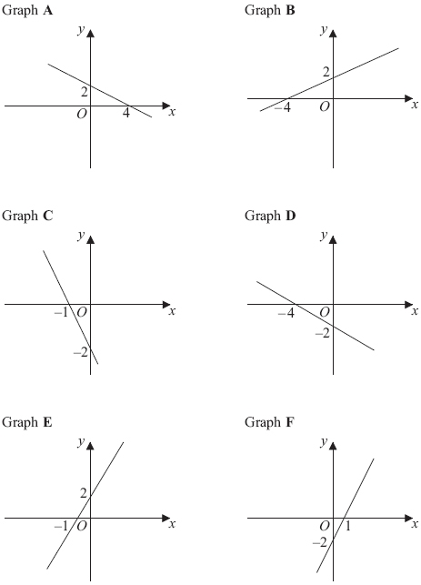
Match each of the graphs A, B, C, D, E and F to the equations in the table.
Equation | y = ½ x + 2 | y = 2x – 2 | y = – ½ x + 2 | y = – 2x – 2 | y = 2x + 2 | y = – ½ x – 2
Graph
(Total for Question is 3 marks)
Q3.
On the grid, draw the graph of y = 8 – 2x for values of x from –1 to 4
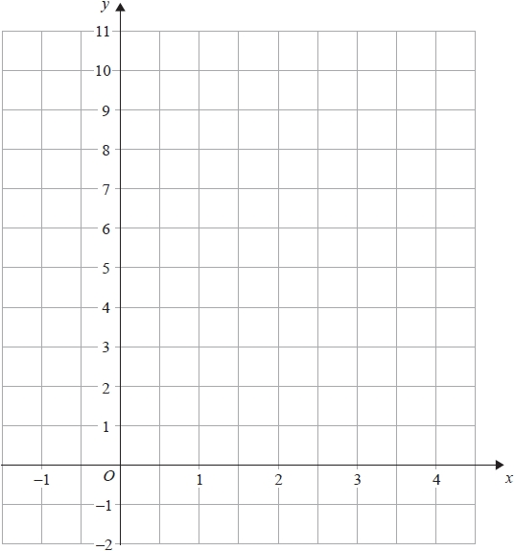

(Total for question = 3 marks)

Q4.
(a) On the grid, draw the graph of y = 4x + 2 from x = –1 to x = 3

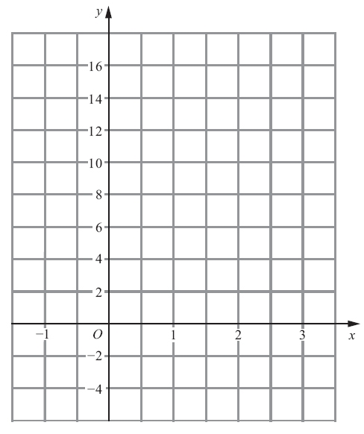
(3)
(b) (i) Write down the equation of a straight line that is parallel to y = 4x + 2

..............................................................................................................................................
(ii) Write down the gradient of a straight line that is perpendicular to y = 4x + 2

..............................................................................................................................................
(2)
(Total for Question is 5 marks)

Q5.
(a) Complete the table of values for y = ½ x + 4
x | –2 | –1 | 0 | 1 | 2
y | 3 |  | 4
(2)
(b) On the grid, draw the graph of y = ½ x + 4
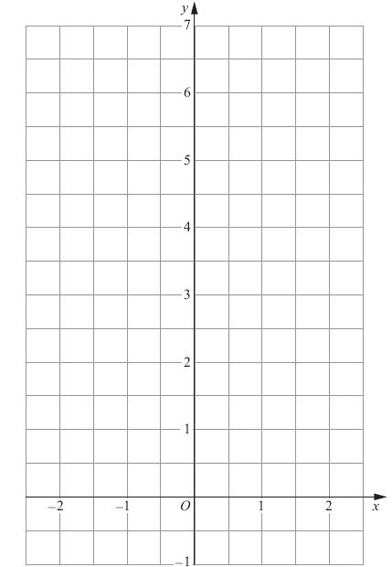
(2)
(c) (i) On the grid, draw the line that is perpendicular to y = ½ x + 4 and passes through the point with coordinates (0, 4).

(ii) Find the equation of this line.

. . . . . . . . . . . . . . . . . . . . . .
(3)
(Total for Question is 7 marks)
Q6.
Line L is drawn on the grid below.
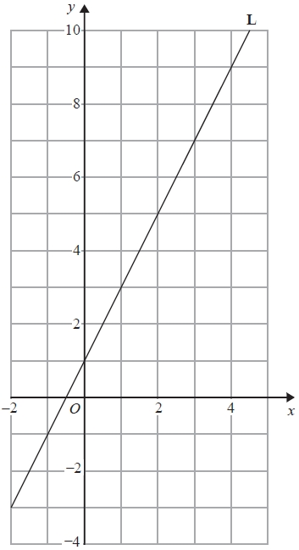
Find the equation for the straight line L. Give your answer in the form y = mx + c

...........................................................
(Total for question is 3 marks)

Q7.
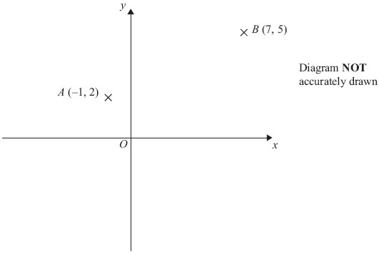
A is the point (–1, 2)
B is the point (7, 5)
(a) Find the coordinates of the midpoint of AB.

..............................................................................................................................................
(2)
P is the point (–4, 4)
Q is the point (1, –5)
(b) Find the gradient of PQ.

..............................................................................................................................................
(2)
(Total for Question is 4 marks)
Q8.
A is the point with coordinates (2, 10)
B is the point with coordinates (5, d)
The gradient of the line AB is 4
Work out the value of d.
d = ...........................................................
(Total for question = 3 marks)
Q9.
The straight line P has been drawn on a grid.
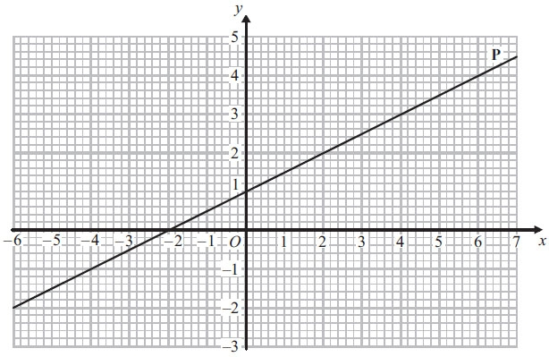
Find the gradient of the line P.

(Total for Question is 2 marks)
Q10.
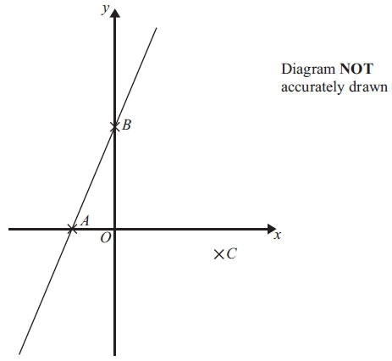
A is (-2, 0), B is (0, 4), C is (5, -1). Find an equation of the line that passes through C and is perpendicular to AB.

..............................................................................................................................................
(Total for Question is 4 marks)

Q11.
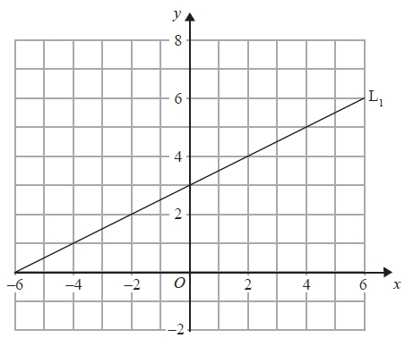
A straight line, L₂, is parallel to the straight line L₁ and passes through the point (0, −5).
Find an equation of the straight line L₂.
...........................................................
(Total for Question is 3 marks)
Q12.
Find an equation of the straight line with gradient 3 that passes through point A.
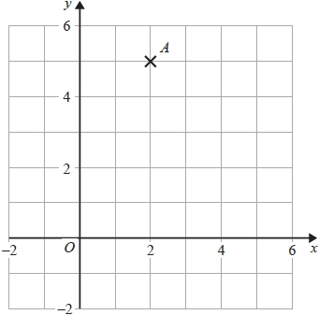

...........................................................
(Total for question = 2 marks)
Q13.
The straight line L has equation y = 2x − 5
Find an equation of the straight line perpendicular to L which passes through (−2, 3).
...........................................................
(Total for Question is 3 marks)

Q14.
The straight line L has equation 4x + y = 7
Find an equation of the straight line perpendicular to L that passes through (–8, 3).

...........................................................
(Total for question = 4 marks)
Q15.
AB is a line segment.
The midpoint of the line segment AB has coordinates (3, 5)
Point A has coordinates (9, 2)
(a) Work out the coordinates of point B.
( ................ , ................ )
(2)
(b) Work out an equation of the straight line that passes through (9, 2) and (3, 5)
...........................................................
(3)
(Total for question = 5 marks)
Q16.
The points A(6, 1) and B (−2, 5) are on the line with equation
M is the midpoint of AB. Find an equation of the line through M that is perpendicular to
...........................................................
(Total for question = 4 marks)
Q17.
A is the point with coordinates (1, 3) B is the point with coordinates (4, −1)
The straight line L goes through both A and B.
Is the line with equation 2y = 3x − 4 perpendicular to line L? You must show how you got your answer.

(Total for Question is 4 marks)
Q18.
In a survey, the outside temperature and the number of units of electricity used for heating were recorded for ten homes. The scatter diagram shows this information.
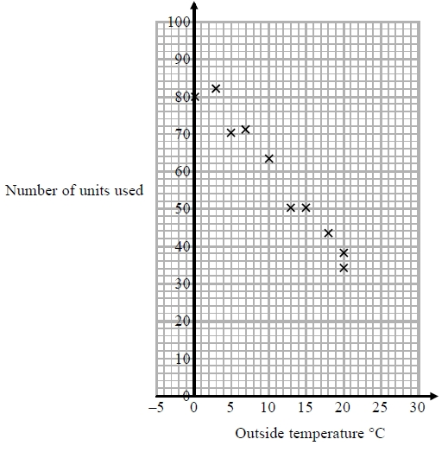
Molly says, "On average the number of units of electricity used for heating decreases by 4 units for each °C increase in outside temperature."
(a) Is Molly right? Show how you get your answer.

(3)
(b) You should not use a line of best fit to predict the number of units of electricity used for heating when the outside temperature is 30 °C.
Give one reason why.
(1)
(Total for question = 4 marks)

Q19.
The equation of the line L₁ is y = 3x − 2
The equation of the line L₂ is 3y − 9x + 5 = 0
Show that these two lines are parallel.

(Total for question = 2 marks)
Q20.
A triangle has vertices P, Q and R.
The coordinates of P are (−3, −6)
The coordinates of Q are (1, 4)
The coordinates of R are (5, −2)
M is the midpoint of PQ. N is the midpoint of QR.
Prove that MN is parallel to PR. You must show each stage of your working.

(Total for question = 4 marks)
Q21.
A(−2, 1), B(6, 5) and C(4, k) are the vertices of a right-angled triangle ABC.
Angle ABC is the right angle.
Find an equation of the line that passes through A and C.
Give your answer in the form ay + bx = c where a, b and c are integers.

...........................................................
(Total for question = 5 marks)

Q22.
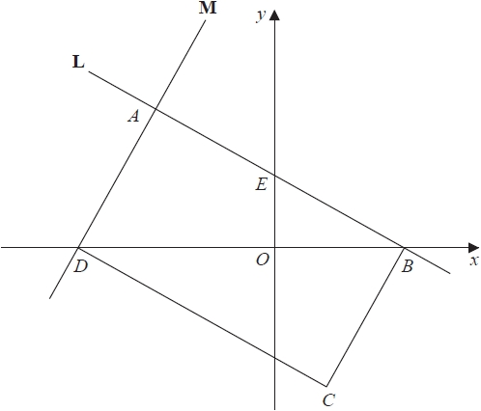
ABCD is a rectangle.
A, E and B are points on the straight line L with equation x + 2y = 12
A and D are points on the straight line M.
AE = EB
Find an equation for M.

...........................................................
(Total for question = 4 marks)
Q23.
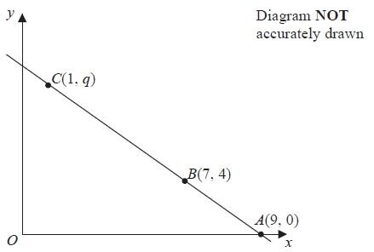
The points A, B and C lie on a straight line.
The coordinates of A are (9, 0).
The coordinates of B are (7, 4).
The coordinates of C are (1, q).
Work out the value of q.

...........................................................
(Total for Question is 3 marks)

Q24.
Water is leaking out of two containers.
The water started to leak out of the containers at the same time.
The straight line P shows information about the amount of water, in litres, in container P.
The straight line Q shows information about the amount of water, in litres, in container Q.
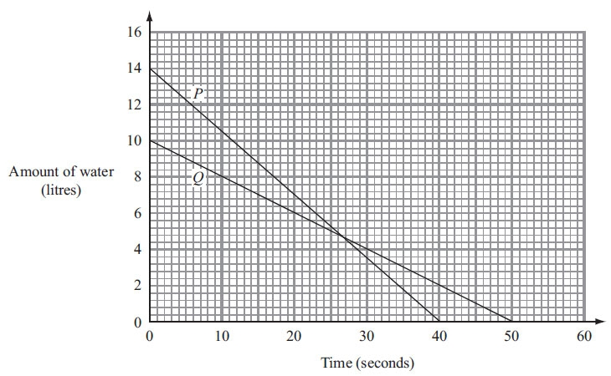
(a) Work out the gradient of line P.

. . . . . . . . . . . . . . . . . . . . . .
(2)

One container will become empty first.
(b) (i) Which container?
You must explain your answer.

(ii) How much water is then left in the other container?

. . . . . . . . . . . . litres
(2)
(Total for Question is 4 marks)

Q25.
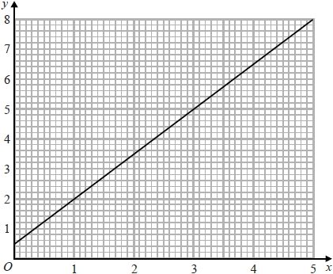
Phone calls cost £ y for x minutes.
The graph gives the values of y for values of x from 0 to 5
(a) (i) Give an interpretation of the intercept of the graph on the y-axis.

(ii) Give an interpretation of the gradient of the graph.

(2)
(b) Find the equation of the straight line in the form y = mx + c
...........................................................
(3)
(Total for question = 5 marks)

Q26.
This graph can be used to convert between degrees Celsius (C) and degrees Fahrenheit (F).

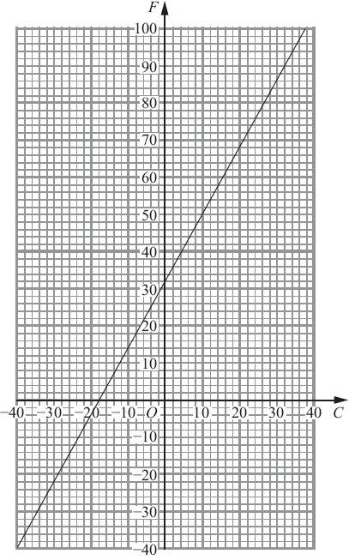
Find the values of m and k such that
F = mC + k

m =. . . . . . . . . . . . . . . . . . . . . .

k =. . . . . . . . . . . . . . . . . . . . . . .
(Total for Question is 3 marks)

Mark Scheme
Q1.
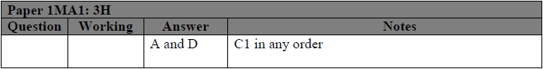
Q2.
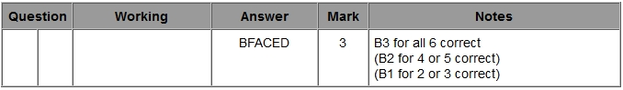
Q3.
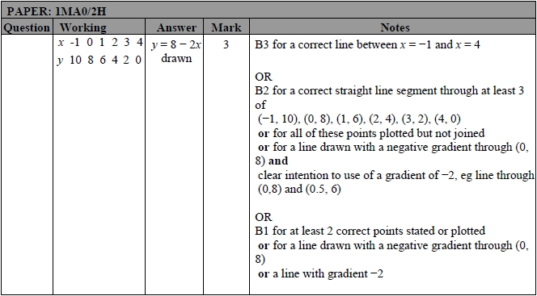

Q4.
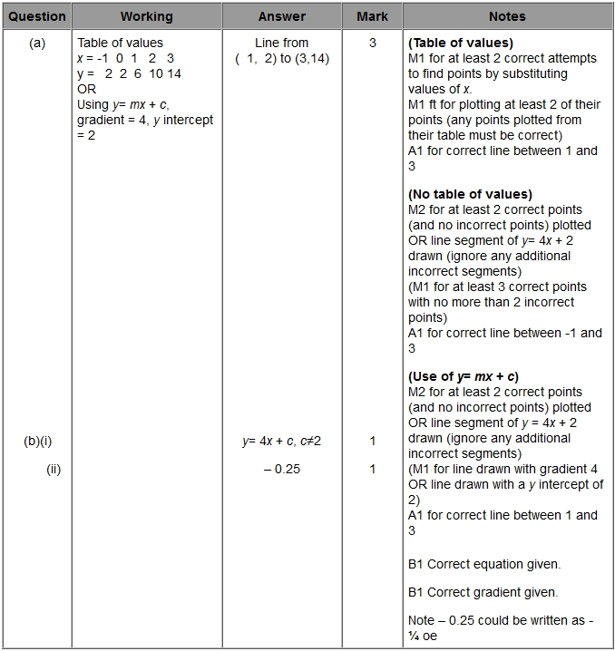
Q5.
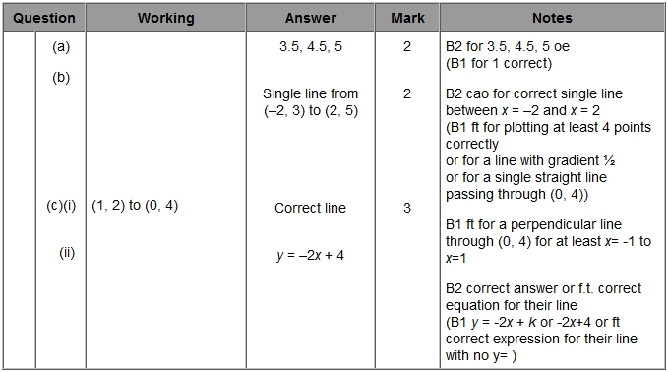
Q6.
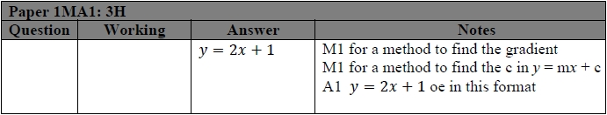
Q7.
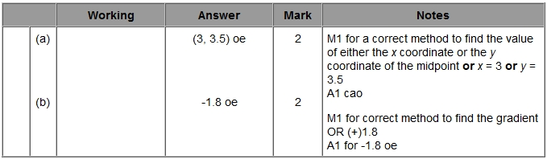
Q8.
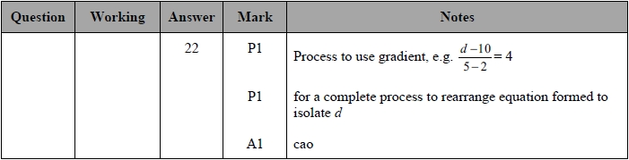
Q9.
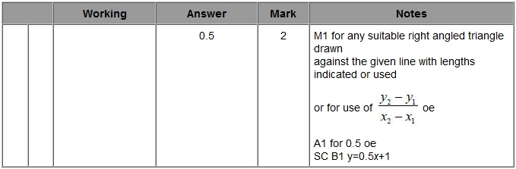

Q10.
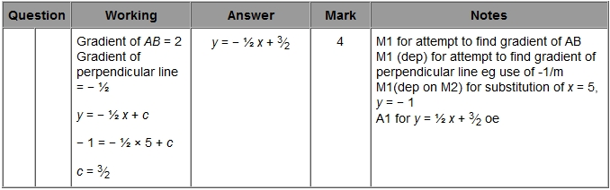
Q11.
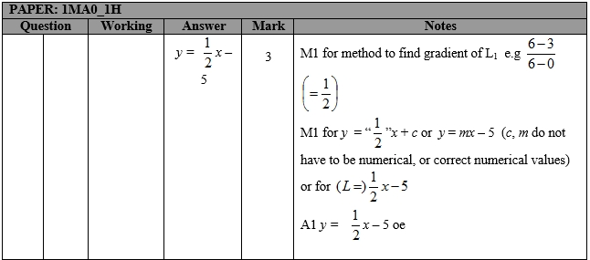
Q12.
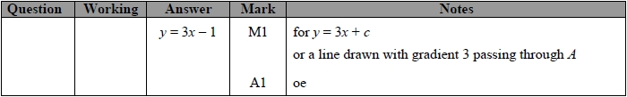
Q13.
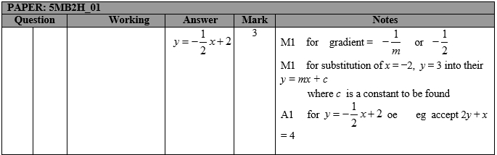

Q14.
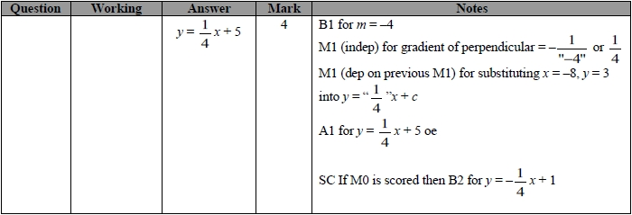
Q15.
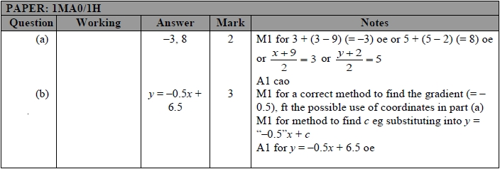
Q16.
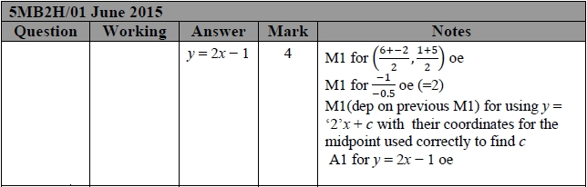
Q17.
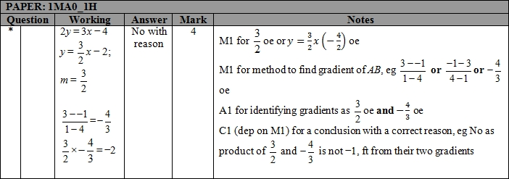
Q18.
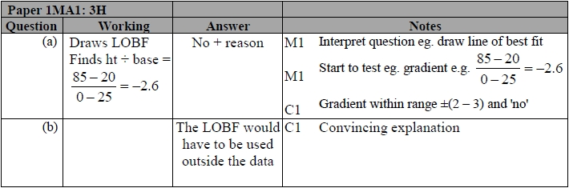
Q19.
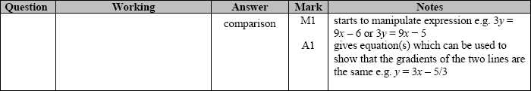
Q20.
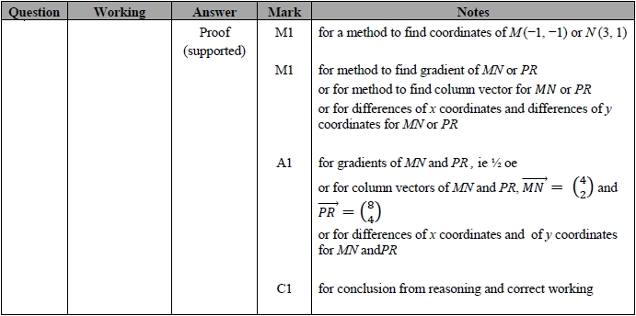
Q21.
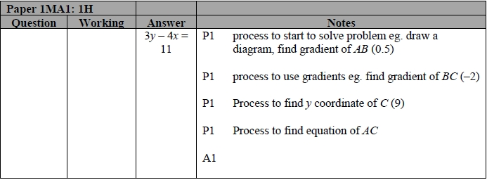
Q22.
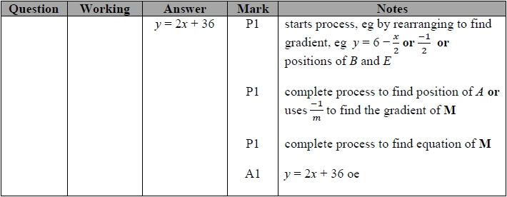
Q23.
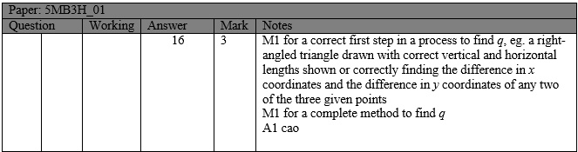
Q24.
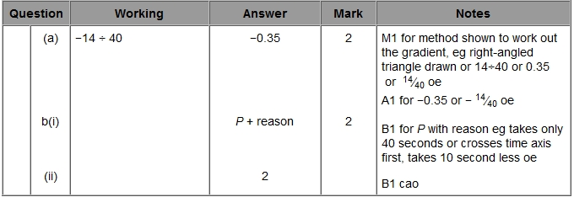
Q25.
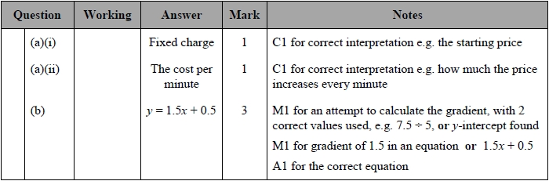
Q26.
