  
HIGHER: TRANSFORMATIONS – This is a selection of the types of question that you need to be able to solve.

**Q1.**

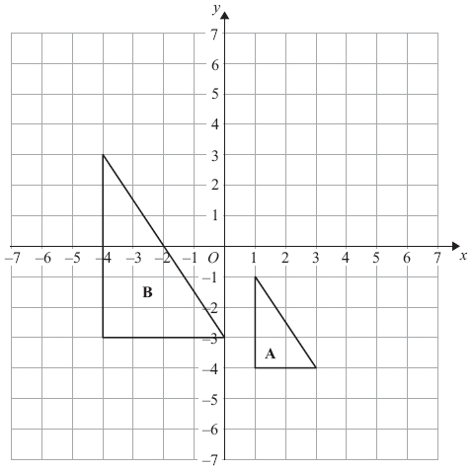

Describe fully the single transformation that maps triangle **A** onto triangle **B**.

**(Total for Question is 3 marks)**

**Q2.** Shape **A** is translated by the vector  to make Shape **B**.

Shape **B** is then translated by the vector  to make Shape **C**.

Describe the single transformation that maps Shape **A** onto Shape **C**.

...........................................................

**(Total for question = 2 marks)**

**Q3.**   
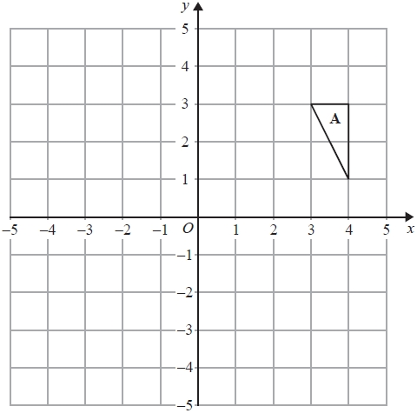

(a)  Rotate triangle **A** 90° anticlockwise with centre *O*.

**(2)**

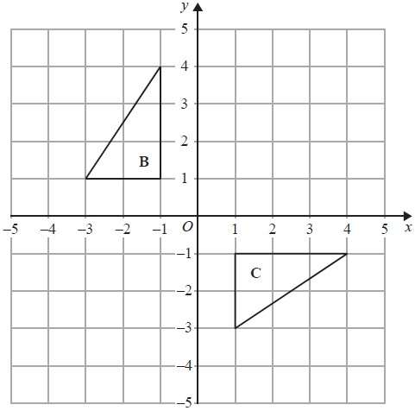

(b)  Describe fully the single transformation that maps triangle **B** onto triangle **C**.

**(2)**

**(Total for question = 4 marks)**

**Q4.** 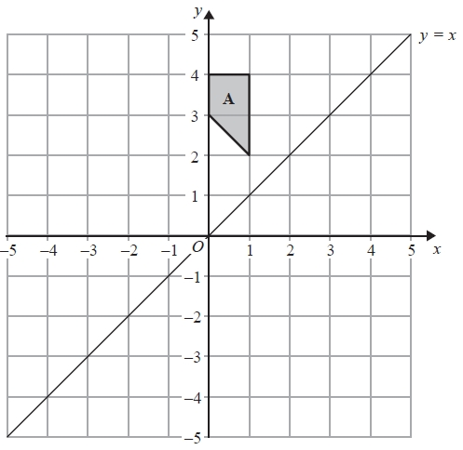

(a)  On the grid, reflect shape **A** in the line *y* = *x*.

**(2)**

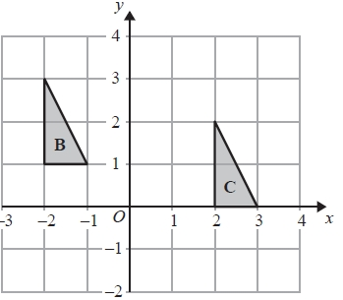

(b)  Describe fully the single transformation that maps triangle **B** onto triangle **C**.

**(2)**

**(Total for question = 4 marks)**

**Q5.**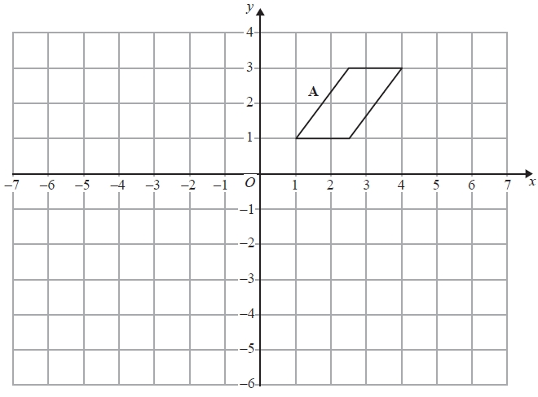

(a)  Reflect shape **A** in the line *x* = −1

**(2)**

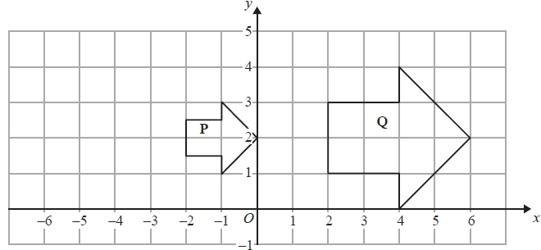

(b)  Describe fully the single transformation that maps shape **P** onto shape **Q**.

**(3)**

**(Total for question = 5 marks)**

**Q6.**

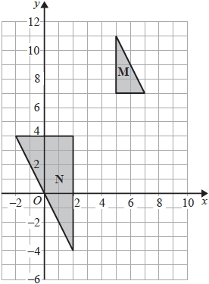

Describe fully the single transformation that maps triangle **M** onto triangle **N**.

**(Total for question = 2 marks)**

**Q7.**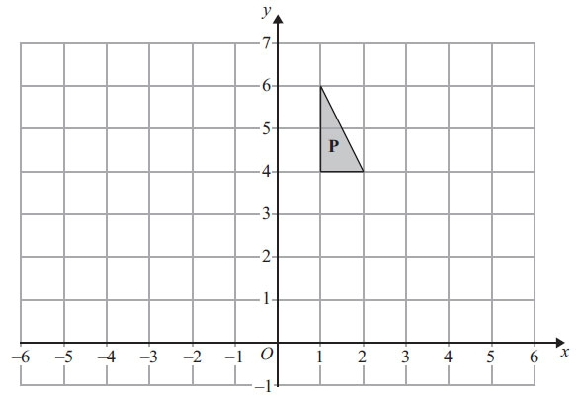

(a) Reflect shape **P** in the line *x* = 3

**(2)**

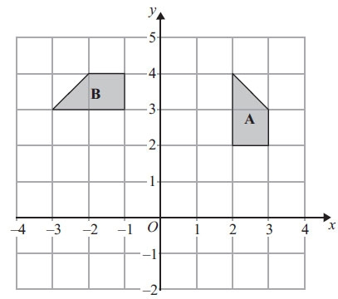

(b) Describe fully the single transformation that maps shape **A** onto shape **B**.

**(3)**

**(Total for Question is 5 marks)**

**Q8.**

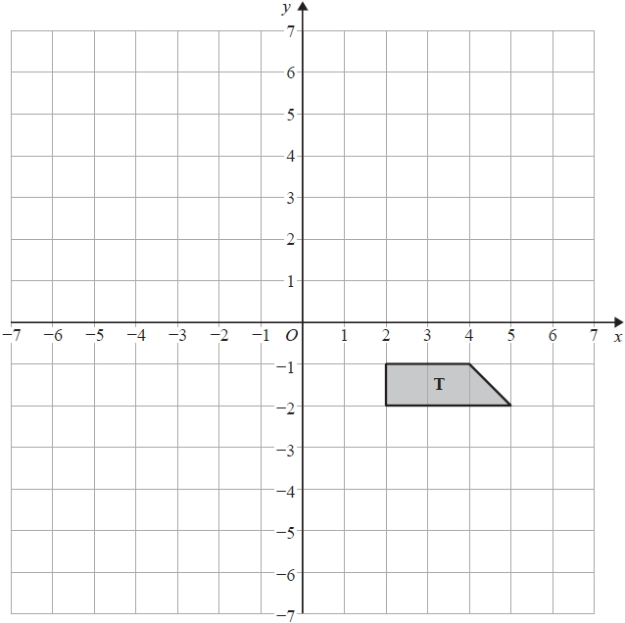

(a)  Rotate trapezium **T** 180° about the origin.

Label the new trapezium **A**.

**(1)**

(b)  Translate trapezium **T** by the vector 

Label the new trapezium **B**.

**(1)**

**(Total for question = 2 marks)**

**Q9.**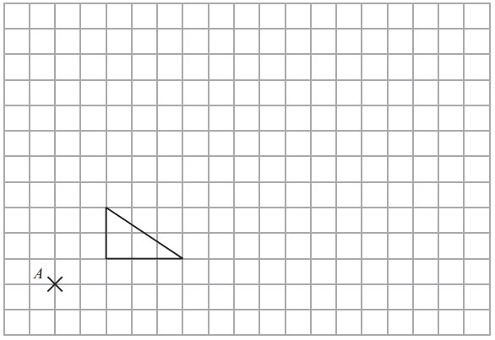

On the grid, enlarge the shape with scale factor 3, centre *A*.

**(Total for Question is 3 marks)**

**Q10.** 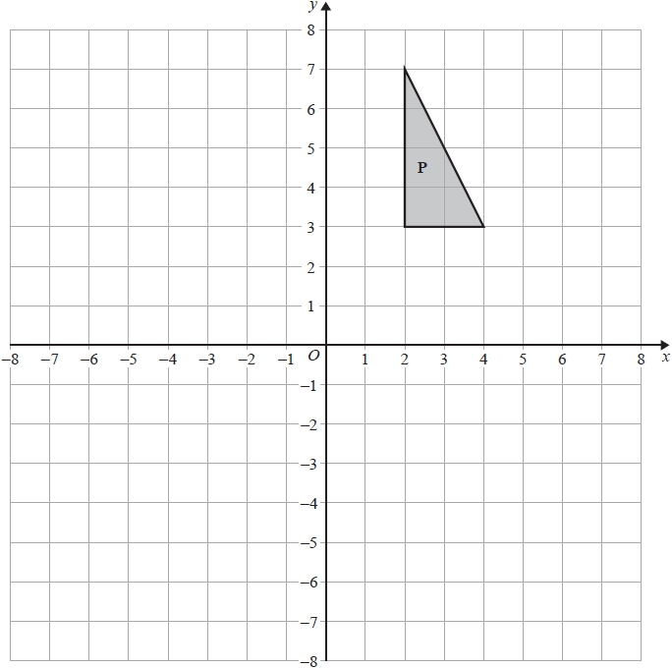

Enlarge shape **P** by scale factor  with centre of enlargement (0, 0). Label your image **Q**.

**(Total for question = 2 marks)**

**Q11.**

 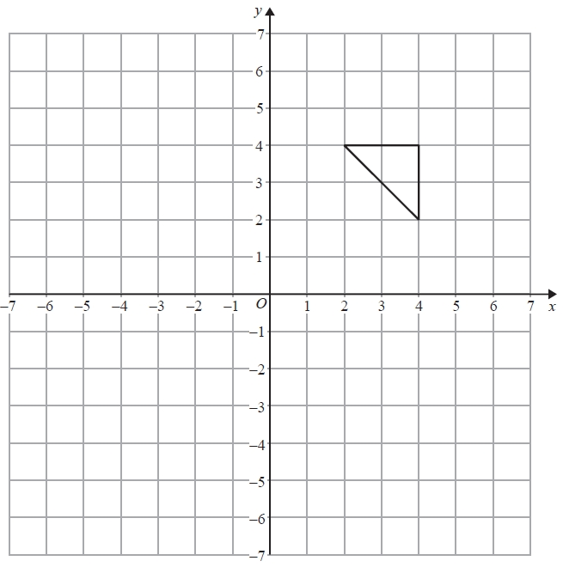

On the grid, enlarge the triangle by scale factorcentre (0, 2)

**(Total for question = 2 marks)**

**Q12.**

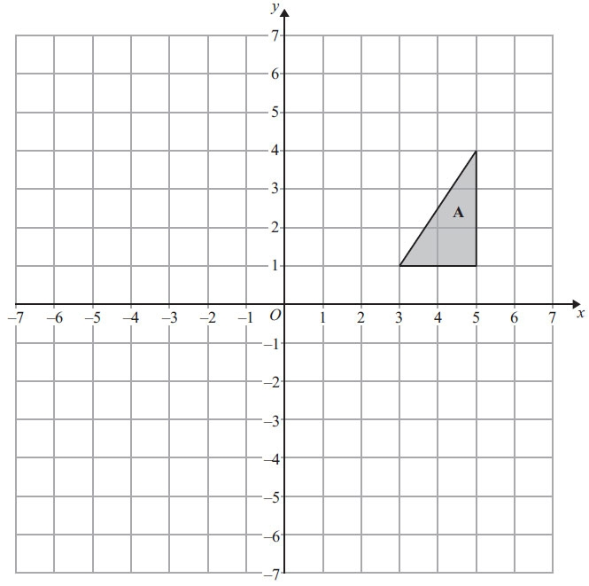

Triangle **A** is reflected in the *x*-axis to give triangle **B**.  
Triangle **B** is then reflected in the line *x* = 1 to give triangle **C**.

Describe fully the single transformation that maps triangle **A** onto triangle **C**.

**(Total for Question is 3 marks)**

**Q13.**

The diagram shows triangle **A** drawn on a grid.

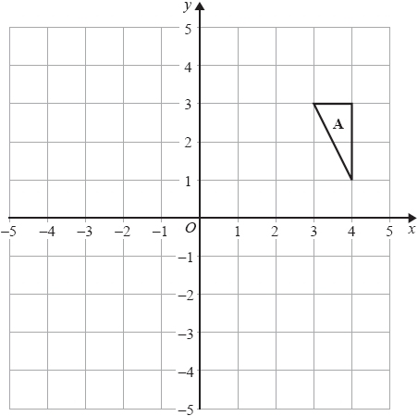

Kyle reflects triangle **A** in the *x*-axis to get triangle **B**.   
He then reflects triangle **B** in the line *y* = *x* to get triangle **C**.

Amy reflects triangle **A** in the line *y* = *x* to get triangle **D**.   
She is then going to reflect triangle **D** in the *x*-axis to get triangle **E**.

Amy says that triangle **E** should be in the same position as triangle **C**.

Is Amy correct?   
You must show how you get your answer.

**(Total for question = 3 marks)**

**Mark Scheme**  
Q1.

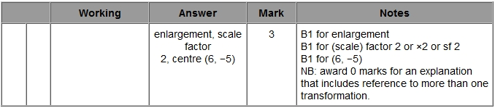

**Q2.**

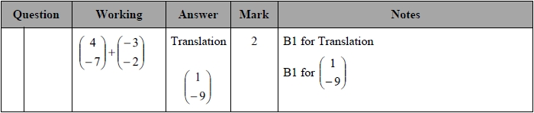

**Q3.**

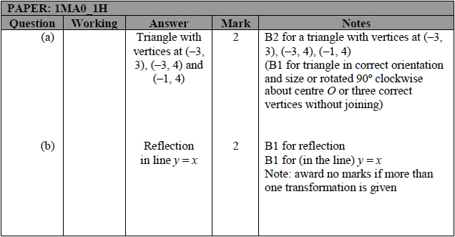

**Q4.**

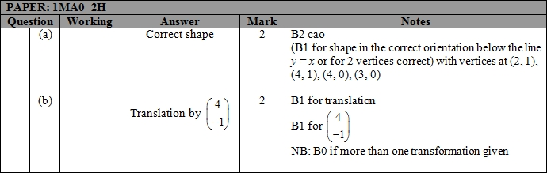

**Q5.**

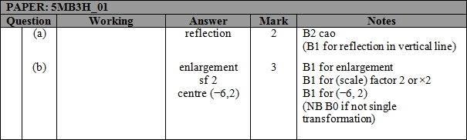

**Q6.**

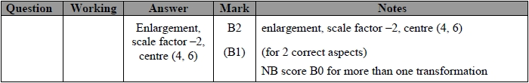

**Q7.**

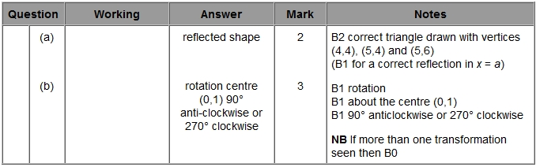

**Q8.**

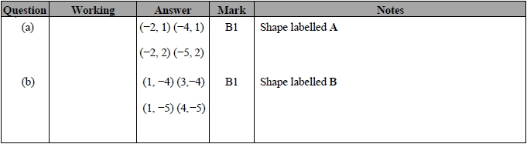

**Q9.** 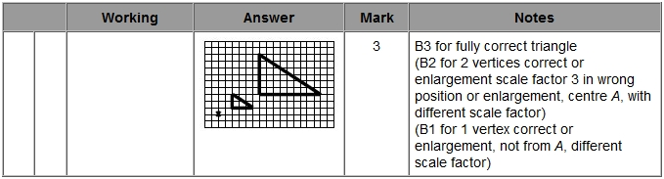

**Q10.**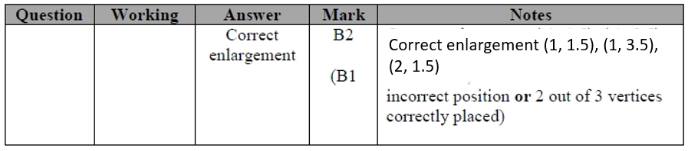

**Q11.**

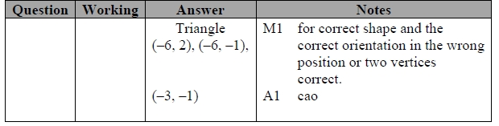

**Q12.**

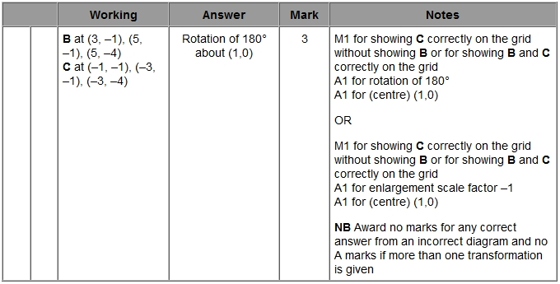

**Q13.**

