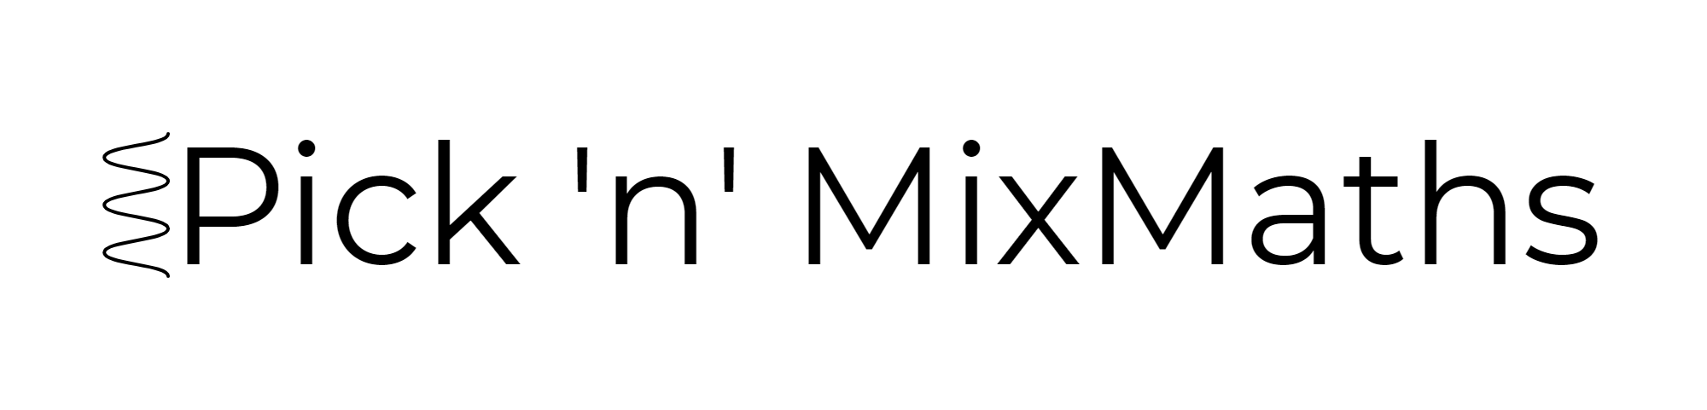  
HIGHER: SURDS – This is a selection of the types of question that you need to be able to solve.

**Q1.**

Expand (1 + √2 )(3 − √2 )

Give your answer in the form *a* + *b* √2 where *a* and *b* are integers.

...........................................................  
**(Total for Question is 2 marks)**

**Q2.** Simplify fully 

...........................................................

**(Total for question = 3 marks)**

**Q3.**

(a) Express  in the form  , where *n* is a positive integer.

**(2)**

(b) Rationalise the denominator of 

**(2)**

**(Total for Question is 4 marks)**

**Q4.**

The perimeter of a square is √120 cm.

Work out the area of the square.

Give your answer in its simplest form.

...........................................................cm2

**(Total for Question is 3 marks)**

**Q5.**

 can be written in the form , where *a*, *c* and *d* are integers.

Find, in terms of *a*, an expression for *c***and** an expression for *d*.

*c* = ...........................................................

*d* = ...........................................................

**(Total for question = 3 marks)**

**Q6.** can be written in the form  Find the value of *a* and the value of *b*.

*a* = ...........................................................

*b* = ...........................................................

**(Total for question = 5 marks)**

**Q7.**Rationalise the denominator of  Give your answer in its simplest form.

**(Total for Question is 3 marks)**

**Q8.** Show that  can be written in the form  where *a* and *b* are integers.

**(Total for question = 3 marks)**

**Q9.**

 where *a* is a fraction

Find the value of *a*.

...........................................................

**(Total for question = 3 marks)**

**Q10.**

Show that     can be written as 

**(Total for question = 3 marks)**

**Q11.** 

Work out the value of *T*.

Give your answer in the form  where *c* is an integer.

...........................................................

**(Total for question = 4 marks)**

**Q12.**  and  where *c* and *d* are positive integers.

Given that *c* : *d* = 1 : 9   
find, in its simplest form, the ratio *a* : *b*

...........................................................

**(Total for question = 3 marks)**

**Q13.**

Here is a trapezium.

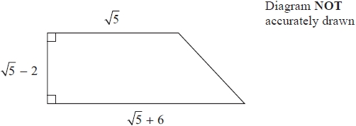

All measurements shown are in centimetres.

Work out the area of the trapezium.   
Give your answer in cm2 in the form *a*√5 + *b* where *a* and *b* are integers.

...........................................................cm2

**(Total for question = 3 marks)**

**Q14.**

*ABD* is a right angled triangle.

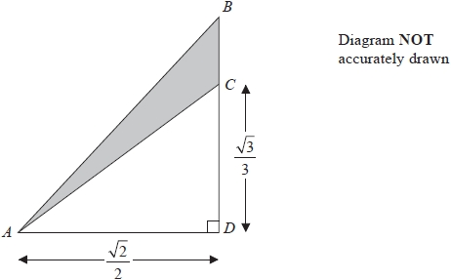

All measurements are given in centimetres.

*C* is the point on *BD* such that 



Work out the exact area, in cm2, of the shaded region.

........................................................... cm2

**(Total for question = 3 marks)**

**Mark Scheme**  
Q1.

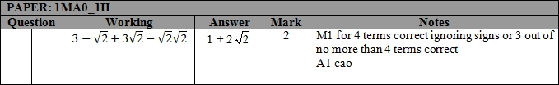

**Q2.**

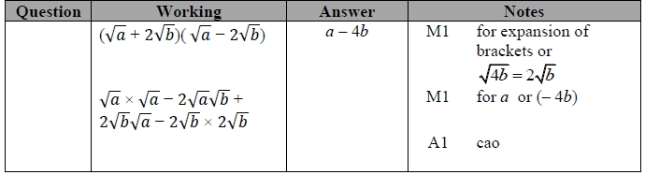

**Q3.**

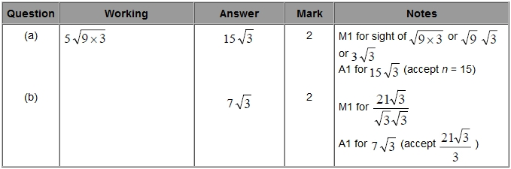

**Q4.**

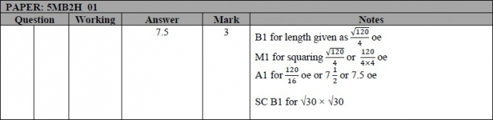

**Q5.**

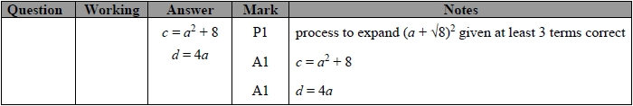

**Q6.**

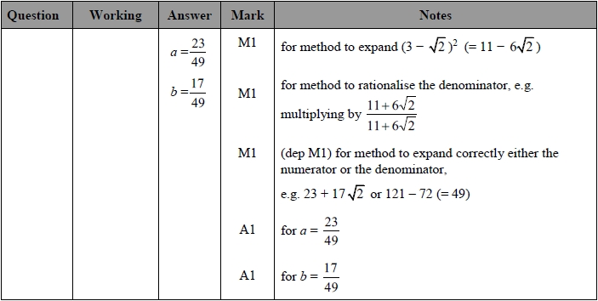

**Q7.**

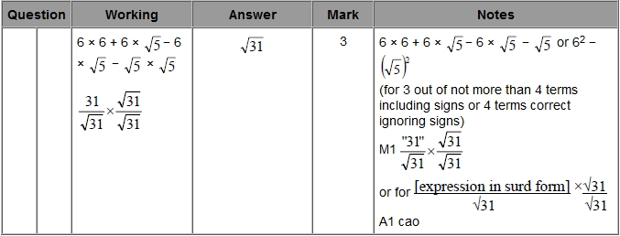

**Q8.**

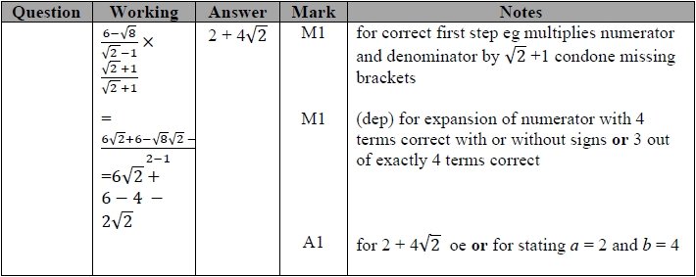

**Q9.**

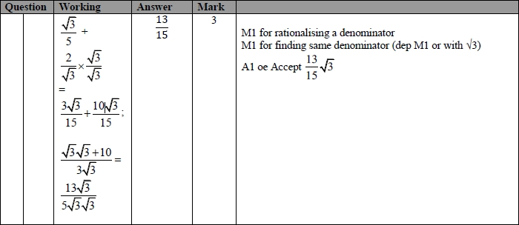

**Q10.**

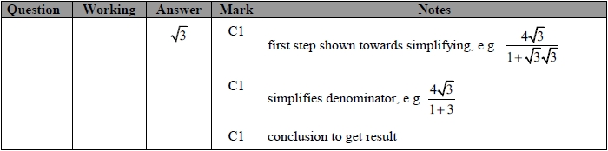

**Q11.**

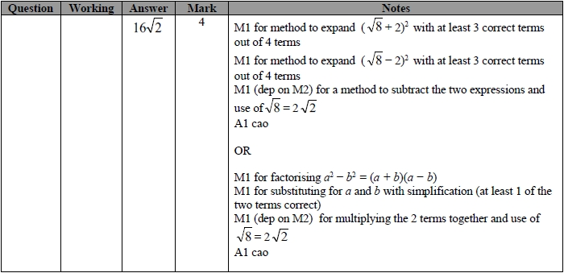

**Q12.**

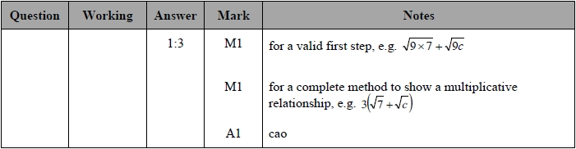

**Q13.**

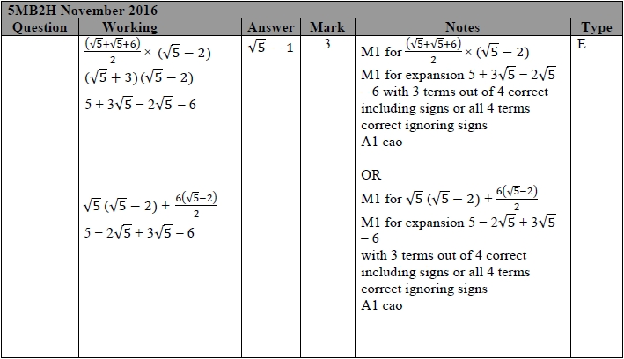

**Q14.**

