HIGHER: BEARINGS – This is a selection of the types of question that you need to be able to solve.
Q1.
The bearing of a ship from a lighthouse is 050°
Work out the bearing of the lighthouse from the ship.

...........................................................°
(Total for Question is 2 marks)
Q2.
The diagram shows the position of a lighthouse L and a harbour H.
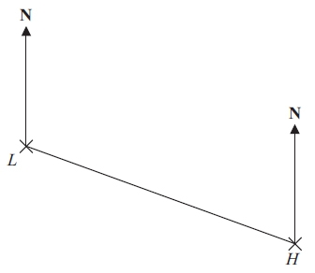
The scale of the diagram is 1 cm represents 5 km.
(a) Work out the real distance between L and H.

. . . . . . . . . . . . . . . . . . . . . . km
(1)
(b) Measure the bearing of H from L.
. . . . . . . . . . . . . . . . . . . . . . °
(1)
A boat B is 20 km from H on a bearing of 040°.
(c) On the diagram, mark the position of boat B with a cross (×).
Label it B.
(2)
(Total for Question is 4 marks)
Q3.
The diagram shows the position of two churches, A and B.
Church C is on a bearing of 130° from church A.
Church C is on a bearing of 245° from church B.
In the space above, draw an accurate diagram to show the position of church C.
Mark the position of church C with a cross ().
Label it C.

(Total for question = 3 marks)

Q4.
The accurate scale drawing shows a map of an island.
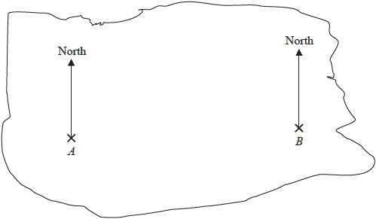

A and B are points on the island.
The real distance, in kilometres, between A and B is 56 km.
Treasure is buried at point C on the island.
Point C is 35 km from A and on a bearing of 300° from B.
Mark the point C with a cross ().

(Total for question = 5 marks)

Q5.
The diagram shows the positions of a lighthouse L, a yacht Y and a tanker T on a map.
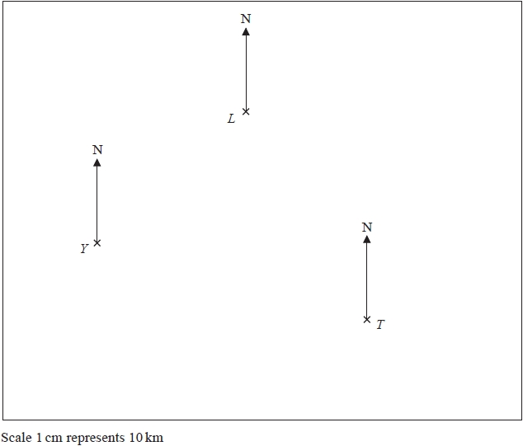
(a) Measure the bearing of L from Y.
........................................................... °
(1)
The tanker, T, sails 80 km on a bearing of 320°.
(b) Find the distance, in km, between the tanker and the lighthouse when the tanker is closest to the lighthouse.
........................................................... km
(2)
(Total for question = 3 marks)

Q6.
The diagram shows the positions of three points, A, B and C, on a map.
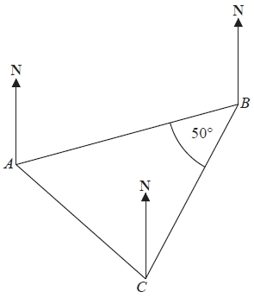
The bearing of B from A is 070°
Angle ABC is 50°
AB = CB
Work out the bearing of C from A.

........................................................... °
(Total for question is 3 marks)

Q7.
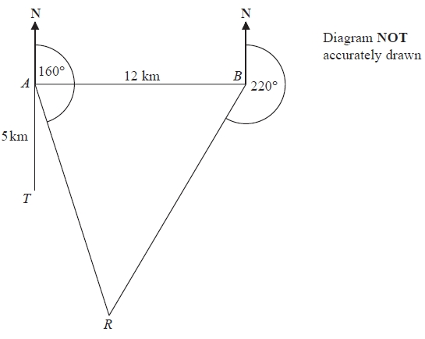
There is a coastguard station at point A and at point B.
B is due East of A.
The distance from A to B is 12 km.
There is a rowing boat at point R.
R is on a bearing of 160° from A.
R is on a bearing of 220° from B.
There is a speedboat at point T.
T is 5 km due South of A.
Work out the shortest distance from T to R.
Give your answer correct to 1 decimal place.
You must show all your working.

...........................................................km
(Total for question = 5 marks)

Mark Scheme
Q1.
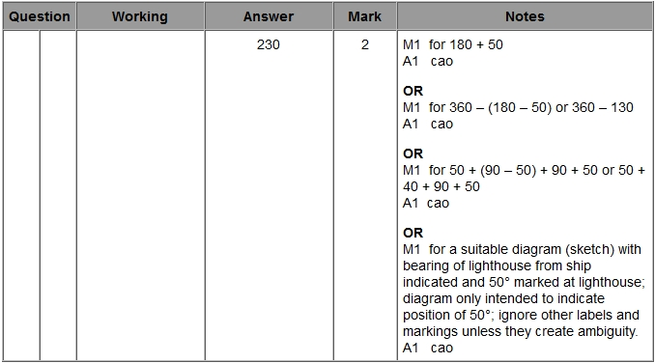
Q2.
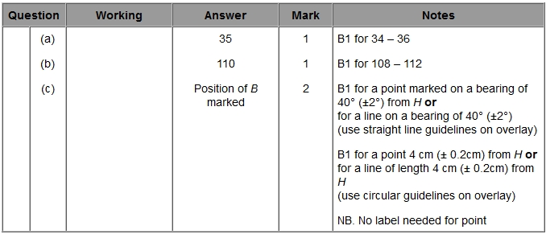
Q3.
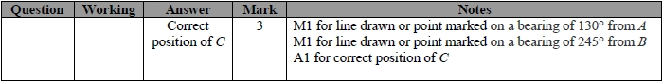

Q4.
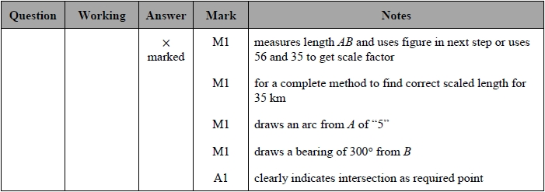
Q5.
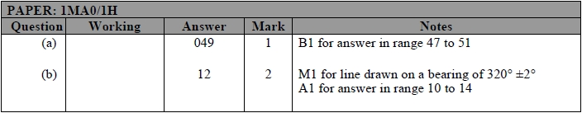
Q6.
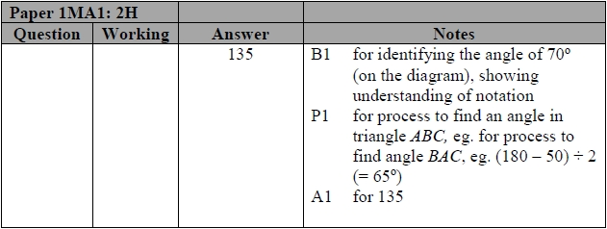
Q7.
