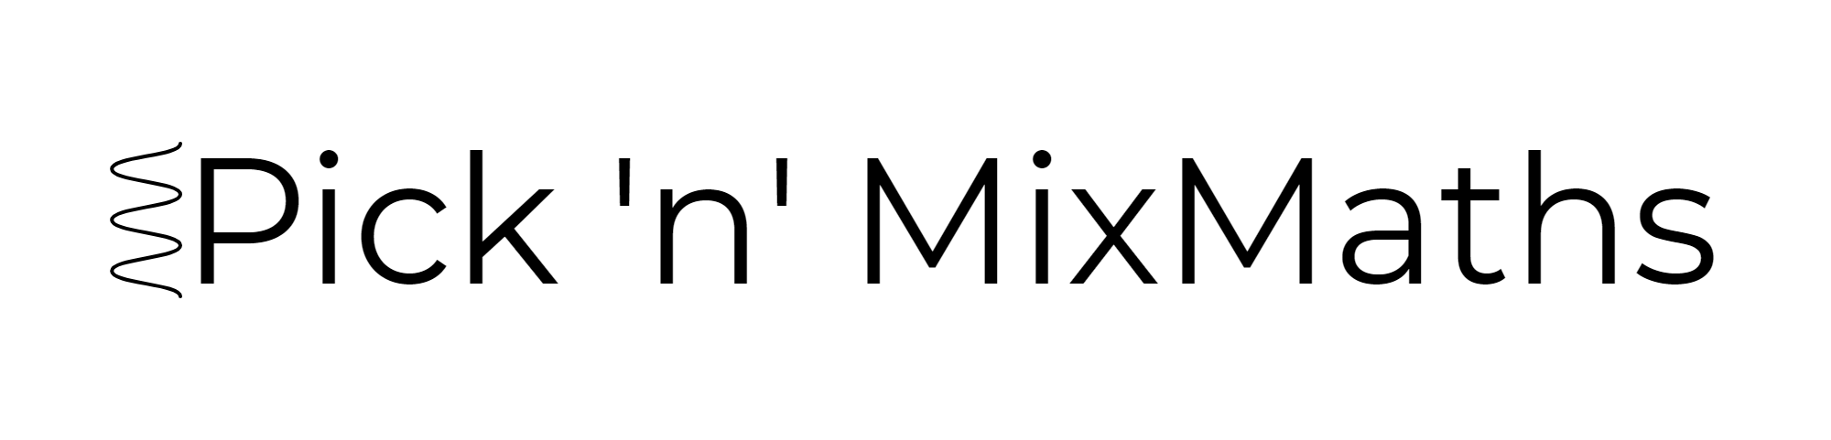
HIGHER: INEQUALITIES – This is a selection of the types of question that you need to be able to solve.
Q1.
− 3 < n ≤ 1
n is an integer.
(a) Write down all the possible values of n.

..............................................................................................................................................
(2)
(b) Solve the inequality 3p−7 > 11

..............................................................................................................................................
(2)
(Total for Question is 4 marks)
Q2.
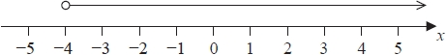
(a) Write down the inequality represented on the number line.
...........................................................
(1)
(b) Solve 4y − 9 ≤ 3
...........................................................
(2)
(c)
−3 ≤ n < 2
−2 < m < 4
n and m are integers.
Given that n = m, write down all the possible values of n.
...........................................................
(2)
(Total for question = 5 marks)
Q3.
3x + 5 > 16
x is an integer.
Find the smallest value of x.

..............................................................................................................................................
(Total for Question is 3 marks)
Q4.
–2 < n ≤ 3
(a) Represent this inequality on the number line.
(2)
(b) Solve the inequality 8x – 3 ≥ 6x + 4

..............................................................................................................................................
(2)
(Total for Question is 4 marks)
Q5.
Solve the inequality

...........................................................
(Total for question = 2 marks)

Q6.
Solve x² > 3x + 4
...........................................................
(Total for question = 3 marks)

Q7.
Solve 2x² – 5x – 12 > 0
...........................................................
(Total for question = 3 marks)

Q8.
The lines y = x – 2 and x + y = 10 are drawn on the grid.
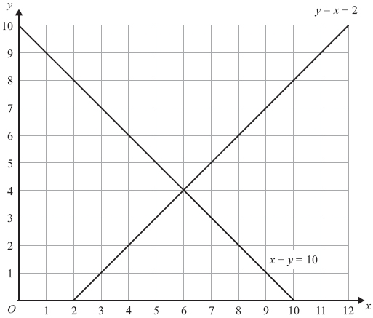
On the grid, mark with a cross (×) each of the points with integer coordinates that are in the region defined by
y > x – 2
x + y < 10
x > 3

(Total for Question is 3 marks)

Q9.
On the grid show, by shading, the region defined by the inequalities
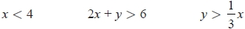
Label the region R.

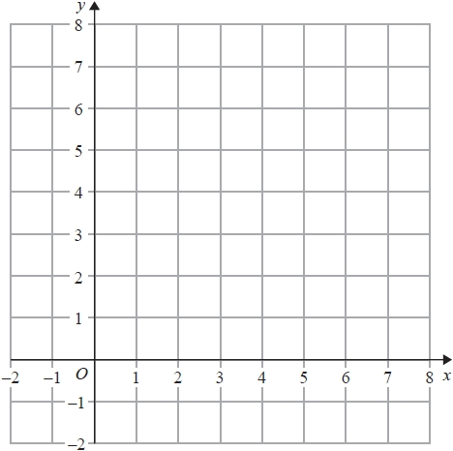

(Total for question = 3 marks)

Q10.
(a) Given that x and y are integers such that
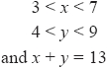
find all the possible values of x.
...........................................................
(2)
(b) On the grid below show, by shading, the region defined by the inequalities

Mark this region with the letter R.
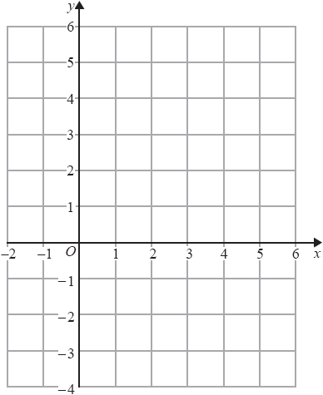
(4)

(Total for question = 6 marks)

Q11.
For her maths homework, Helen answered the following question.
Shade the region that is defined by all these inequalities.
x + y ≤ 6 y ≥ 0 y ≤ x + 2
Here is Helen's answer.
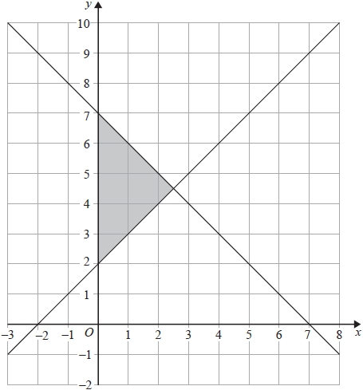
Helen made some mistakes when she answered the question.
Write down two mistakes Helen made.

(Total for question = 2 marks)

Q12.
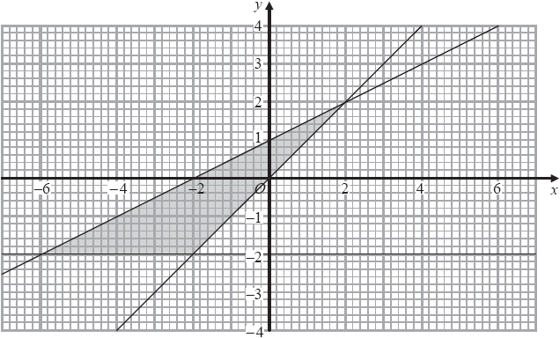
Write down the three inequalities that define the shaded region.

(Total for question = 4 marks)
Q13.
Here is a cuboid.
All measurements are in centimetres. x is an integer.
The total volume of the cuboid is less than 900 cm³
Show that

(Total for question = 3 marks)
Q14.
Here is a rectangle and a right-angled triangle.
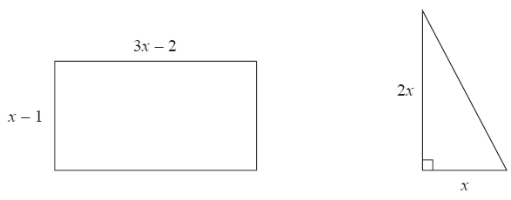
All measurements are in centimetres. The area of the rectangle is greater than the area of the triangle.
Find the set of possible values of x.

...........................................................
(Total for question = 5 marks)

Q15.
The region R, shown shaded in the diagram, is the region between two circles with the same centre.
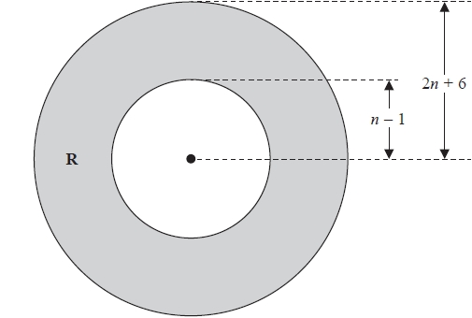
The outer circle has radius (2n + 6)
The inner circle has radius (n – 1)
All measurements are in centimetres.
The area of R is greater than the area of a circle of radius (n + 13) cm.
n is an integer.
Find the least possible value of n.
You must show all of your working.

...........................................................
(Total for question = 5 marks)
Mark Scheme
Q1.
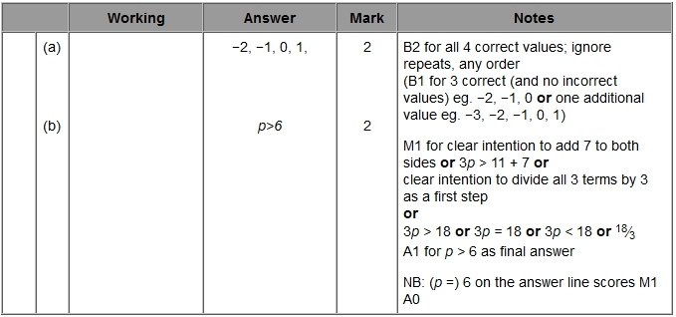
Q2.
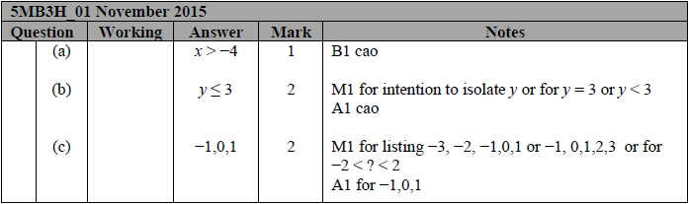
Q3.
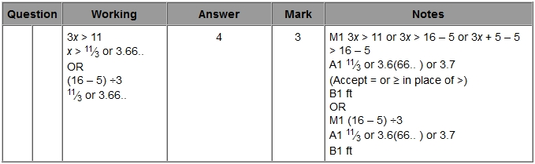
Q4.
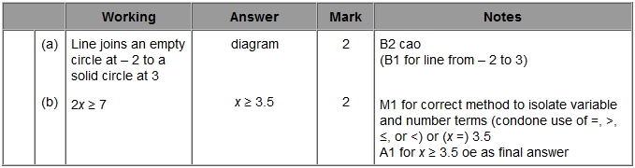
Q5.
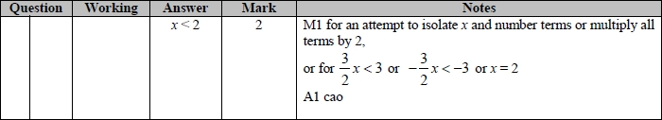
Q6.
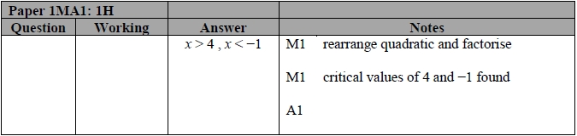
Q7.
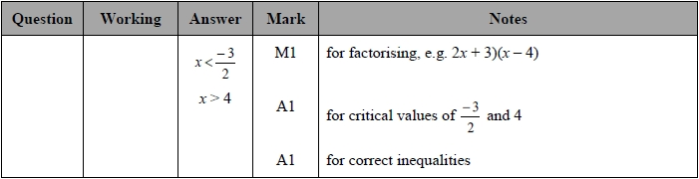
Q8.
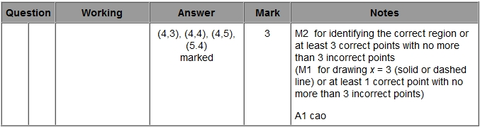
Q9.
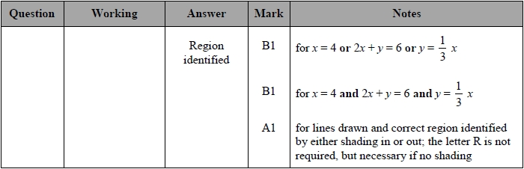
Q10.
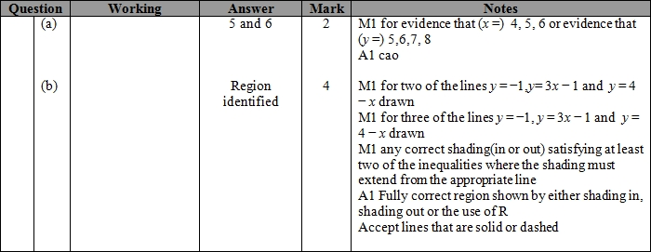
Q11.
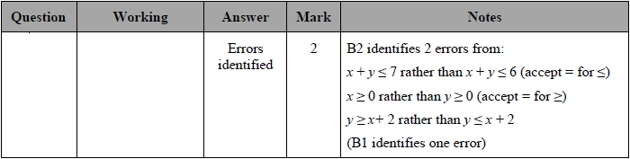
Q12.
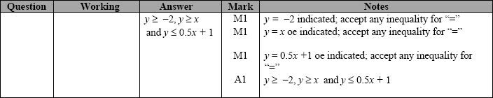
Q13.
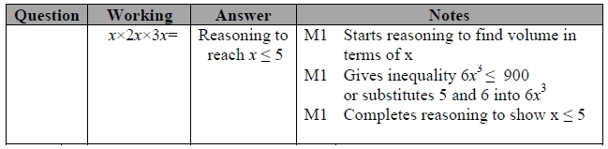

Q14.
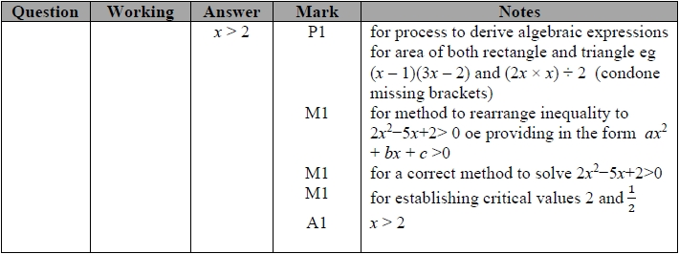
Q15.
