HIGHER: SIMULTANEOUS EQUATIONS – This is a selection of the types of question that you need to be able to solve.
Q1. NON-CALCULATOR
Solve the simultaneous equations
3x + 2y = 4
4x + 5y = 17

x ...........................................................

y ...........................................................
(Total for Question is 4 marks)
Q2.
Solve the simultaneous equations
5x + 2y = −2
3x − 5y = 11.2

x = ..........................................................
y = ...........................................................
(Total for question = 4 marks)
Q3.
The Singh family and the Peterson family go to the cinema.
The Singh family buy 2 adult tickets and 3 child tickets.
They pay £28.20 for the tickets.
The Peterson family buy 3 adult tickets and 5 child tickets.
They pay £44.75 for the tickets.
Find the cost of each adult ticket and each child ticket.

(Total for question = 5 marks)
Q4.
Susie has to deliver some packages and some parcels.
The total number of packages is 4 times the number of parcels.
The total number of packages and parcels is 40
Each parcel has a weight of 1.5 kg.
The total weight of the packages and parcels is 37.6 kg.
Each of the packages has the same weight.
Work out the weight of each package.

. . . . . . . . . . . . . . . . . . . . . . kg
(Total for Question is 4 marks)
Q5.
A and B are straight lines.
Line A has equation 2y = 3x + 8
Line B goes through the points (−1, 2) and (2, 8)
Do lines A and B intersect?
You must show all your working.

(Total for Question is 3 marks)

Q6.
Solve algebraically the simultaneous equations
x² + y² = 25
y − 3x = 13

...........................................................
(Total for question = 5 marks)

Q7.
(a) On the grid, construct the graph of x² + y² = 16
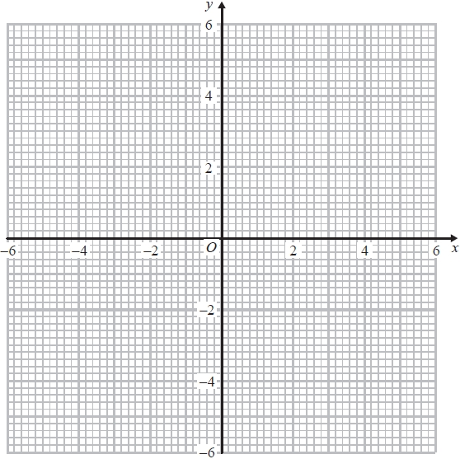
(2)
(b) Find estimates for the solutions of the simultaneous equations
x² + y² = 16
y = 2x + 1

...........................................................
(3)
(Total for question = 5 marks)

Mark Scheme
Q1.
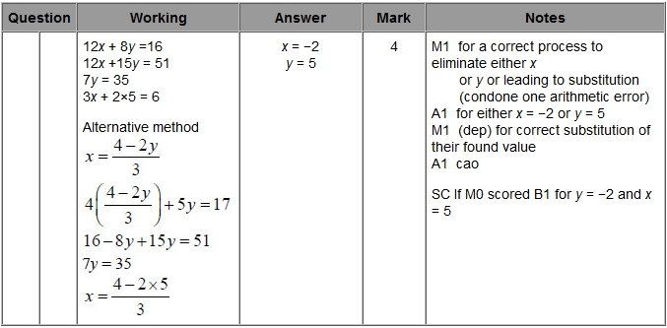
Q2.
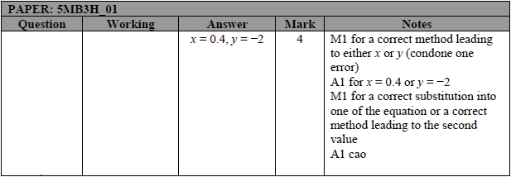
Q3.
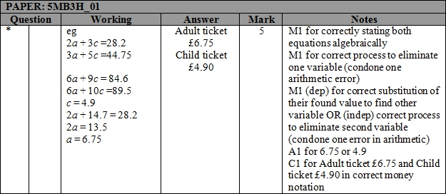

Q4.
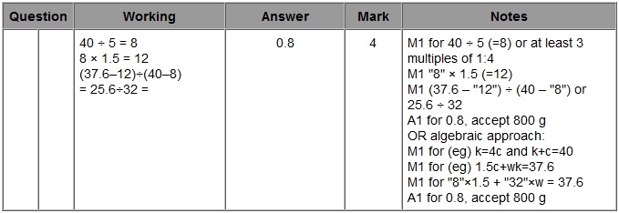
Q5.
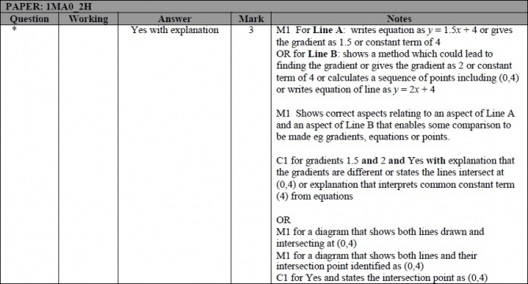
Q6.
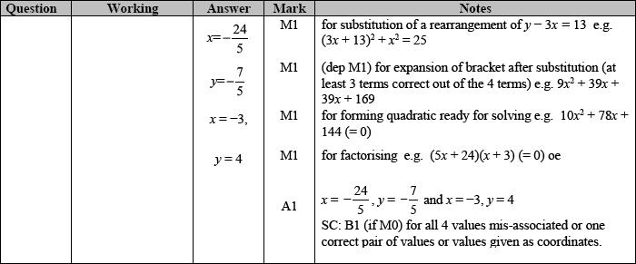

Q7.
