HIGHER: TRANSFORMING FUNCTIONS – This is a selection of the types of question that you need to be able to solve.
Q1.
The graph of y = f(x) is shown on each of the grids.
(a) On this grid, sketch the graph of y = f(x – 3)
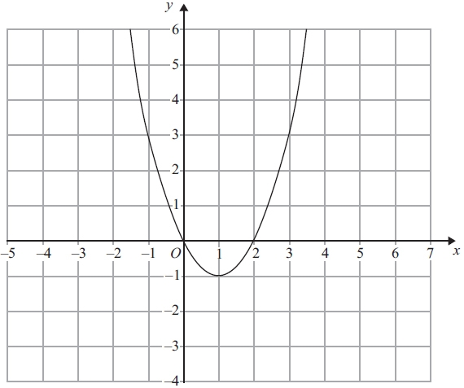
(2)

(b) On this grid, sketch the graph of y = f(x) + 2
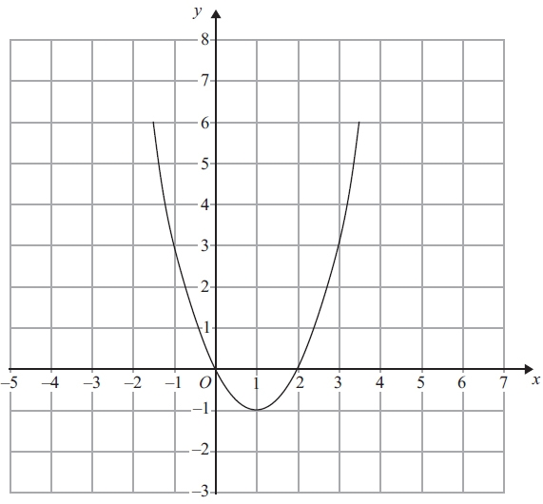
(2)
(Total for Question is 4 marks)

Q2.
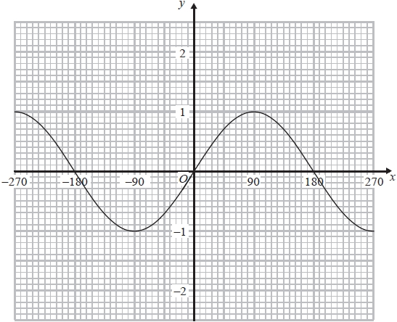
The graph of y = sin x° for values of x from –270 to +270 is shown above.
On the same axes, draw the graph of y = 1 – sin x° for values of x from –270 to +270
(Total for question = 2 marks)

Q3.
The graph of y = f(x) is shown on the grid.
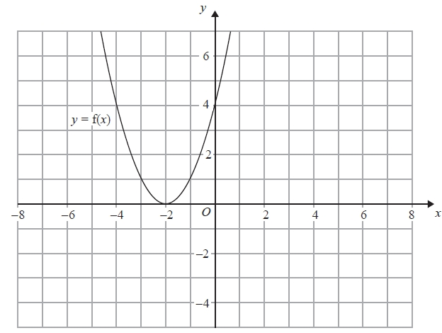
(a) On the grid above, sketch the graph of y = f(x + 3)
(2)
The graph of y = g(x) is shown below.
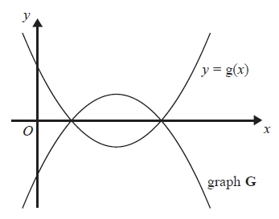
The graph G is the reflection of y = g(x) in the x-axis.
(b) Write down an equation of graph G.
...........................................................
(1)
(Total for question = 3 marks)

Q4.
The graph of y = f(x) is shown on both grids below.
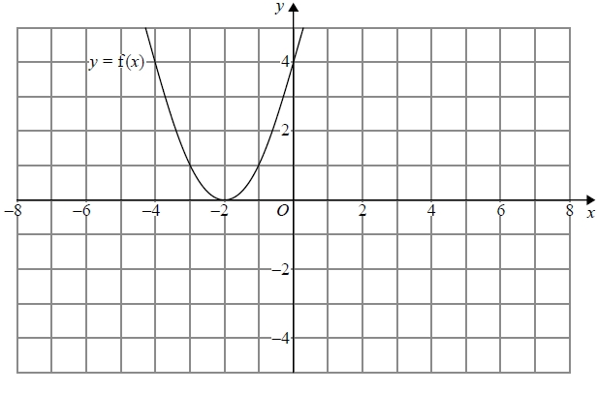
(a) On the grid above, sketch the graph of y = f(−x)
(1)
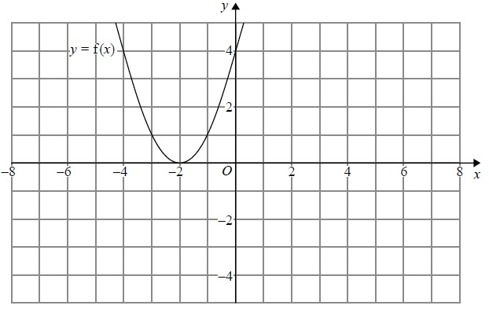
(b) On this grid, sketch the graph of y = −f(x) + 3
(1)
(Total for question = 2 marks)

Q5.
The graph of y = f(x) is shown on the grid.
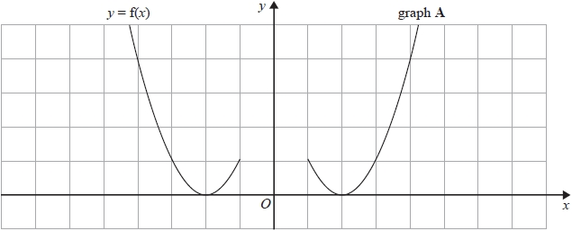
Graph A is a reflection of the graph of y = f(x).
(a) Write down the equation of graph A.
...........................................................
(1)
The graph of y = g(x) is shown on the grid.
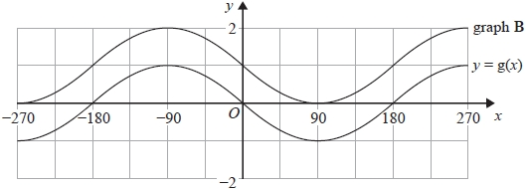
Graph B is a translation of y = g(x).
(b) Write down the equation of graph B.
...........................................................
(1)
(Total for question = 2 marks)

Q6.
(a) The graph of y = f(x) is shown on both grids below.
(i) On this grid, draw the graph of y = -f(x)
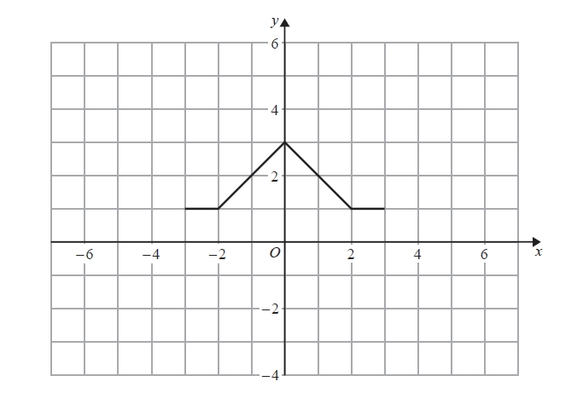
(ii) On the grid below, draw the graph of y = f(x – 3)
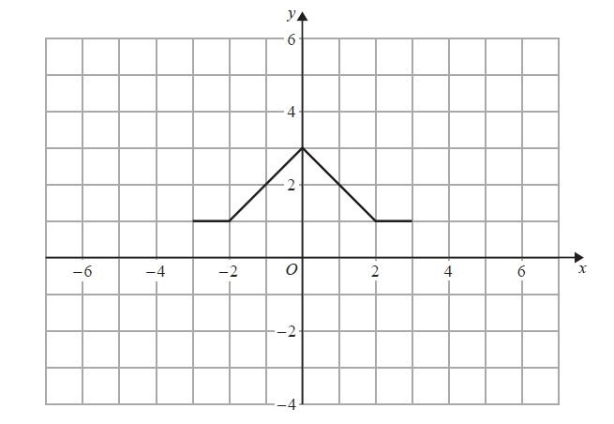
(2)
(Total for question = 4 marks)
Q7.
y = f(x)
The graph of y = f(x) is shown on the grid.
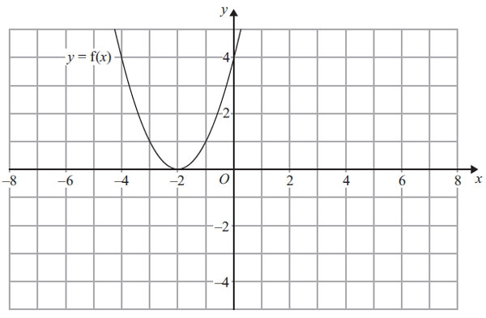
(a) On the grid above, sketch the graph of y = – f(x).
(2)
The graph of y = f(x) is shown on the grid.
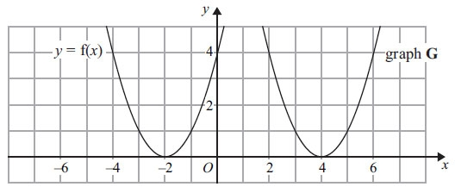
The graph G is a translation of the graph of y = f(x).
(b) Write down the equation of graph G.

..............................................................................................................................................
(2)
(Total for Question is 3 marks)

Q8.
Here is the graph of y = sin x° for –180 ≤ x ≤ 180
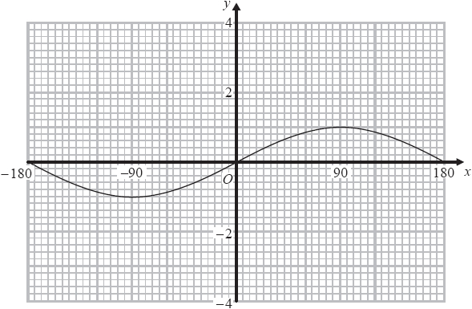
(a) On the grid above, sketch the graph of y = sin x° + 2 for –180 ≤ x ≤ 180
(2)
Here is the graph of y = cos x° for –180 ≤ x ≤ 180
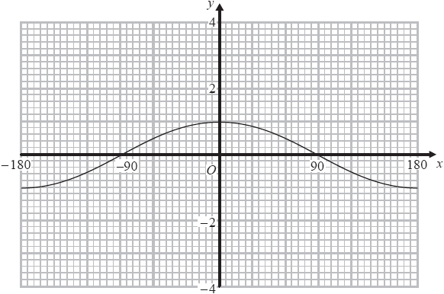
(b) On the grid above, sketch the graph of y = cos (x + 90) for –180 ≤ x ≤ 180
(2)

(Total for question = 4 marks)
Q9.
Here is a sketch of the curve y = sin (x + a)° + b
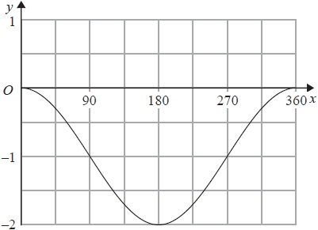
Given that 0 < a < 360
find the value of a and the value of b.
a = ...........................................................
b = ...........................................................
(Total for question = 2 marks)

Q10.
The graph of y = f(x) is shown on the grid.
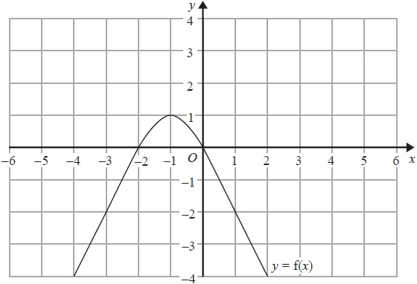
(a) On the grid, sketch the graph of y = f(x − 1)
(1)
The graph of y = f(x) has a turning point at the point ( −1, 1)
(b) Write down the coordinates of the turning point of the graph of y = f(–x) + 2
( ................ , ................ )
(1)
(Total for question = 2 marks)

Q11.
The graph of y = f(x) is transformed to give the graph of y = −f(x + 3)
The point A on the graph of y = f(x) is mapped to the point P on the graph of y = −f(x + 3)
The coordinates of point A are (9, 1)
Find the coordinates of point P.

(............................ , ............................)
(Total for question is 2 marks)
Mark Scheme
Q1.
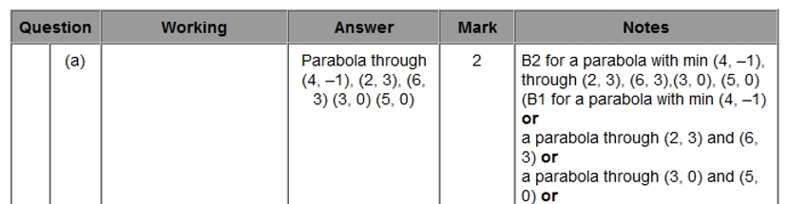
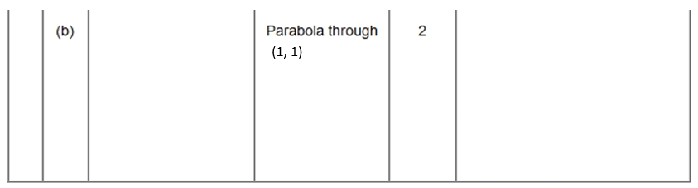
Q2.
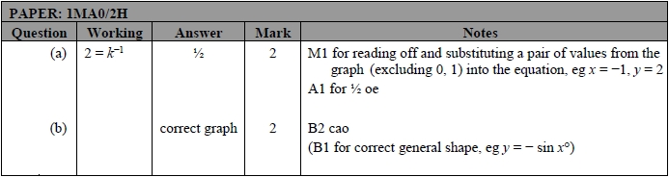
Q3.
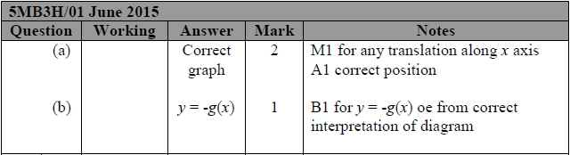
Q4.
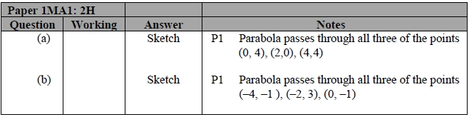
Q5.
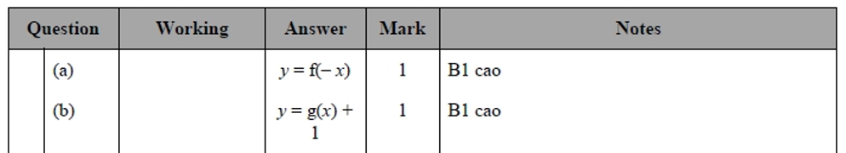
Q6.
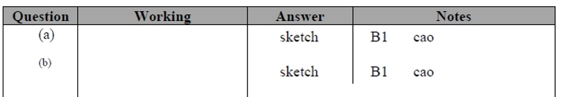
Q7.
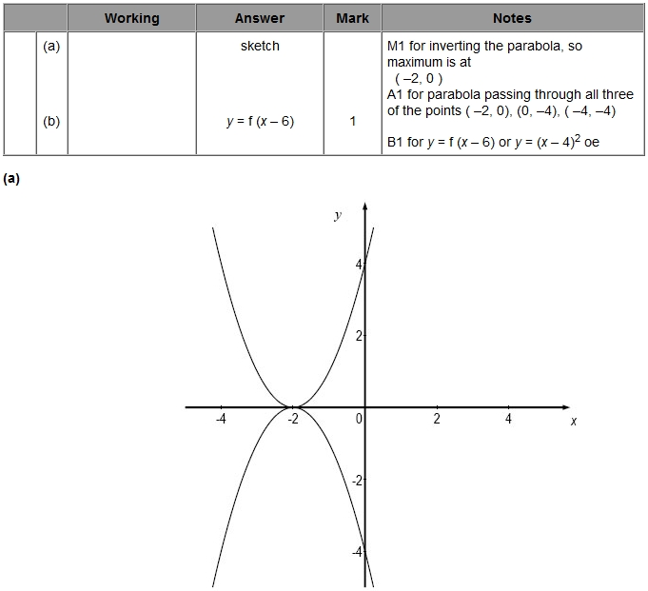

Q8.
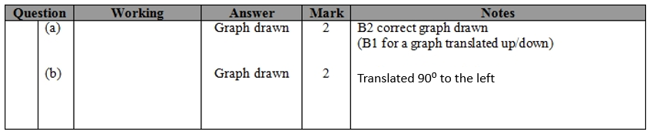
Q9.
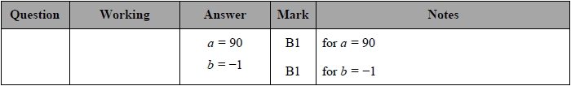
Q10.
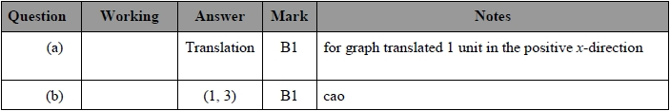
(a)
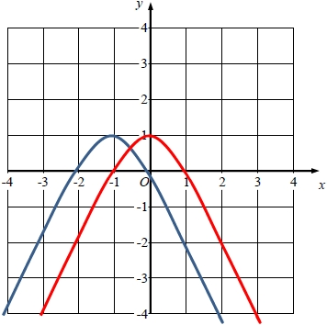
Q11.
