  
HIGHER: ALGEBRAIC FRACTIONS – This is a selection of the types of question that you need to be able to solve.

**Q1.**Simplify  

      ..............................................................................................................................................

**(Total for Question is 3 marks)**

**Q2.**Simplify fully     

...........................................................

**(Total for question = 3 marks)**

**Q3.**Write as a single fraction in its simplest form



      ..............................................................................................................................................

**(Total for Question is 4 marks)**

**Q4.**Write  as a single fraction in its simplest form.

      ..............................................................................................................................................

**(Total for Question is 3 marks)**

**Q5.**Simplify fully 

      ..............................................................................................................................................

**(Total for Question is 3 marks)**

**Q6.** (a)  Simplify fully 

...........................................................

**(2)**

(b)  Write  as a single fraction in its simplest form.

...........................................................

**(3)**

**(Total for question = 5 marks)**

**Q7.** Show that  can be written in the form  where *a*, *b*, *c* and *d* are integers.

**(Total for question is 3 marks)**

**Q8.** Show that  simplifies to  where *a*, *b*, *c* and *d* are integers

...........................................................

**(Total for question = 3 marks)**

**Q9.**

Simplify fully  

...........................................................

**(Total for question = 3 marks)**

**Q10.** Write 

as a single fraction in its simplest form. You must show your working.

...........................................................

**(Total for question is 4 marks)**

**Q11.** Show that  simplifies to a*x* where a is an integer.

**(Total for question = 4 marks)**

**Q12.**  can be written as a single fraction in the form

where *a* and *b* are integers. Work out the value of *a* and the value of *b*.

*a* = ...........................................................

*b* = ...........................................................

**(Total for question = 4 marks)**

**Q13.**

Show that  can be written as 

**(Total for question = 2 marks)**

**Q14.**

Prove that, for all positive values of *n*,



**(Total for question = 4 marks)**

**Q15.**

Solve 

*x* = . . . . . . . . . . . . . . . . . . . . . .

**(Total for Question is 3 marks)**

**Q16.**

Solve   

*x* = ...........................................................

**(Total for question = 4 marks)**

**Q17.** Solve 

*x* = ...........................................................

**(Total for question is 3 marks)**

**Q18. NON-CALCULATOR**   
Solve  Give your solutions as surds.

...........................................................

**(Total for question = 4 marks)**

**Q19.**

Given that 2*x* – 1 : *x* – 4 = 16*x* + 1 : 2*x* – 1

find the possible values of *x*.

...........................................................

**(Total for question = 5 marks)**

**Mark Scheme**  
Q1.

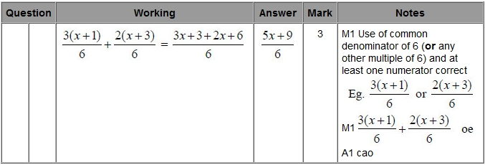

**Q2.**

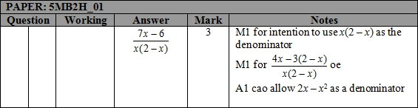

**Q3.**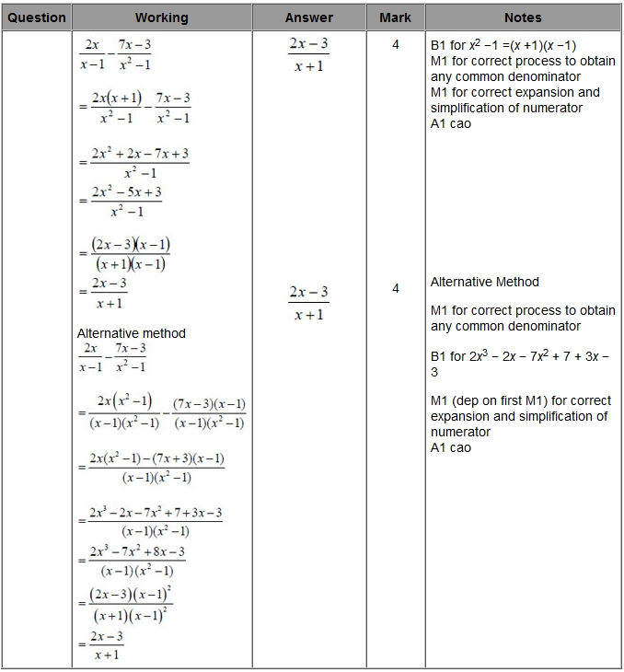

**Q4.**

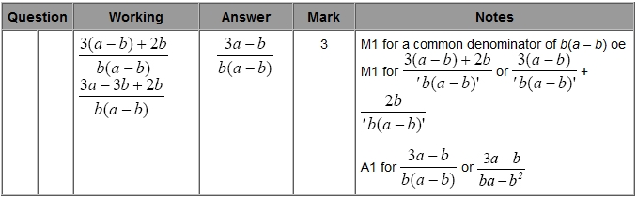

**Q5.**

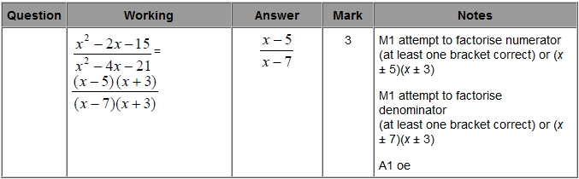

**Q6.**

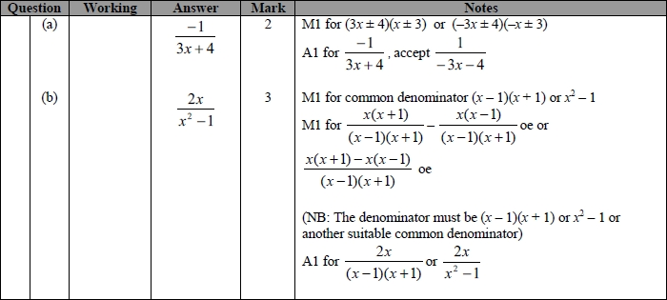

**Q7.**

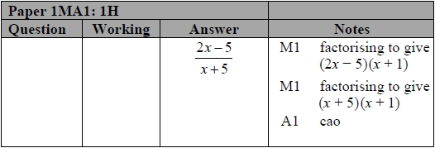

**Q8.**

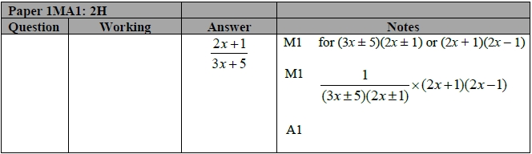

**Q9.**

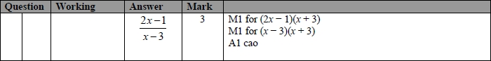

**Q10.**

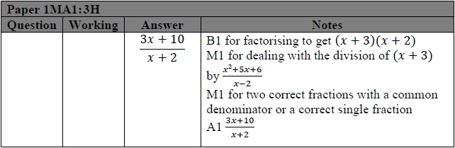

**Q11.**

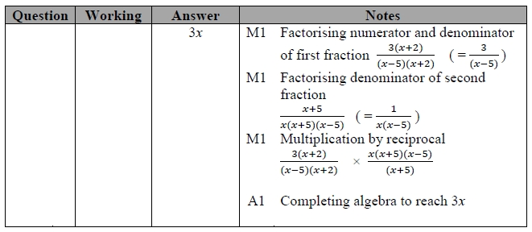

**Q12.**

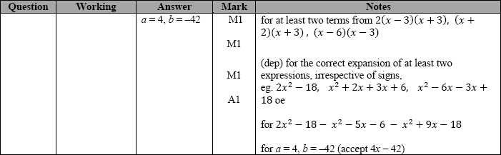

**Q13.**

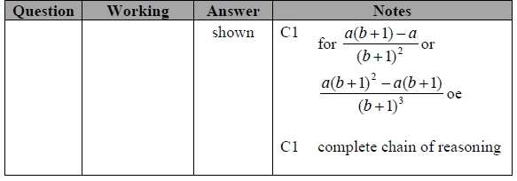

**Q14.**

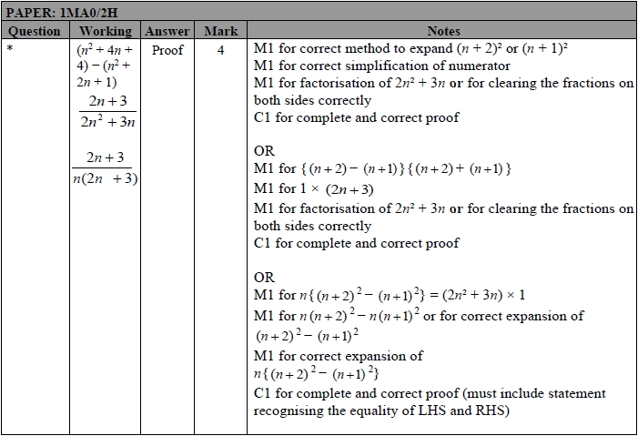

**Q15.** 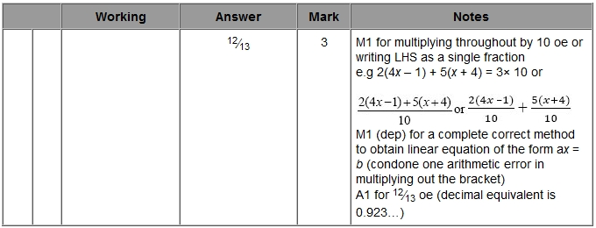

**Q16.**

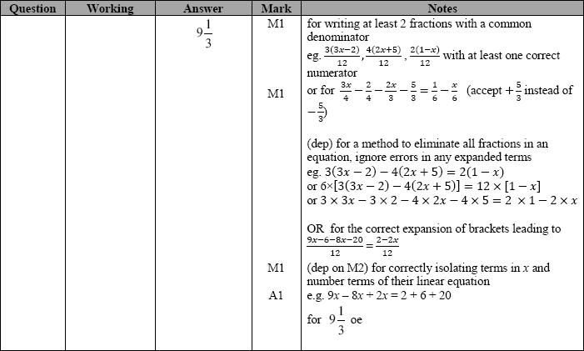

**Q17.**

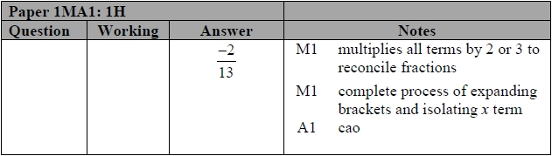

**Q18.**

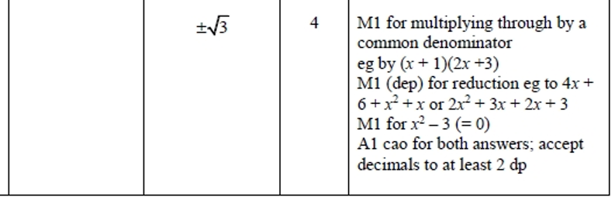

**Q19.**