Maths Predicted Paper
Higher Paper 1 Non-Calculator

MARK SCHEME

Q1.

(a) 15.6 ÷ 4 or 156 ÷ 40
or
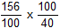
Correctly multiplying both numbers by the same number so that 0.4 becomes an integer
M1
3.9
oe
SC1 digits 39
A1
(b) Any decimal greater than and less than
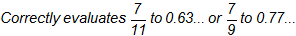
B2
(c) Any correct fraction
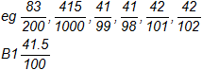
or
any ‘correct’ fraction with non-integer numerator and/or denominator
or
any decimal between 41% and 42%
B2
[6]
Q2.
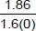
oe 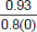 or 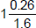
M1
or 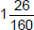
oe with no decimal values
A1
or
B1ft
ft correct simplification of their fraction using the digits 186 and 16(0)
ignore incorrect conversion from to a mixed number
Additional Guidance
Cannot score B1ft from an incorrect mixed number
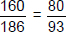
M0A0B1ft
implies B1ft
M0A0B1ft
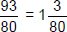 (incorrect conversion to mixed number)
M1A1B1
(incorrect simplification of fraction)
M1A1B0
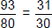 (incorrect simplification of fraction)
M1A1B0
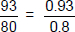 (incorrect simplification of fraction)
M1A1B0
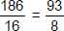
M0A0B1ft
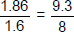
M1A0B0
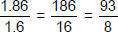
M1A0B1ft
(simplification does not come from 186 and 16(0))
M1A0B0
[3]
Q3.
Alternative method 1
24 ÷ 4 × 3 or 18
oe
M1
their 18 × 60 or 1080
oe
1080 implies M2
M1dep
1080 and (of a day)
A1
Alternative method 2
24 × 60 or 1440
oe
M1
their 1440 ÷ 4 × 3 or 1080
oe
1080 implies M2
M1dep
1080 and (of a day)
A1
Alternative method 3
24 ÷ 4 × 3 or 18
oe
M1
1000 ÷ 60
or 16(.6…) or 16.7 or 17
may be seen in either order (M marks not dependent)
[16 h 36 m, 16 h 42 m] implies division 16 or 17 may be embedded
M1
16(.6…) or 16.7 or 17 or [16 h 36 m, 16 h 42 m]
and
18 and (of a day)
16 or 17 may be embedded
A1
Alternative method 4
24 × 60 or 1440
oe
M1
1000 ÷ their 1440 (× 100)
or or 0.69… or 69(…)%
oe
or 0.69… or 69(…)% implies M2
M1dep
and and (of a day)
or
0.69… and 0.75 and (of a day)
or
69(…)% and 75% and (of a day)
A1
Additional Guidance
Ignore units for the M marks but they must be correct, if given, for the A mark
of 24 is insufficient method unless a correct method or 18 is seen
Once 1000 ÷ 60 or 16 or 16.6… or 16.7 or 17 is seen in Alt method 3, ignore any incorrect conversion to hours and minutes. If the student only shows hours and minutes, they must be in the given range.
Do not accept (of a day) in equivalent form e.g. 1080 or 18
A0
[3]
Q4.

Divides 8 by 11, showing at least 0.7
M1
Strand (i) Correct notation
Accept 0.7272…
Q1
[2]
Q5.

Alternative method 1
(x =) 0.288.....
and (10x =) 2.88.....
At least two 8s needed
M1
9x = 2.6 or
oe
M1dep
A1
Alternative method 2
(10x =) 2.88.....
and (100x =) 28.8.....
At least two 8s needed
M1
90x = 26 or
oe
M1dep
A1
Alternative method 3
(1x =) 0.288.....
and (100x =) 28.8.....
At least two 8s needed
M1
99x = 28.6 or 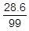
oe
M1dep
A1
Alternative method 4
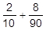
oe fractions
M1
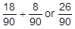
oe
Correct conversion to a common
denominator
M1dep
A1
Additional Guidance
Any fraction equivalent to
M1 M1 A0
[3]
Q6.
4 × 10 or 40
and 2 × 3 or 6
or
and
or
0.5 and 0.3
oe eg 50% and 30%
M1
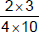 or 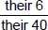 or 0.015
oe eg or × or 0.5 × 0.3
M1dep
15
A1
Additional Guidance
2 : 4 and 3 : 10
M0
[3]
Q7.
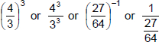
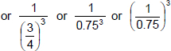
M1
or
oe fraction, mixed number or decimal
A1
Additional Guidance
followed by an incorrect attempt to convert to a mixed number
M1A1
M0A0
[2]
Q8.
Alternative method 1
(8⁴ =) (2³)⁴ or 2¹²
or
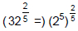 or 2²
M1
22¹² and 2²
or calculation in the form
2ª ÷ 2^{b} where a – b = 10
2^{c} × 2^{d} where c + d = 10
M1dep
2¹⁰
Accept m = 10
A1
Alternative method 2
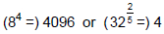
M1
1024
M1dep
2¹⁰
Accept m = 10
A1
Additional Guidance
Note that 1024 from 32 × 32 scores 2 marks if 1024 is their final numerical answer
However, if they then try to find they are clearly processing
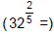, so this would only score 0 marks without further work
If a numerical method and an index method are both attempted and an incorrect answer is given, award up to M1M1 from the better method
[3]
Q9.

4.5 × 10³ or
M1
0.0045 or 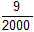
SC1 number given in standard form with negative index and then correctly changed to decimal.
A1
[2]
Q10.
10.8 × 10^{(5 – 2)} or 10.8 × 10³
or 540 000 × 0.02 or 5400 × 2
or 10 800
oe
M1
1.08 × 10⁴
SC1 1.1 × 10⁴
A1
[2]
Q11.
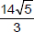
oe eg 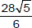
B2 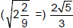
or
and
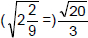 or 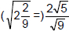
B1
or or
B3
Additional Guidance
For B1 or B2, allow for and 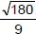 for
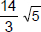
B3
+ = 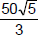
B2
+ = 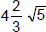
B2
+ = 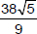
B1
+ 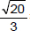 = 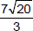
B1
[3]
Q12.
Alternative method 1
M1
implies M1A1
A1
27 with M1A1 seen
A1
Alternative method 2
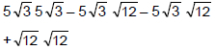
or
or
or
or
or
oe expansion
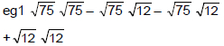
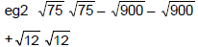
M1
75 – 30 – 30 + 12
or
75 – 60 + 12
implies M1A1
A1
27 with M1A1 seen
A1
Additional Guidance
27 with no working
M0A0A0
Alt 1
M0A0A0
Alt 2 75 – 30 – 30 – 12
M1A0A0
Alt 1
(condone missing brackets)
M1A1A1
Only converting to decimals
M0A0A0
[3]
Q13.
Alternative method 1
4 × 5 + c = 23
oe 20 + c = 23
M1
c = 3
implied by (0, 3)
or 3 shown as y-axis intercept
A1
y = 4x + 3
SC1 y = 4x + c c ≠ 3
A1
Alternative method 2
y – 23 = 4(x – 5)
oe
M1
y – 23 = 4x – 20
M1dep
y = 4x + 3
SC1 y = 4x + c c ≠ 3
A1
Additional Guidance
If 3 is clearly linked to c in y = mx + c condone M1A1
4x + 3 on answer line, y = 4x + 3 seen in working
M1A1A1
4x + 3 on answer line, y = 4x + 3 not seen in working
M1A1A0
m = 4, c = 3 on answer line, y = 4x + 3 seen in working
M1A1A1
m = 4, c = 3
M1A1A0
y = mx + 3
M1A1A0
23 = 4 × 5 + 3 embedded value for c
M1A0A0
4x + c on answer line with c ≠ 3
M0A0A0
[3]
Q14.
(a) 2x + 10 = 3x − 20
oe
180 − (2x + 10) + 3x − 20 = 180
M1
3x − 2x = 20 + 10 or x = 30
oe
M1dep
2 × their 30 + 10 or 3 × their 30 − 20 or 70
oe
M1dep
110
A1
Additional Guidance
x = 30, y = 180 − 3(30) + 20 = 110
M1M1M1A1
x = 30, y = 180 − 3(30) − 20 = 110 recovered missing bracket
M1M1M1A1
x = 30, y = 180 − 3(30) − 20 = 70 not recovered
M1M1M0A0
2x + 10 = 3x − 20
3x − 2x = 20 + 10
x = 10
2 × 10 + 10 (= 30)
M1M1M1A0
2x + 10 = 3x − 20
x = 10
2 × 10 + 10 (= 30)
M1M0M0A0
y + 2x + 10 = 3x − 20 + y
M1M0M0A0
w = 3x − 20 seen or on diagram
M0M0M0A0
w = 2x + 10 seen or on diagram
M0M0M0A0
(b) 2x + 10 = 60 or 2x = 60 − 10 or 2x = 50 or x = 25
M1
3 × their 25 − 20 or 55 or 180 − 55 or 125
oe
M1dep
(y =) 125 and bigger or (y is) 15 bigger
oe
ft their (a)
A1ft
Additional Guidance
Note: A complete logical explanation of the effect of lines not being parallel
eg w is smaller so 2x + 10 is smaller so x is smaller so 3x − 20 is smaller so y is bigger
M1M1A1
2 × 25 + 10 = 60
M1M0A0
y is bigger ticked but no valid working
M0M0A0
[7]
Q15.
Alternative method 1
x + 2x + 2x + 10 or 5x + 10
or x + 2x + 2x + 10 + 90
or 5x + 100
oe
M1
x + 2x + 2x + 10 = 360 – 90
or 5x + 10 = 270
or x + 2x + 2x + 10 + 90 = 360
or 5x + 100 = 360
or 5x = 260
oe
M1dep
(x =) 52 or 2x = 104
or 2x + 10 = 114
may be on diagram
A1
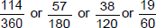
or 0.31(6..) or 0.317 or 0.32
or 31(.6…)% or 31.7% or 32%
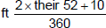
B1ft
Alternative method 2
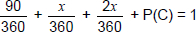
or
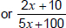
oe
M1
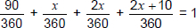
oe
M1dep
(x =) 52 or 2x = 104
or 2x + 10 = 114
may be on diagram
A1
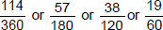
or 0.31(6..) or 0.317 or 0.032
or 31(.6...)% or 31.7% or 32%
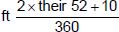
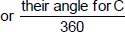
B1ft
Additional Guidance
Ignore incorrect simplification or conversion after oe
M1M1A1B1
M1M1
x + 2x + 2x + 10 followed by 6x + 10 = 270
M1M0
Do not accept decimal within fraction for final answer if correct fraction not seen
The follow through is not available if A1 awarded
[4]
Q16.
Alternative method 1
35x + 6x = ax or 35 + 6 = a
or 41x = ax
M1
a = 41
A1
40 + 3b = 13
oe
M1
b = −9
SC3 a = 41, b = –27 or a = 41, b =
A1
Alternative method 2
35x + 40 + 6x + 3b
or 41x + 40 + 3b
M1
35x + 6x = ax or 35 + 6 = a
and
40 + 3b = 13
oe
eg 41x = ax and 3b = −27
M1dep
a = 41
implies first M1 only
A1
b = −9
SC3 a = 41, b = −27 or a = 41, b =
A1
Additional Guidance
a = 41 and b = −9
M1A1M1A1
a = 41 or b = −9
M1A1
35x, 40, 6x and 3b seen without addition signs shown or implied
M0
35x + 40 + 6x + b leading to an answer of a = 41 and b = −27
SC3
35x + 8 + 6x + 3b leading to an answer of a = 41 and b =
SC3
35x + 8 + 6x + b leading to an answer of a = 41 and b = 5
M1A1
a = 41x
M0
For accept 1.66... or 1.67
Condone multiplication signs eg 35 × x for 35x
[4]
Q17.

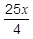
B1
[1]
Q18.

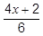 or 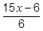
oe
M1
+ = 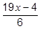
A1
[2]
Q19.

x (2y − 3) or 2xy − 3x
oe
M1
2xy − 3x = 5y + 4
oe
M1dep
2xy − 5y = 3x + 4
or y(2x − 5) = 3x + 4
or 5y − 2xy = −3x − 4
or y(5 − 2x) = −3x − 4
M1dep
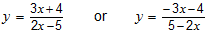
A1
Additional Guidance
If there is choice mark the working linked to the answer line
2xy − 3x = 5y + 4 is M1M1 as minimum
2xy − 5y = 3x + 4 or y(2x − 5) = 3x + 4 is M1M1M1 as minimum
Condone x × (2y − 3)
M1
[4]
Q20.

(a) y = tan x
B1
(b) y = 2^{x}
B1
[2]
Q21.
Fully correct curve
and
point (0, –2) indicated
B1 fully correct curve
or
partially correct curve with point (0, –2) indicated
B2
Additional Guidance
A partially correct curve must
start in the 3rd quadrant and finish in the 1st quadrant, passing through the 4th quadrant
not include a section with negative gradient
A fully correct curve must
have all the properties of a partially correct curve
have only a decreasing gradient to the left of the y-axis
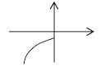
have only an increasing gradient to the right of the y-axis
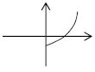
Condone a positive gradient at the y-intercept
Condone straight line segments at each end of the curve
Fully correct curve with y-intercept labelled –2
B2
Partially correct curve with y-intercept labelled –2
B1
y-intercept labelled (–2, 0) is incorrect and can score a maximum of B1
Ignore any numbers on the axes other than the y-intercept
y-intercept (0, – 2) stated does indicate the point (0, –2)
Additional Guidance
Unlabelled notches do not indicate the point (0, –2)
A table of values does not indicate the point (0, –2)
Graph consisting only of straight lines
B0
A fully correct curve but point (0, –2) is not indicated
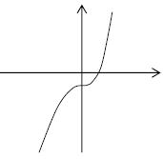
B1
Partially correct curve with point (0, –2) indicated
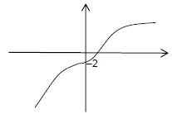
B1
Fully correct curve with point (0, –2) indicated
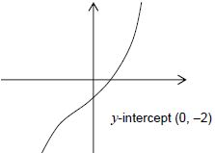
B2
Partially correct curve with point (0, –2) indicated
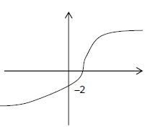
B1
Curve includes a negative gradient so not partially correct
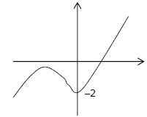
B0
[2]
Q22.

(a) 3
B1
(b) Correct attempt at full area
eg1 × 5 × 5 + 5 × their 3 + × 4 × 5
(= 12.5 + 15 + 10)
eg2 × (12 + their 3) × 5
(= × 15 × 5)
ft their 3 from (a) for M2 and M1
M1 Correct attempt at a relevant area
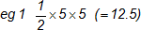
eg 2 5 × their 3 (= 15)
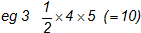
eg 4 Counting squares
M2
37.5
oe
ft from M2 and their 3 from (a)
A1ft
(c) 1
B1
(d) acceleration
B1
[6]
Q23.

Draws the line x = −3 as a dashed line
at least from y = 0 to y = 5
B1
Draws the line x + y = 2 as a solid line
at least from x = −3 to x = 2
B1
Draws the line y = as a solid line
at least from x = −3 to x = 2
B1
Correctly labels or shades the region satisfying all three inequalities
ft their three lines
B1ft
Additional Guidance
Only withhold a mark for an incorrect line style on the first occasion
With only one or two or with four or more lines drawn it is impossible to score the last B1
[4]
Q24.
(a) D
B1
(b) C
B1
(c) E
B1
[3]
Q25.
Alternative method 1
(second differences =) 4
or 2n² or a = 2
second difference seen at least once and not contradicted
M1
11 − 2 × 1² and 26 − 2 × 2² and
45 – 2 × 3² (and 68 – 2 × 4²)
or
9 and 18 and 27 (and 36)
or 9n
M1dep
2n² + 9n
oe
A1
Alternative method 2
any two of
a + b + c = 11
4a + 2b + c = 26
9a + 3b + c = 45
16a + 4b + c = 68
M1
3a + b = 26 − 11
and 5a + b = 45 − 26
or
a = 2 and b = 9 (and c = 0)
oe
obtains two correct equations in same two variables from their equations
M1dep
2n² + 9n
oe
A1
Alternative method 3
(second differences =) 4
or 2n² or a = 2
second difference seen at least once and not contradicted
M1
3a + b = 26 − 11
and substitutes a = 2
or b = 9 or 9n
M1dep
2n² or 9n
oe
A1
[3]

