HIGHER: CUMULATIVE FRQUENCY & BOX PLOTS – This is a selection of the types of question that you need to be able solve.
Q1.
The table shows information about the times taken by 100 people in a fun run.
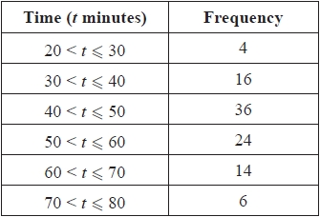
(a) Complete the cumulative frequency table for this information.
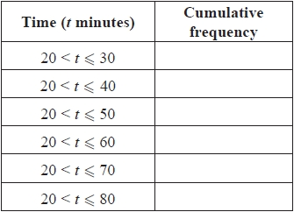
(1)
(b) On the grid, draw a cumulative frequency graph for your table.
(2)
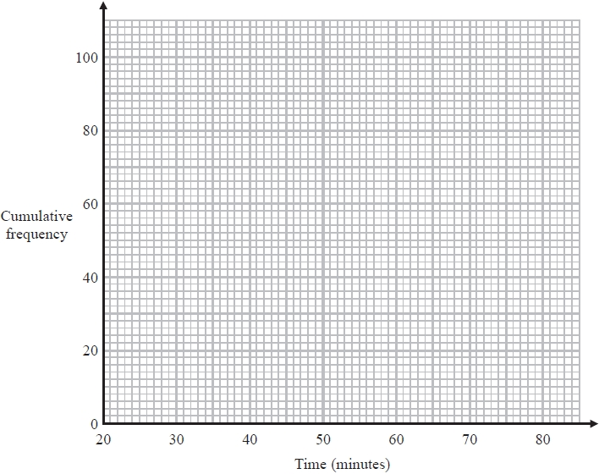
(c) Use your graph to find an estimate for the median time.
........................................................... minutes
(1)
(d) Use your graph to find an estimate for the number of people who took longer than 63 minutes.
...........................................................
(2)
(Total for question = 6 marks)

Q2.
The grouped frequency table shows information about the weekly wages of 80 factory workers.
Weekly wage (£x) | Frequency
100 < x ≤ 200 | 8
200 < x ≤ 300 | 15
300 < x ≤ 400 | 30
400 < x ≤ 500 | 17
500 < x ≤ 600 | 7
600 < x ≤ 700 | 3
(a) Complete the cumulative frequency table.
Weekly wage (£x) | Cumulative  Frequency
100 < x ≤ 200
200 < x ≤ 300
300 < x ≤ 400
400 < x ≤ 500
500 < x ≤ 600
600 < x ≤ 700
(1)
(b) On the grid opposite, draw a cumulative frequency graph for your table.
(2)
(c) Use your graph to find an estimate for the interquartile range.

..............................................................................................................................................
(2)
(d) Use your graph to find an estimate for the number of workers with a weekly wage of more than £530

..............................................................................................................................................
(2)
(Total for Question is 7 marks)

Q3.
Some students were asked how many times they each used their mobile phones last week.
The box plots give information about the male students' answers and about the female
students' answers.
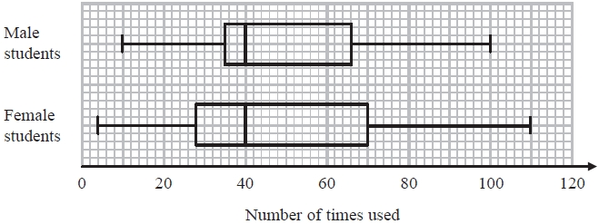
Compare the two distributions represented by the box plots.

(Total for question = 3 marks)
Q4.
Presta recorded the number of lemons on each of 60 lemon trees.
The incomplete table and box plot give information about her results.
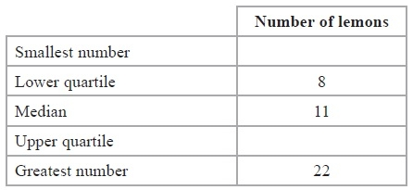
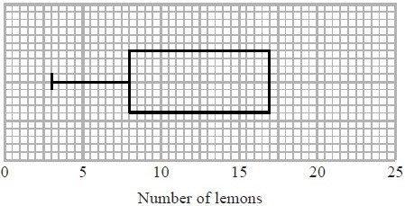
(a) (i) Use the information in the table to complete the box plot.
(ii) Use the information in the box plot to complete the table.
(3)
Some of these 60 lemon trees have 8 or more lemons on them.
(b) Find an estimate for the number of lemon trees with 8 or more lemons on them.

...........................................................
(2)
(Total for Question is 5 marks)

Q5.
The table gives information about the weights of 60 parcels.
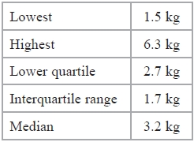
Draw a box plot for this information.
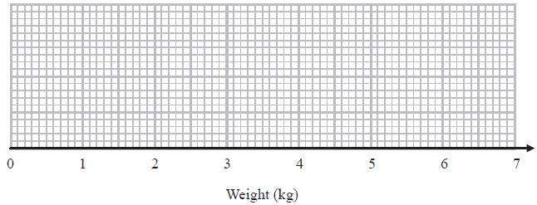

(Total for question = 3 marks)

Q6.
Here are the times, in seconds, that 15 people waited to be served at Rose's garden centre.
5 | 9 | 11 | 14 | 15 | 20 | 22 | 25 | 27 | 27 | 20 | 22 | 25 | 27
(a) On the grid, draw a box plot for this information.

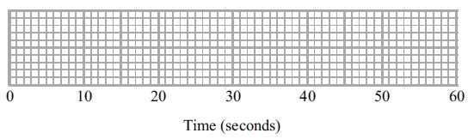
(3)
The box plot below shows the distribution of the times that people waited to be served at Green's garden centre.

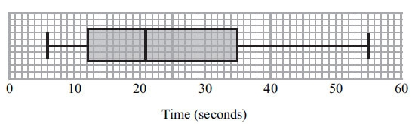
(b) Compare the distribution of the times that people waited at Rose's garden centre and the distribution of the times that people waited at Green's garden centre.

(2)
(Total for Question is 5 marks)

Q7.
The table gives some information about the weights of 60 babies.
Lowest | 2.0 kg
Highest | 6.5 kg
Lower quartile | 2.8 kg
Upper quartile | 4.2 kg
Median | 3.0 kg
(a) Draw a box plot to show this information.
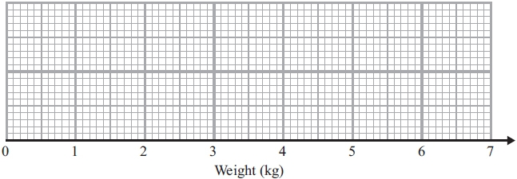
(2)
There are 60 babies.
(b) Work out an estimate for the number of these babies with a weight greater than 2.8 kg.

..............................................................................................................................................
(2)
(Total for Question is 4 marks)
Q8.
The table shows some information about the weights, in kg, of some boxes.
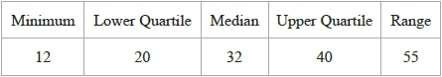
Yusuf uses this information to draw the box plot below.
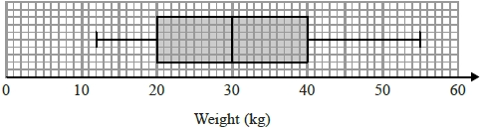
Write down two things wrong with this box plot.

(Total for question = 2 marks)
Q9.
The cumulative frequency graph gives information about the speeds, in mph, of 400 cars passing a speed camera between 7 am and 8 am one day.
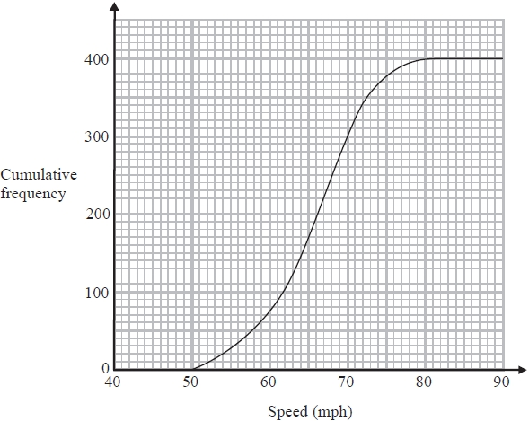
(a) Work out an estimate for the number of cars passing this speed camera at speeds greater than 72 mph.
...........................................................
(2)

The least speed for these 400 cars was 50 mph.
The greatest speed for these 400 cars was 81 mph.
(b) Use the cumulative frequency graph and the information above to draw a box plot to show the distribution of the speeds of these 400 cars.
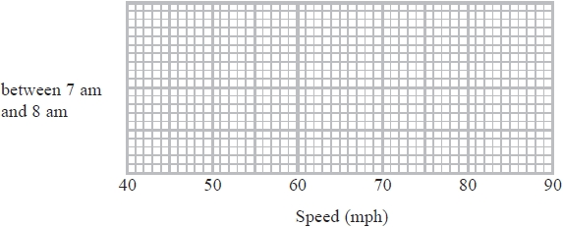
(3)

The box plot below shows the distribution of the speeds of the cars passing the speed camera between 1 pm and 2 pm the same day.
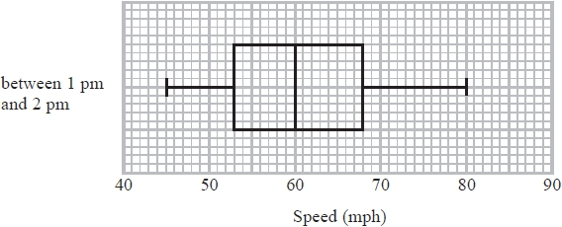
*(c) Compare the two distributions of the speeds.

(2)
(Total for question = 7 marks)

Q10.
Joan measured the heights of students in four different classes.
She drew a cumulative frequency graph and a box plot for each class.
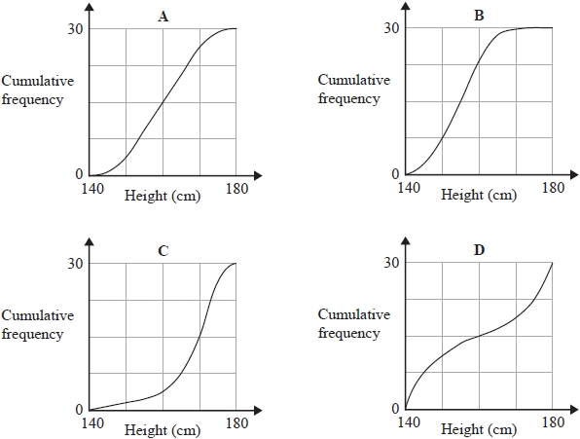
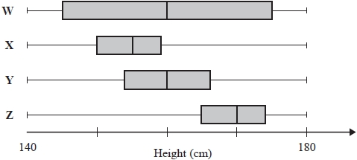
Match each cumulative frequency graph to its box plot.
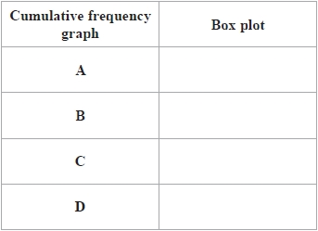
(Total for question = 2 marks)
Q11.
The cumulative frequency graphs give information about the heights of two groups of children, group A and group B.
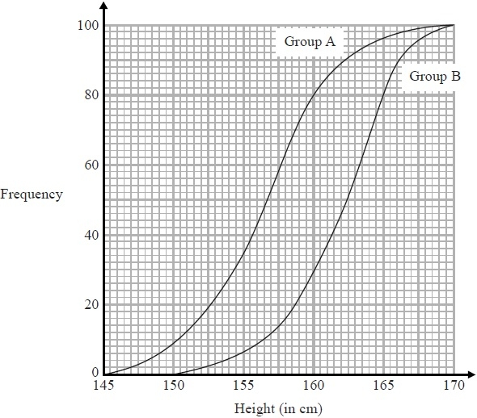
Compare the heights of the children in group A and the heights of the children in group B.

(Total for Question is 2 marks)

Mark Scheme
Q1.
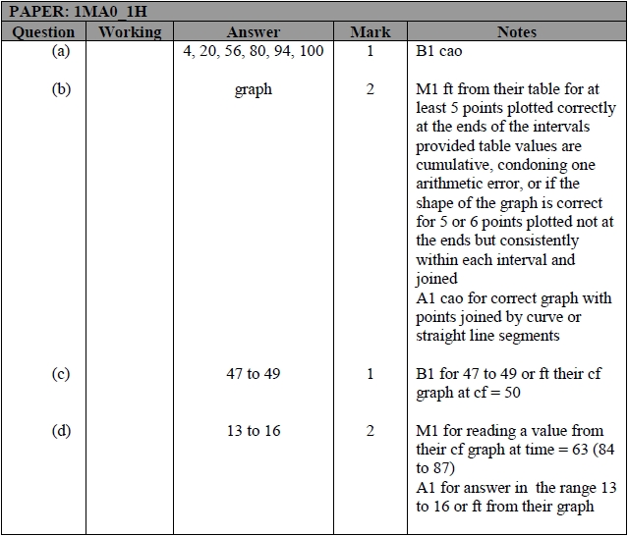

Q2.
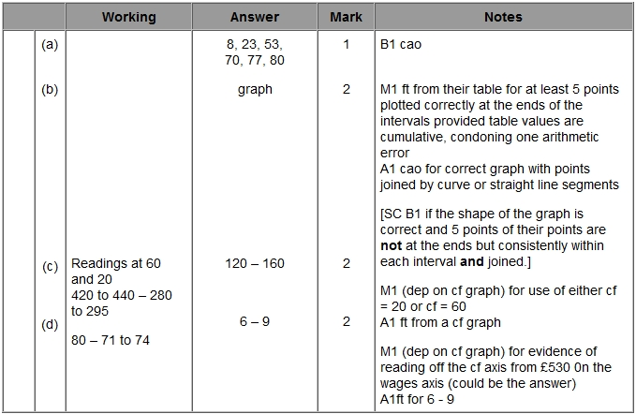
Q3.
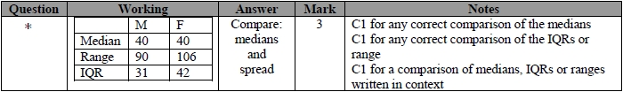
Q4.
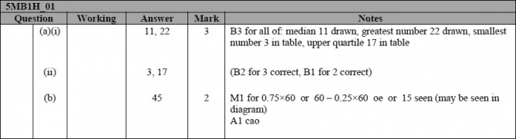
Q5.
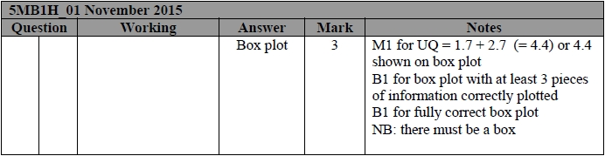
Q6.
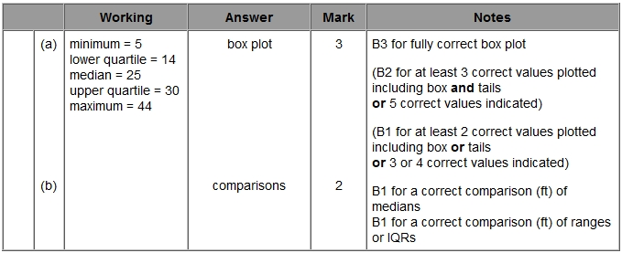

Q7.
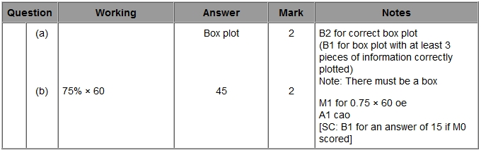
Q8.
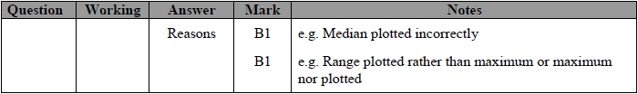
Q9.
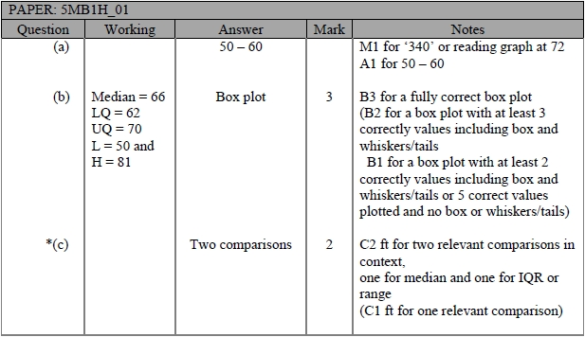
Q10.
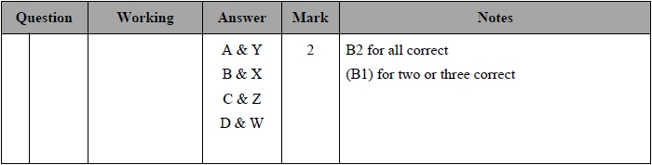

Q11.
