HIGHER: SEQUENCES – This is a selection of the types of question that you need to be able to solve.
Q1.
The nth term of a number sequence is 2n + 1
Write down the first 3 terms of the number sequence.
...........................................................
(Total for question = 2 marks)
Q2.
The nth term of sequence A is 3n − 2
The nth term of sequence B is 10 − 2n
Sally says there is only one number that is in both sequence A and sequence B.
Is Sally right?
You must explain your answer.

(Total for question = 2 marks)
Q3.
Here are the first five terms of an arithmetic sequence.
2 5 8 11 14
(a) Write down an expression, in terms of n, for the nth term of this sequence.
...........................................................
(2)
(b) Is 299 a term of this sequence?
You must give a reason for your answer.

(2)
(c) Write down an expression, in terms of n, for the (n + 1)th term of this sequence.

...........................................................
(1)
(Total for question = 5 marks)

Q4.
Here is an equilateral triangle.
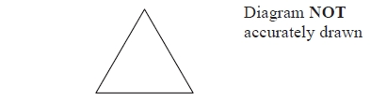
The equilateral triangle has a perimeter of 24 cm.
Some of these equilateral triangles are used to make this sequence of quadrilaterals.
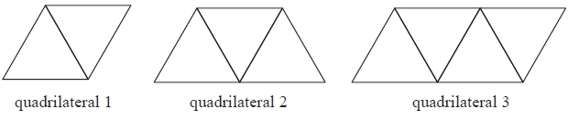
Find an expression for the perimeter, in centimetres, of quadrilateral n.

...........................................................
(Total for question = 3 marks)

Q5.
Here are the first four terms of a quadratic sequence 3 8 15 24
(a) Find an expression, in terms of n, for the nth term of this sequence.

...........................................................
(3)
The nth term of a different sequence is 2^{n} + 5
(b) Show that 36 is not a term of this sequence.

(1)
(Total for question = 4 marks)
Q6.
Here are the first five terms of a sequence 4 11 22 37 56
Find an expression, in terms of n, for the nth term of this sequence.

...........................................................
(Total for question = 3 marks)
Q7.
The diagram shows the first 10 sides of a spiral pattern. It also gives the lengths, in cm, of the first 5 sides.
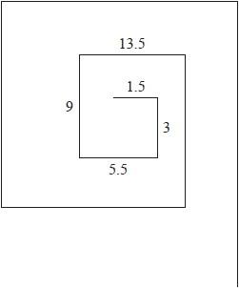
The lengths, in cm, of the sides of the spiral form a sequence.
Find an expression in terms of n for the length, in cm, of the nth side.

...........................................................
(Total for question = 3 marks)

Q8.
Here are the first six terms of a Fibonacci sequence.
1 1 2 3 5 8
The rule to continue a Fibonacci sequence is,
the next term in the sequence is the sum of the two previous terms.
(a) Find the 9th term of this sequence.
...........................................................
(1)
The first three terms of a different Fibonacci sequence are
a b a + b
(b) Show that the 6th term of this sequence is 3a + 5b

(2)
Given that the 3rd term is 7 and the 6th term is 29,
(c) find the value of a and the value of b.
...........................................................
(3)
(Total for question = 6 marks)

Q9.
S is a geometric sequence.
(a) Given that are the first three terms of S, find the value of x.
You must show all your working.

...........................................................
(3)
(b) Show that the 5th term of S is
(2)
(Total for question = 5 marks)

Mark Scheme
Q1.
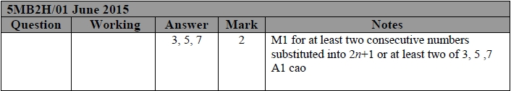
Q2.
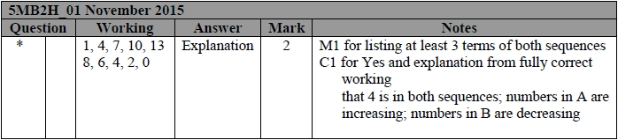
Q3.
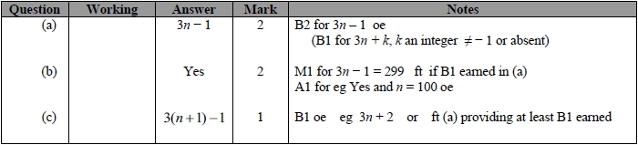
Q4.
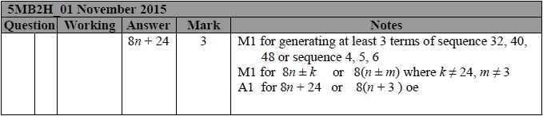
Q5.
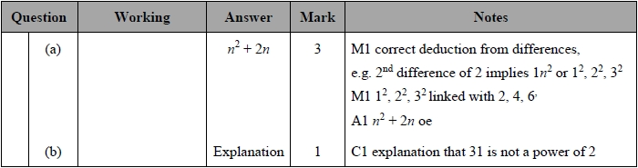

Q6.
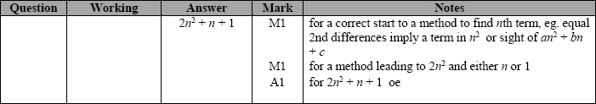
Q7.
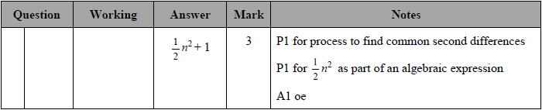
Q8.
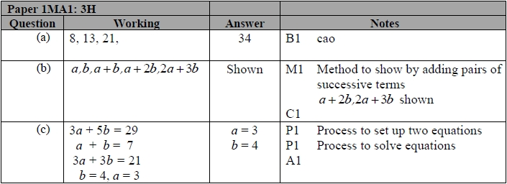
Q9.
