Maths Predicted Paper
Foundation Paper 3 Calculator

Q1.
Circle the value of the digit 7 in 9.17
(Total 1 mark)
Q2.
Which of these numbers has exactly four factors?
Circle your answer.
4 8 12 16
(Total 1 mark)
Q3.
A competition
took place in 1983
takes place every six years.
Circle the year in which it will also take place.
2083 2036 2049 2023
(Total 1 mark)
Q4.

(a) Work out the highest common factor (HCF) of 15 and 20
___________________________________________________________________
___________________________________________________________________
Answer _________________________________________
(1)
(b) Work out the lowest common multiple (LCM) of 6 and 8
___________________________________________________________________
___________________________________________________________________
___________________________________________________________________
Answer _________________________________________
(2)(Total 3 marks)
Q5.
(a) Complete the number machine so that q = 7r − 2
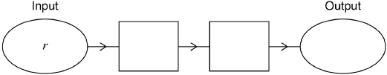
(2)
(b) Write down the output y in terms of x.
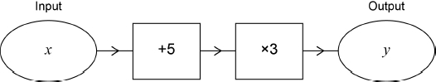
___________________________________________________________________
Answer _________________________________________
(1)
(Total 3 marks)
Q6.
Simplify 8x − 3 + 6x
Circle your answer.
2x − 3 11x 5 + 6x 14x − 3
(Total 1 mark)
Q7.
(a) Simplify a × a × a + b + b
___________________________________________________________________
___________________________________________________________________
Answer _________________________________________
(2)
(b) Simplify 5(x + 3) − x + 2
___________________________________________________________________
___________________________________________________________________
Answer _________________________________________(3)(Total 5 marks)
Q8.

Jody’s pay is £315 per week.
She works for 37 hours per week.
(a) Work out her hourly rate of pay.
___________________________________________________________________
___________________________________________________________________
Answer £ _______________________________________
(2)
(b) Jody wants to work out her yearly pay.
She says,
“There are 4 weeks in a month, so I will multiply £315 by 4
There are 12 months in a year, so I will multiply the answer by 12
£315 × 4 × 12 = £15 120”
Does her method give the correct amount for her yearly pay?
Tick a box

 | No, her yearly  pay is more |  | Yes |  | No, her yearly  pay is less
Show working to support your answer.
___________________________________________________________________
___________________________________________________________________
___________________________________________________________________
___________________________________________________________________
___________________________________________________________________
___________________________________________________________________
___________________________________________________________________
(2)
(Total 4 marks)

Q9.
(a) Divide 120 in the ratio 1 : 4
___________________________________________________________________
___________________________________________________________________
___________________________________________________________________
___________________________________________________________________
___________________________________________________________________
Answer ___________ : ___________
(2)
(b) Write the ratio 7 : 4 in the form n : 1
___________________________________________________________________
___________________________________________________________________
___________________________________________________________________
___________________________________________________________________
___________________________________________________________________
Answer ___________ : ___________(1)(Total 3 marks)
Q10.
Rana sells 192 cakes in the ratio small : medium : large = 7 : 6 : 11
The profit for one medium cake is twice the profit for one small cake.
The profit for one large cake is three times the profit for one small cake.
Her total profit is £532.48
Work out the profit for one small cake.
_______________________________________________________________________
_______________________________________________________________________
_______________________________________________________________________
_______________________________________________________________________
_______________________________________________________________________
_______________________________________________________________________
_______________________________________________________________________
_______________________________________________________________________
Answer £ _________________________________________
(Total 5 marks)
Q11.
PQ and RS are parallel.
Not drawn
accurately
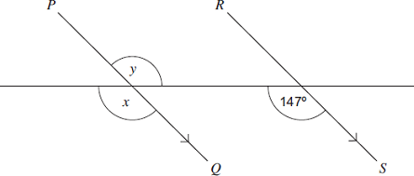
(a) Write down the value of x.
Give a reason for your answer.
Answer _________________degrees
Reason ____________________________________________________________
(2)
(b) Write down the value of y.
Give a reason for your answer.
Answer _________________degrees
Reason ____________________________________________________________
(2)
(Total 4 marks)
Q12.

White paint and red paint are mixed together in the ratio 2 : 3
(a) Draw a graph that can be used to work out the amount of red paint needed given the amount of white paint.
Your graph must show up to 10 litres of white paint.
___________________________________________________________________
___________________________________________________________________(3)
(b) How much red paint needs to be mixed with 9 litres of white paint?
Answer __________________________________ litres(1)
(Total 4 marks)
Q13.

The direct route between two airports A and B is 450 km
An aircraft leaves A at 09.15
It arrives at B at 10.55
(a) Work out the average speed of the aircraft.
Assume the aircraft travelled the direct route.
___________________________________________________________________
___________________________________________________________________
___________________________________________________________________
___________________________________________________________________
Answer .................................................... km/h
(3)
(b) In fact the aircraft did not travel the direct route.
How does this affect the average speed?
Tick a box.

 | Faster |  | Slower |  | The same
Give a reason for your answer.
___________________________________________________________________
___________________________________________________________________
__________________________________________________________(2)(Total 5 marks)
Q14.
Here is a circle.
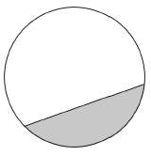
Circle the word that describes the shaded part.
segment chord sector arc (Total 1 mark)
Q15.
On a journey, Laura sees 30 vehicles.
Each vehicle is a car, a van or a lorry.
She draws this bar chart.
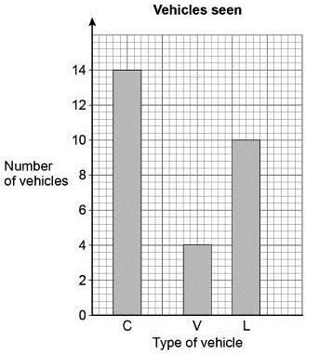
Make two criticisms of her bar chart.
Criticism 1 ______________________________________________________________
_______________________________________________________________________
_______________________________________________________________________
_______________________________________________________________________
Criticism 2 ______________________________________________________________
_______________________________________________________________________
_______________________________________________________________________
_______________________________________________________________________
(Total 2 marks)

Q16.
This shape is an isosceles trapezium.
Ten of these shapes are put together.
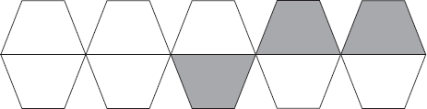
(a) What percentage of the ten shapes is shaded?
Answer ___________________________________%
(1)
(b) What is the mathematical name of the shape below?
Circle your answer
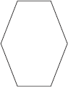

Octagon | Pentagon | Hexagon | Decagon
(1)
(Total 2 marks)
Q17.
Which shape must have rotational symmetry?
Circle your answer.
isosceles triangle trapezium kite parallelogram
(Total 1 mark)

Q18.
Which of these shapes has no lines of symmetry?
Circle the correct letter.
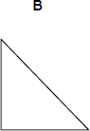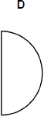
(Total 1 mark)
Q19.
(a) Match each shape to its number of sides.
One has been done for you.
(3)

(b)
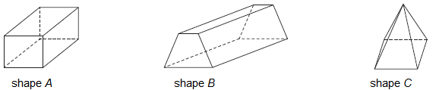
Here is a net for one of these shapes.
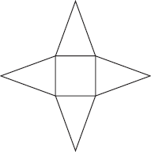
Which shape is it?
Answer _________________________________________
(1)
(Total 4 marks)
Q20.
Here is a rectangle.
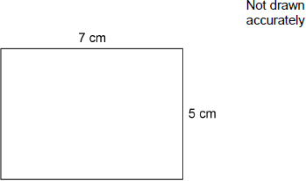
Work out the perimeter.
Circle your answer.
12 cm 24 cm 35 cm 70 cm
(Total 1 mark)
Q21.

The table shows the number of desktop computers and laptops in 50 households.

Desktop computers
Laptops |  | 0 | 1 | 2 | 3
 | 0 | 0 | 6 | 1 | 0
 | 1 | 5 | 10 | 4 | 4
 | 2 | 1 | 8 | 5 | 0
 | 3 | 3 | 2 | 1 | 0
(a) How many households have two laptops?
___________________________________________________________________
Answer _________________________________________
(1)
(b) How many households have more laptops than desktop computers?
___________________________________________________________________
Answer _________________________________________
(2)
(Total 3 marks)
Q22.
Here is a right-angled triangle.
Not drawn accurately
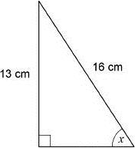
Use trigonometry to work out the size of angle x.
_______________________________________________________________________
_______________________________________________________________________
_______________________________________________________________________
_______________________________________________________________________
_______________________________________________________________________
Answer _________________________________________ degrees
(Total 2 marks)
Q23.

50 people took a test.
Before the test, they predicted whether they would pass or fail.
30 people predicted they would pass.
26 of the people who predicted they would pass did pass.
37 people passed altogether.
Complete the frequency tree.
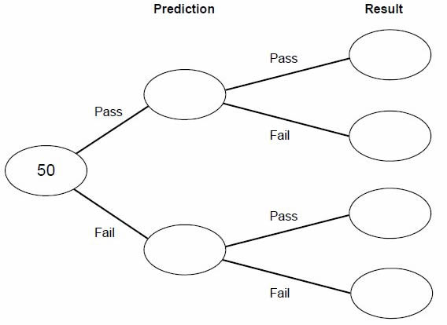
(Total 2 marks)
Q24.

Work out the area of this pentagon.
Not drawn accurately
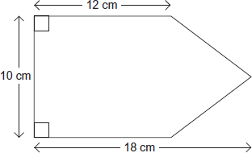
_______________________________________________________________________
_______________________________________________________________________
_______________________________________________________________________
_______________________________________________________________________
_______________________________________________________________________
_______________________________________________________________________
Answer _______________________________ cm²
(Total 3 marks)
Q25.
A linear sequence starts
11 21 31 41 ...
Work out an expression for the nth term of the sequence.
_______________________________________________________________________
_______________________________________________________________________
_______________________________________________________________________
_______________________________________________________________________
Answer _________________________________________
(Total 2 marks)
Q26.
Which of these is a geometric progression?
Circle your answer.

1 3 5 7 9 | 1 3 6 10 15
1 4 9 16 25 | 1 3 9 27 81
(Total 1 mark)
Q27.
Here are some numbers.
10 13 15 20 27 39
10 15 20 is an arithmetic progression.
Use three of the numbers to make a different arithmetic progression.
Describe the rule
Answer ___________ ___________ ___________
Rule __________________________________________________________________
_______________________________________________________________________
(Total 2 marks)
Q28.
The length of each side of a regular pentagon is 8.4 cm to 1 decimal place.
(a) Complete the error interval for the length of one side.
___________________________________________________________________
___________________ cm ≤ length < ___________________ cm
(2)
(b) Complete the error interval for the perimeter.
___________________________________________________________________
___________________ cm ≤ perimeter < ___________________ cm
(1)
(Total 3 marks)
Q29.
Use trigonometry to work out the length x.
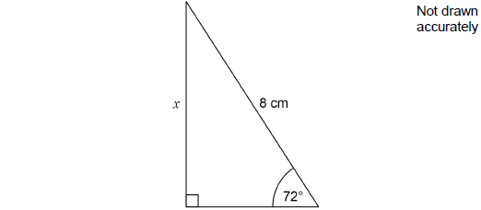
_______________________________________________________________________
_______________________________________________________________________
_______________________________________________________________________
_______________________________________________________________________
_______________________________________________________________________
_______________________________________________________________________
Answer _________________________________________ cm
(Total 2 marks)
Q30.
The height of a tree is 12 metres, correct to the nearest metre.
Circle the error interval.
11.5 m ≤ height < 12.5 m 11.5 m ≤ height ≤ 12.5 m
11.5 m < height ≤ 12.5 m 11.5 m < height < 12.5 m
(Total 1 mark)
Q31. The graph y = a + bx − x² is shown.
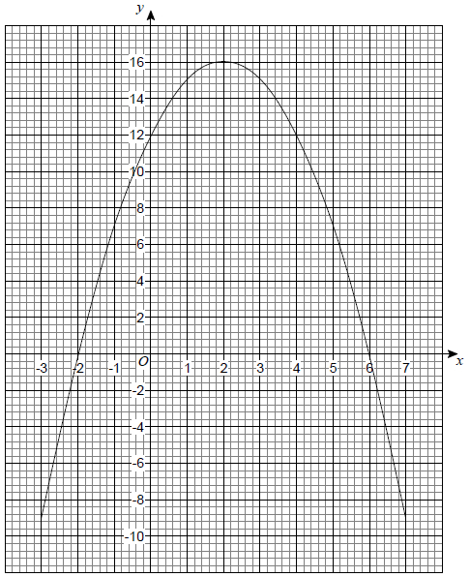
(a) Circle the coordinates of the turning point of the curve.
(−2, 0) (0, 12) (2, 16) (6, 0)
(1)
(b) Circle the value of a.
−2 12 16 6
(1)
(c) Circle the two roots of a + bx − x² = 0
−2 and 6 2 and −6 2 and 6 −2 and −6 (1)(Total 3 marks)
Q32.
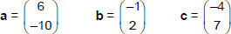
(a) Work out a + b + c
___________________________________________________________________
___________________________________________________________________
___________________________________________________________________
___________________________________________________________________
Answer
(2)
(b) Show that a + 2c = kb, where k is an integer.
___________________________________________________________________
___________________________________________________________________
___________________________________________________________________
___________________________________________________________________
___________________________________________________________________
___________________________________________________________________
___________________________________________________________________
___________________________________________________________________
(2)
(Total 4 marks)

