  
HIGHER: ITERATION – This is a selection of the types of question that you need to be able to solve.

**Q1.**

The number of bees in a beehive at the start of year *n* is *Pn*.   
The number of bees in the beehive at the start of the following year is given by

*Pn* + 1 = 1.05(*Pn* − 250)

At the start of 2015 there were 9500 bees in the beehive.

How many bees will there be in the beehive at the start of 2018?

...........................................................

**(Total for question is 3 marks)**

**Q2.**

At time t = 0 hours a tank is full of water.

Water leaks from the tank.   
At the end of every hour there is 2% less water in the tank than at the start of the hour.

The volume of water, in litres, in the tank at time *t* hours is *Vt*

Given that

*V*0 = 2000

*Vt*+1 = *kVt*

write down the value of *k*.

*k* = ...........................................................

**(Total for question = 1 mark)**

**Q3.**

(a)  Show that the equation *x*3 + 4*x* = 1 has a solution between *x* = 0 and *x* = 1

**(2)**

(b)  Show that the equation *x*3 + 4*x* = 1 can be arranged to give 

**(1)**

(c)  Starting with *x*0 = 0, use the iteration formula  twice, to find an estimate for the solution of *x*3 + 4*x* = 1

...........................................................

**(3)**

**(Total for question = 6 marks)**

**Q4.**

(a)  Show that the equation     *x*3 + 7*x* – 5 = 0     has a solution between *x* = 0 and *x* = 1

**(2)**

(b)  Show that the equation     *x*3 + 7*x* – 5 = 0     can be arrange to give 

**(2)**

(c)  Starting with *x*0 = 1, use the iteration formula       three times to find an estimate for the solution of     x3 + 7*x* – 5 = 0

...........................................................

**(3)**

(d)  By substituting your answer to part (c) into   *x*3 + 7*x* – 5,   
comment on the accuracy of your estimate for the solution to     *x*3 + 7*x* – 5 = 0

**(2)**

**(Total for question = 9 marks)**

**Q5.**

(a)  Show that the equation *x*3 − 3*x*2 + 3 = 0 has a solution between *x* = 2 and *x* = 3

**(2)**

(b)  Show that the equation *x*3 − 3*x*2 + 3 = 0 can be rearranged to give 

**(1)**

(c)  Starting with *x*0 = 2, use the iteration formula to find the value of *x*2  
Give your answer correct to 3 decimal places.

...........................................................

**(3)**

**(Total for question = 6 marks)**

**Q6.**

(a)  Show that the equation 3*x*2 − *x*3 + 3 = 0 can be rearranged to give 

**(2)**

(b)  Using

 find the values of *x*1, *x*2 and *x*3

...........................................................

**(3)**

(c)  Explain what the values of *x*1, *x*2 and *x*3 represent.

**(1)**

**(Total for question is 6 marks)**

**Mark Scheme**  
Q1.

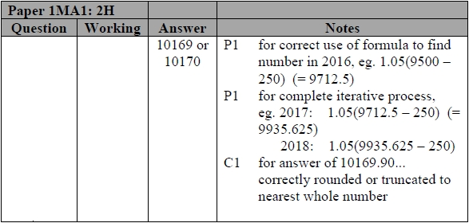

**Q2.**



**Q3.**

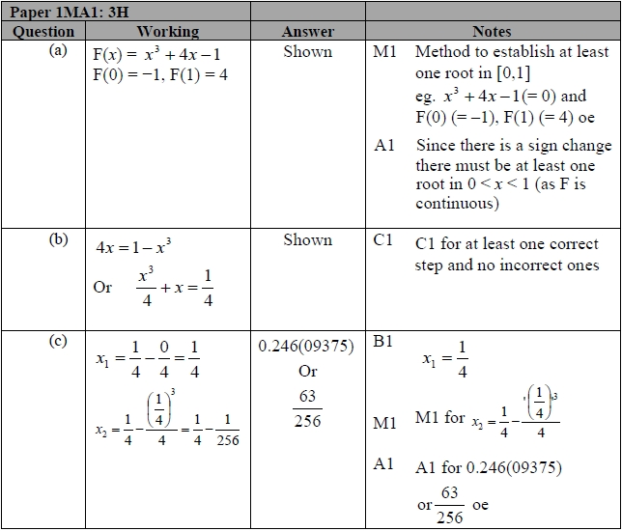

**Q4.**

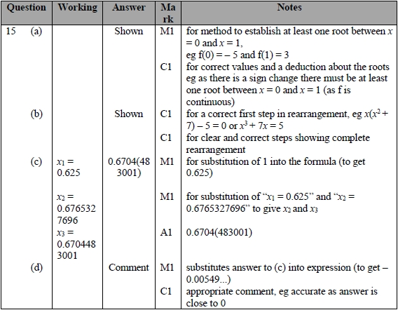

**Q5.**

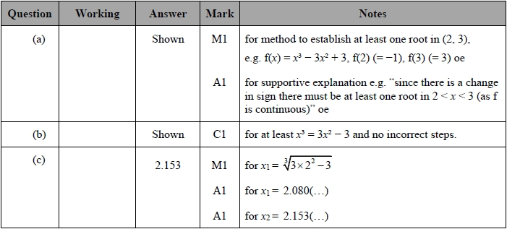

**Q6.**

