  
HIGHER: FUNCTIONS – This is a selection of the types of question that you need to be able to solve.

**Q1.** f and g are functions such that 

Find gf(4). Give your answer as a fraction.

...........................................................

**(Total for question = 2 marks)**

**Q2.**  
The function f is such that f(*x*) = 4*x* − 1

(a)  Find f−1(x)

f−1(*x*) = ...........................................................

**(2)**

The function g is such that

g(*x*) = *kx*2 where *k* is a constant.

Given that fg(2) = 12

(b)  work out the value of *k*

*k* = ...........................................................

**(2)**

**(Total for question = 4 marks)**

**Q3.**

For all values of *x* f(*x*) = 2*x* − 3    and    g(*x*) = *x*2 + 2

(a)  Find   g(−4)

...........................................................

**(1)**

(b)  Show that   gf(*x*) = 4*x*2 − 12*x* + 11

**(2)**

(c)  Solve   fg(*x*) = gf(*x*)

...........................................................

**(4)**

**(Total for question = 7 marks)**

**Q4.**

The functions f and g are such that



(a)  Find the value of f(10)

...........................................................

**(1)**

(b)  Find g–1(*x*)

g–1(*x*) = ...........................................................

**(2)**

(c)  Show that ff(*x*) = 9*x* – 48

**(2)**

**(Total for question = 5 marks)**

**Q5.**



(a)  Work out f(5)

Give your answer as a fraction.

...........................................................

**(2)**

(b)  Write down a value of *x* for which f(*x*) is not defined.

...........................................................

**(1)**

Given that f(*x*) = 4

(c)  find the possible values of *x*.

Give your answer in the form  where *p*, *q* and *r* are positive integers.

...........................................................

**(5)**

**(Total for question = 8 marks)**

**Q6.**

f(*x*) = *x*3  
g(*x*) = 4*x* – 1

(a)  Find  fg(2)

...........................................................

**(2)**

h(*x*) = fg(*x*)

(b)  Find an expression for  h–1(*x*)

h–1(*x*) = ...........................................................

**(3)**

**(Total for question = 5 marks)**

**Q7.**

The functions f and g are such that

f(*x*) = 5*x* + 3          g(*x*) = *ax* + *b*          where *a* and *b* are constants.

g(3) = 20    and    f−1(33) = g(1)

Find the value of *a* and the value of *b*.

*a* = ...........................................................

*b* = ...........................................................

**(Total for question = 5 marks)**

**Mark Scheme**

Q1.

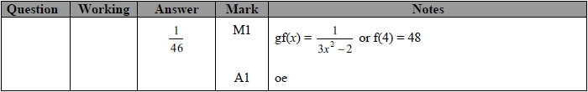

**Q2.**

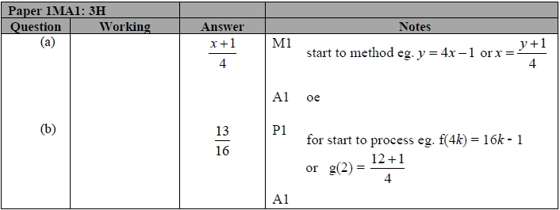

**Q3.**

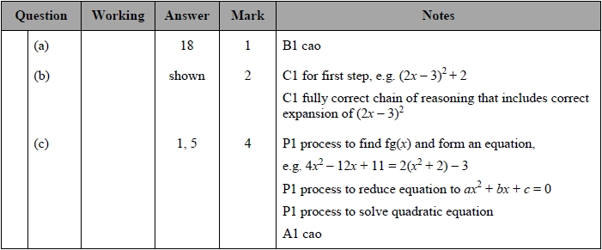

**Q4.**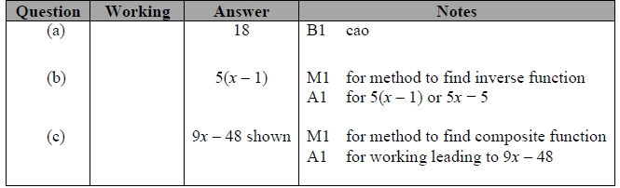

**Q5.**

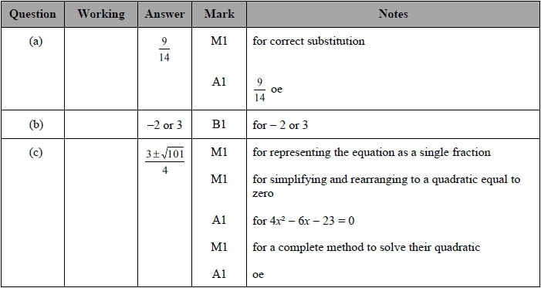

**Q6.**

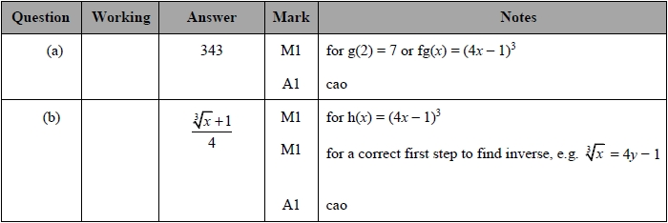

**Q7.** 