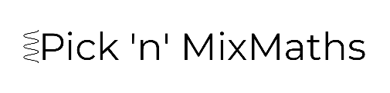
HIGHER: SURFACE AREA & VOLUME – This is a selection of the types of question that you need to be able solve.
Q1.
A rectangle has an area of 4 m^{2.}
Write this area in cm².

........................................................... cm²
(Total for question = 2 marks)
Q2.
Change 2 m³ to cm³.

........................................................... cm³
(Total for question = 2 marks)

Q3.
The diagram shows a prism with a cross section in the shape of a trapezium.
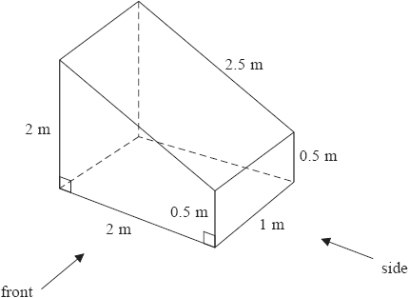
On the centimetre grid below, draw the front elevation and the side elevation of the prism.
Use a scale of 2 cm to 1 m.

(Total for question = 4 marks)

Q4.
Here are the front elevation and the plan of a prism.
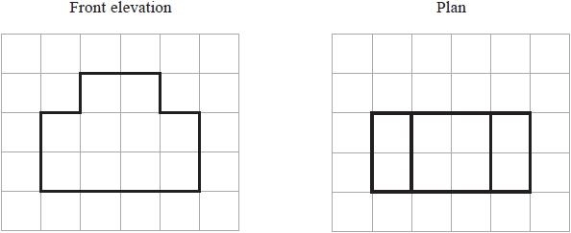
On the grid below, draw the side elevation of the prism.

(Total for question = 2 marks)

Q5.
The plan, front elevation and side elevation of a solid prism are drawn on a centimetre grid.
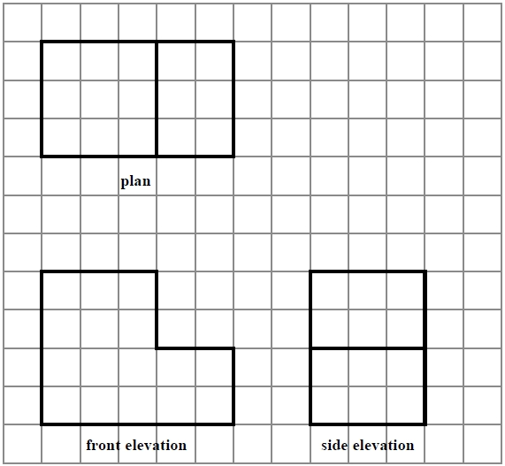
In the space below, draw a sketch of the solid prism.
Write the dimensions of the prism on your sketch.

(Total for question = 2 marks)

Q6.
This diagram, drawn on a centimetre grid, is an accurate net of a triangular prism.
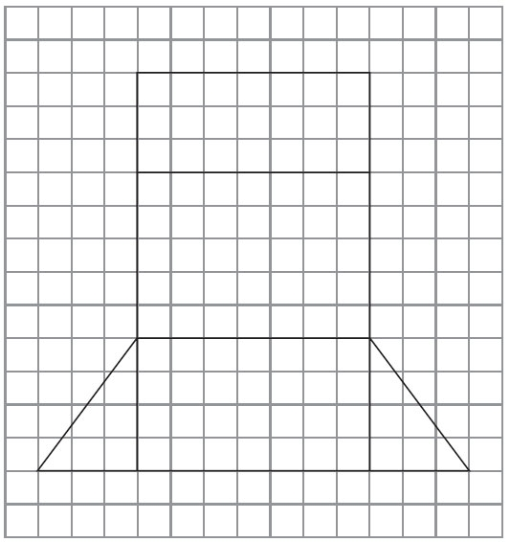
Work out the volume of the prism.

. . . . . . . . . . . . . . . . . . . . . .
(Total for Question is 4 marks)
Q7.
A sofa has 6 identical cushions. Each cushion is a cuboid 18 cm by 80 cm by 95 cm.
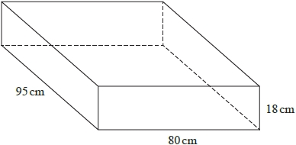
The cushions are covered with a protective spray. The protective spray is in cans.
The label on each can has this information.

(a) Work out how many cans are needed to cover the 6 cushions with protective spray.

...........................................................
(5)
The information on each label is inaccurate. The spray in each can covers 10% more than 4 m².
(b) How will this affect the number of cans needed for the 6 cushions?
You must show how you get your answer.

(2)
(Total for question = 7 marks)
Q8.
Frances grows plants in a container. Each of the 5 faces of the container is made of glass.
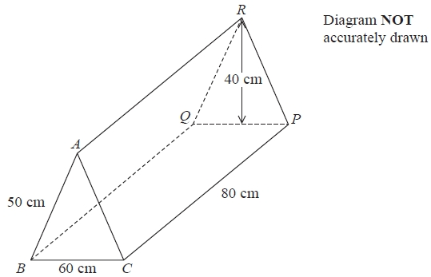
The container is in the shape of a prism.
The cross section of the prism is an isosceles triangle with height 40 cm.
BC = 60 cm
AB = AC = 50 cm
CP = 80 cm
Work out the total area of glass needed to make the container.

........................................................... cm²
(Total for question = 3 marks)

Q9.
Here is a solid prism. Work out the volume of the prism. You must show all your working.
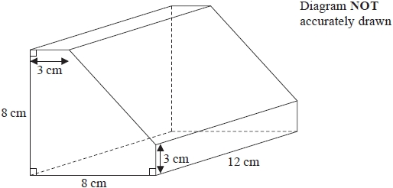

........................................................... cm³
(Total for question = 4 marks)
Q10.
This shape is a solid prism. The cross section of the prism is a trapezium.
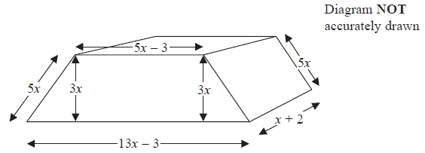
Show that the total surface area of the prism is 82x² + 32x − 12

(Total for Question is 4 marks)
Q11.
The diagram shows a solid hemisphere of radius 5 cm. Find the total surface area of the solid hemisphere.
Give your answer in terms of π.
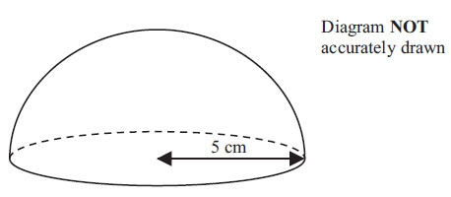

. . . . . . . . . . . . . . . . . . . . . . . . cm²
(Total for Question is 3 marks)
Q12.
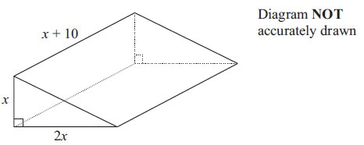
The diagram shows a solid triangular prism. All the measurements are in centimetres.
The volume of the prism is V cm³. Find a formula for V in terms of x. Give your answer in simplified form.

(Total for Question is 3 marks)
Q13.
The diagram shows the area of each of three faces of a cuboid.
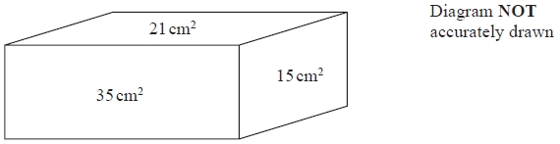
The length of each edge of the cuboid is a whole number of centimetres. Work out the volume of the cuboid.
...........................................................
(Total for question = 4 marks)
Q14.
Ali has some packets.
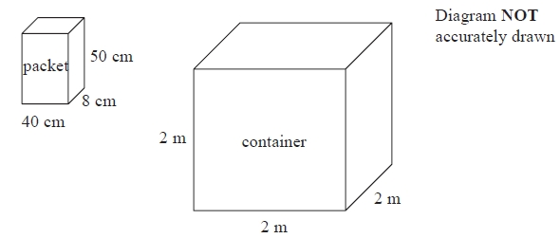
Each packet has dimensions 40 cm by 8 cm by 50 cm.
Ali fills a container with these packets. The container is a cube of side 2 m.
Ali fills the container completely with these packets. Work out the number of packets.
...........................................................
(Total for Question is 4 marks)
Q15.
The diagram shows an oil tank in the shape of a prism.
The cross section of the prism is a trapezium.
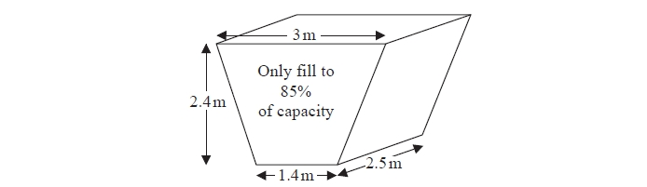
The tank is empty.
Oil flows into the tank.
After one minute there are 300 litres of oil in the tank.
Assume that oil continues to flow into the tank at this rate.
(a) Work out how many more minutes it takes for the tank to be 85 full of oil.
(1 m³ = 1000 litres)

........................................................... minutes
(5)
The assumption about the rate of flow of the oil could be wrong.
(b) Explain how this could affect your answer to part (a).

(1)

(Total for question = 6 marks)

Q16.
Jan has some metal that she is going to make into solid metal spheres.
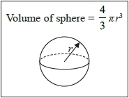
Each sphere will have a radius of 2.15 cm. Jan has 1490 cm³ of metal.
(a) Work out an estimate for the number of spheres that Jan can make.

...........................................................
(3)
(b) If you calculate the number of spheres accurately, how do you think your answer to part (a) will change?
Give a reason for your answer.

(1)
(Total for question = 4 marks)

Q17.
Ella is designing a glass in the shape of a cylinder.
The glass must hold a minimum of ½ litre of liquid.
The glass must have a diameter of 8 cm.
Calculate the minimum height of the glass.

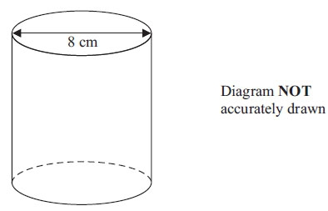

(Total for Question is 5 marks)

Q18.
The diagram shows a solid shape.
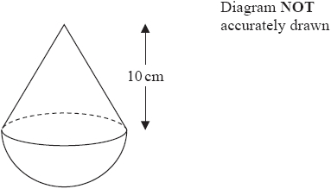
The solid shape is made from a hemisphere and a cone.
The radius of the hemisphere is equal to the radius of the base of the cone.
The cone has a height of 10 cm. The volume of the cone is 270π cm³.
Work out the total volume of the solid shape. Give your answer in terms of π.

........................................................... cm³
(Total for question = 5 marks)
Q19.
A solid is made by putting a hemisphere on top of a cone.
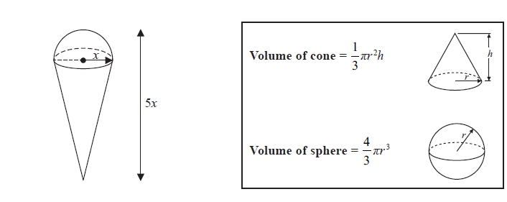
The total height of the solid is 5x. The radius of the base of the cone is x. The radius of the hemisphere is x
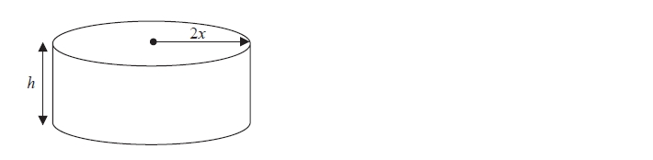
A cylinder has the same volume as the solid. The cylinder has radius 2x and height h
All measurements are in centimetres.
Find a formula for h in terms of x. Give your answer in its simplest form.

...........................................................
(Total for question = 5 marks)

Q20.
The diagram shows a solid metal cylinder.
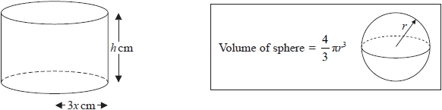
The cylinder has base radius 3x cm and height h cm.
The metal cylinder is melted.
All the metal is then used to make 270 spheres.
Each sphere has a radius of
Find an expression, in its simplest form, for h in terms of x.

...........................................................
(Total for question = 3 marks)

Q21.
The diagram shows a solid cone.
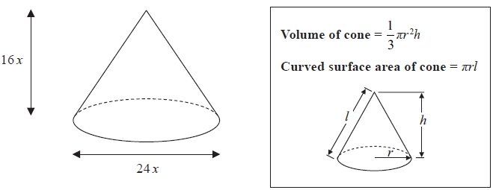
The diameter of the base of the cone is 24x cm. The height of the cone is 16x cm.
The curved surface area of the cone is 2160π cm². The volume of the cone is Vπ cm³, where V is an integer.
Find the value of V.

...........................................................
(Total for question is 5 marks)
Mark Scheme
Q1.
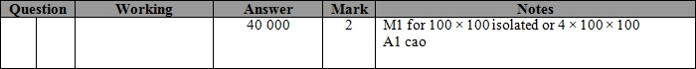
Q2.
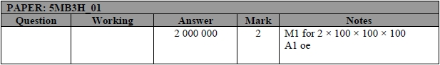
Q3.
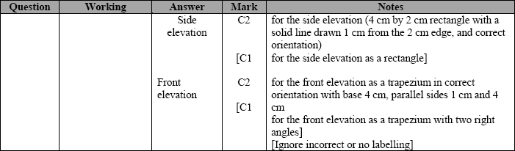
Q4.
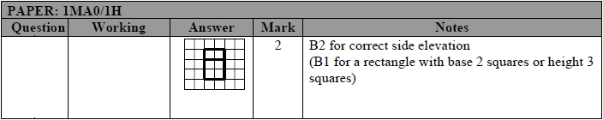
Q5.
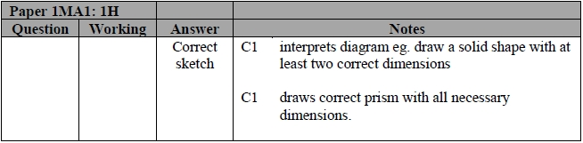
Q6.
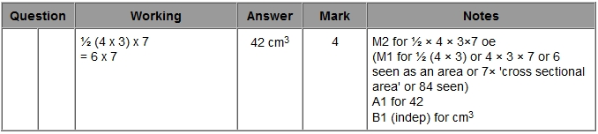
Q7.
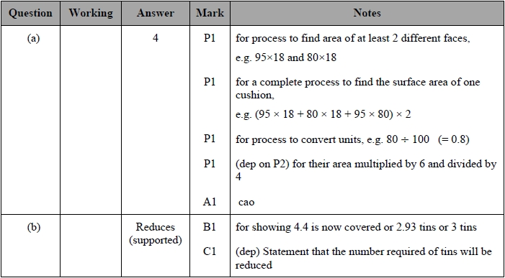
Q8.
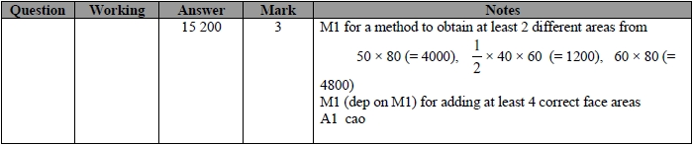
Q9.
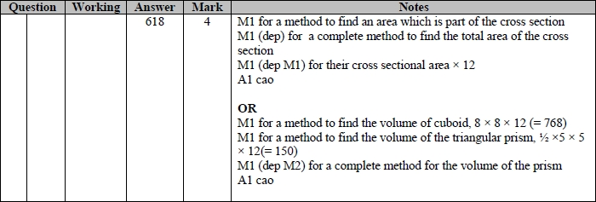

Q10.
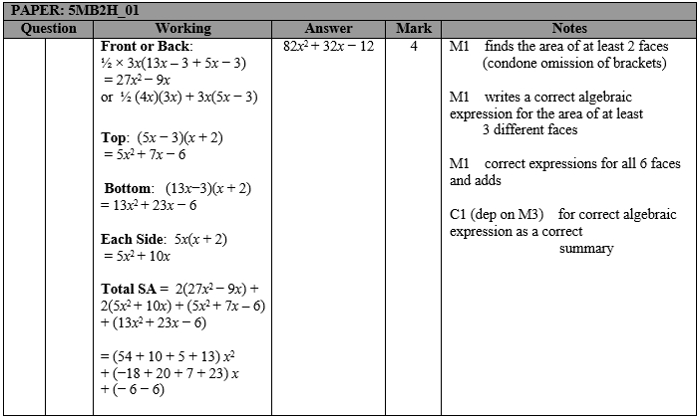
Q11.
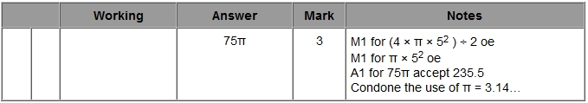
Q12.
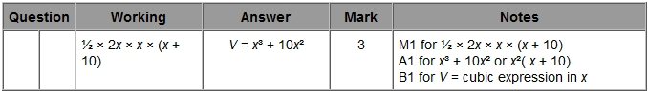
Q13.
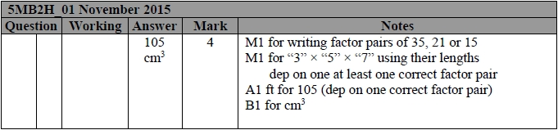

Q14.
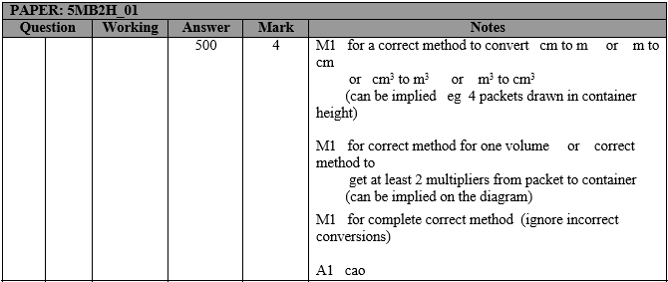
Q15.
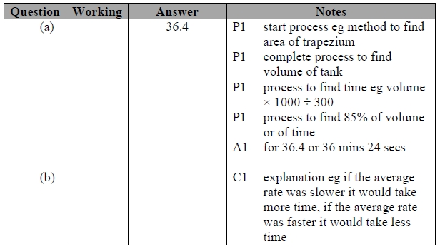
Q16.
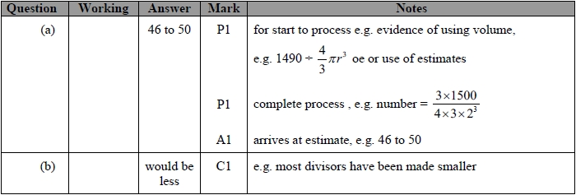

Q17.
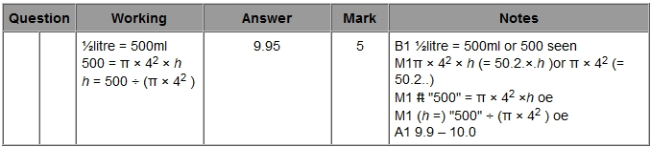
Q18.
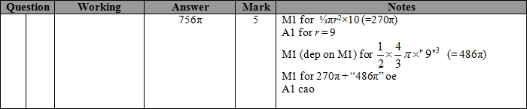
Q19.
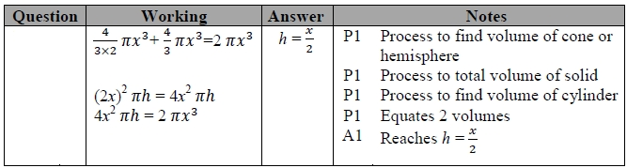
Q20.
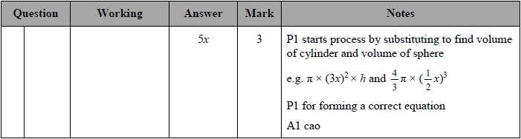
Q21.
