HIGHER: ACCURACY & BOUNDS – This is a selection of the types of question that you need to be able to solve.
Q1.
A piece of wood has a length of 65 centimetres to the nearest centimetre.
(a) What is the least possible length of the piece of wood?

..............................................................................................................................................
(1)
(b) What is the greatest possible length of the piece of wood?

..............................................................................................................................................
(1)
(Total for Question is 2 marks)
Q2.
Kiera used her calculator to work out the value of a number x.
She wrote down the first two digits of the answer on her calculator.
She wrote down 7.3
Write down the error interval for x.

...........................................................
(Total for question = 2 marks)

Q3.
Sasha drops a ball from a height of d metres onto the ground.
The time, t seconds, that the ball takes to reach the ground is given by
where g m/s² is the acceleration due to gravity.
d = 35.6 correct to 3 significant figures.
g = 9.8 correct to 2 significant figures.
(a) Write down the lower bound of d.

..............................................................................................................................................
(1)
(b) Calculate the lower bound of t. You must show all your working.

..............................................................................................................................................
(3)
(Total for Question is 4 marks)
Q4.
v = 37.6 correct to 3 significant figures.
u = 11.3 correct to 3 significant figures.
t = 8.4 correct to 2 significant figures.
Work out the upper bound for the value of a.
Show your working clearly.
...........................................................
(Total for question = 3 marks)
Q5.
a = 6.43 correct to 2 decimal places.
b = 5.514 correct to 3 decimal places.
By considering bounds, work out the value of v to a suitable degree of accuracy. Give a reason for your answer.
...........................................................
(Total for question = 5 marks)
Q6.
The petrol consumption of a car, in litres per 100 kilometres, is given by the formula

Nathan's car travelled 148 kilometres, correct to 3 significant figures.
The car used 11.8 litres of petrol, correct to 3 significant figures.
Nathan says,
“My car used less than 8 litres of petrol per 100 kilometres.”
Could Nathan be wrong?
You must show how you get your answer.

(Total for question = 3 marks)
Q7.
a is 8.3 cm correct to the nearest mm
b is 6.1 cm correct to the nearest mm
Calculate the upper bound for c.
You must show your working.
........................................................... cm
(Total for question = 4 marks)
Q8.
A train travelled along a track in 110 minutes, correct to the nearest 5 minutes. Jake finds out that the track is 270 km long. He assumes that the track has been measured correct to the nearest 10 km.
(a) Could the average speed of the train have been greater than 160 km/h?
You must show how you get your answer.
(4)
Jake's assumption was wrong. The track was measured correct to the nearest 5 km.
(b) Explain how this could affect your decision in part (a).

(1)
(Total for question = 5 marks)
Q9.
Jerry wants to cover a triangular field, ABC, with fertiliser.
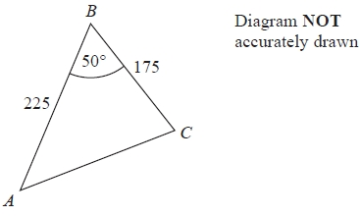
Here are the measurements Jerry makes
angle ABC = 50° correct to the nearest degree,
BA = 225 m correct to the nearest 5 m,
BC = 175 m correct to the nearest 5 m.
Work out the upper bound for the area of the field. You must show your working.
...........................................................m²
(Total for Question is 3 marks)
Q10.
The volume of a sphere is 70 cm³ correct to the nearest cm³.
Calculate the upper bound for the surface area of the sphere.
Give your answer correct to 1 decimal place. You must show all your working.

...........................................................cm²
(Total for question = 4 marks)
Mark Scheme
Q1.
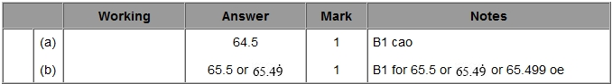
Q2.
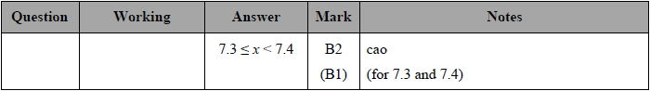
Q3.
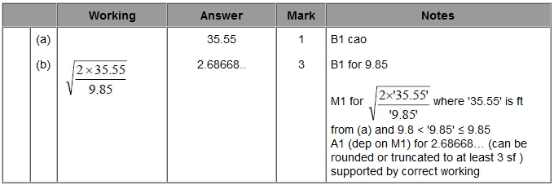
Q4.
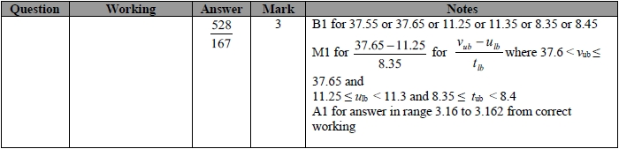
Q5.
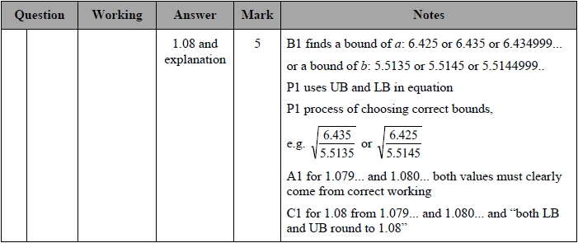
Q6.
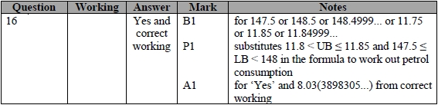
Q7.
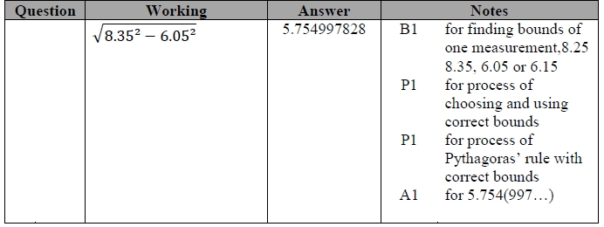
Q8.
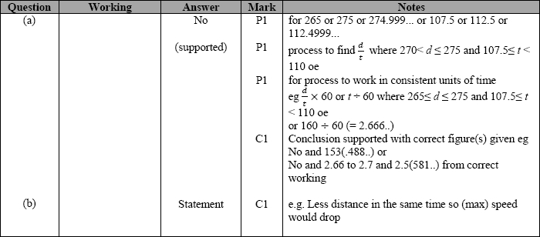
Q9.
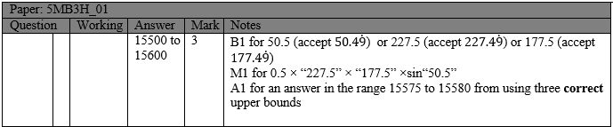

Q10.
