HIGHER: SCATTER GRAPHS – This is a selection of the types of question that you need to be able to solve.
Q1.
Carlos has a cafe in Clacton.
Each day, he records the maximum temperature in degrees Celsius (°C) in Clacton and the number of hot chocolate drinks sold. The scatter graph shows this information.
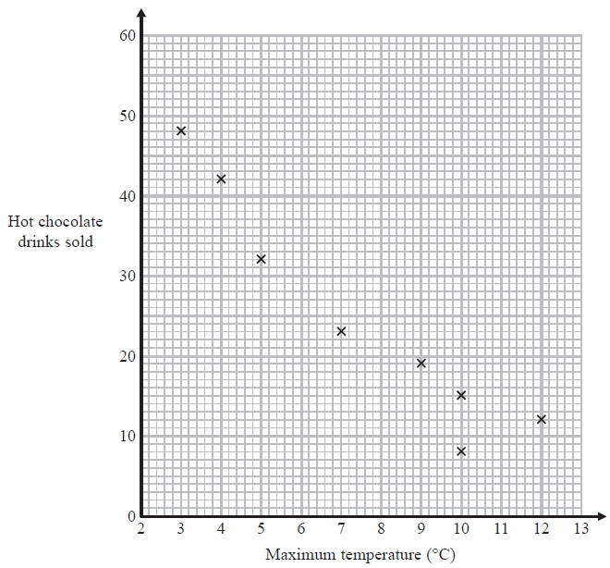
On another day the maximum temperature was 6 °C and 35 hot chocolate drinks were sold.
(a) Show this information on the scatter graph.
(1)
(b) Describe the relationship between the maximum temperature and the number of hot chocolate drinks sold.
(1)
(c) Draw a line of best fit on the scatter diagram.
(1)
One day the maximum temperature was 8 °C.
(d) Use your line of best fit to estimate how many hot chocolate drinks were sold.

(1)
(Total for Question is 4 marks)
Q2.
Jean records the maximum daily temperature each day for 10 days.
She also records the number of children going to a paddling pool for each of these days.
She draws this scatter graph for her information.
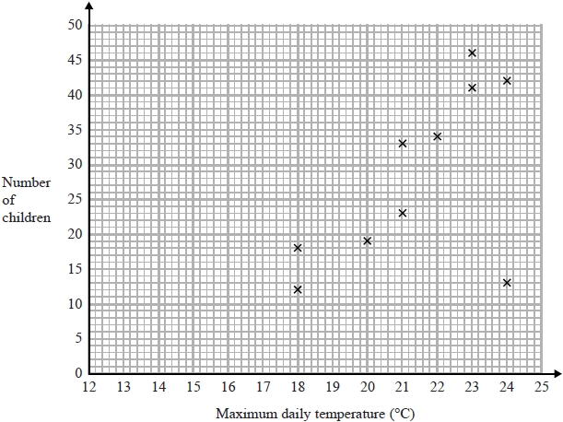
Jean's information for one of these days is an outlier on the scatter graph.
(a) Give a possible reason for this.

(1)
(b) What type of correlation does the scatter graph show?

(1)
On the 11th day, the maximum daily temperature was 19°C.
(c) Write down an estimate for the number of children going to the paddling pool on the 11th day.

(1)
It would not be sensible to use the scatter graph to predict the number of children going to the paddling pool on a day when the maximum daily temperature was 13°C.
(d) Give a reason why.

(1)
(Total for question = 4 marks)
Q3.
The scatter diagram shows information about 10 students.
For each student, it shows the number of hours spent revising and the mark the student achieved in the Spanish test.
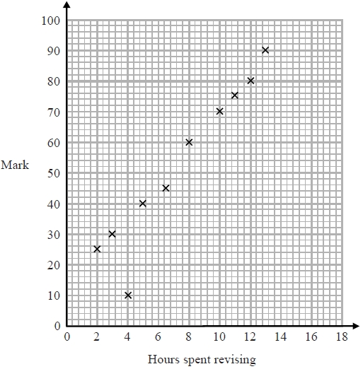
One of the points is an outlier.
(a) Write down the coordinates of the outlier.
(1)
For all the other points
(b) (i) draw the line of best fit,
(ii) describe the correlation.
(2)
A different student studies for 9 hours.
(c) Estimate the mark gained by this student.
(1)
The Spanish test was marked out of 100
Lucia says, "I can see from the graph that had I revised for 18 hours I would have got full marks."
(d) Comment on what Lucia says.

(1)
(Total for question is 5 marks)
Q4.
In a survey, the outside temperature and the number of units of electricity used for heating were recorded for ten homes. The scatter diagram shows this information.
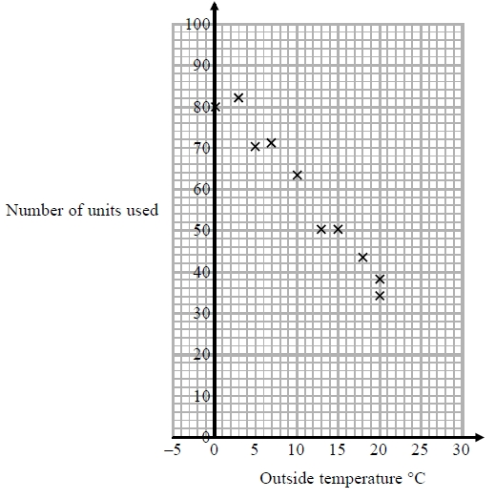
Molly says,
"On average the number of units of electricity used for heating decreases by 4 units for each °C increase in outside temperature."
(a) Is Molly right? Show how you get your answer.

(3)
(b) You should not use a line of best fit to predict the number of units of electricity used for heating when the outside temperature is 30 °C.
Give one reason why.

(1)
(Total for question = 4 marks)

Q5.
Katie measured the length and the width of each of 10 pine cones from the same tree.
She used her results to draw this scatter graph.
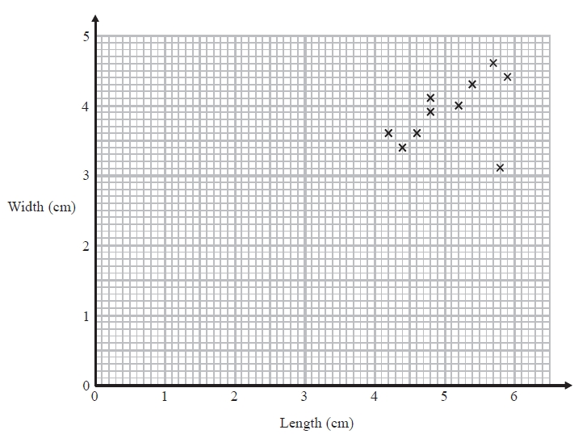
(a) Describe one improvement Katie can make to her scatter graph.

(1)
The point representing the results for one of the pine cones is an outlier.
(b) Explain how the results for this pine cone differ from the results for the other pine cones.

(1)
(Total for question = 2 marks)

Q6.
Bill wants to compare the heights of pine trees growing in sandy soil with the heights of pine trees growing in clay soil.
The scatter diagram gives some information about the heights and the ages of some pine trees.
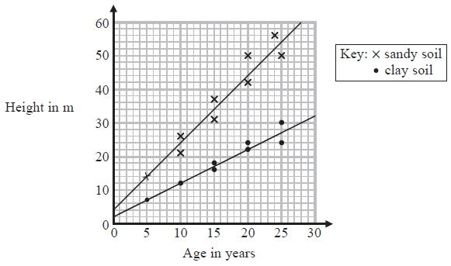
(a) Describe the relationship between the height of pine trees and the age of pine trees growing in sandy soil.

(1)
A pine tree growing in clay soil is 18 years old.
(b) Find an estimate for the height of this tree.
...........................................................m
(1)
A pine tree is growing in sandy soil.
(c) Work out an estimate for how much the height of this tree increases in a year.
...........................................................m
(2)
(d) Compare the rate of increase of the height of trees growing in clay soil with the rate of increase of the height of trees growing in sandy soil.

(2)
(Total for question = 6 marks)
Q7.
A delivery driver records for each delivery the distance he drives and the time taken.
The scatter graph shows this information.
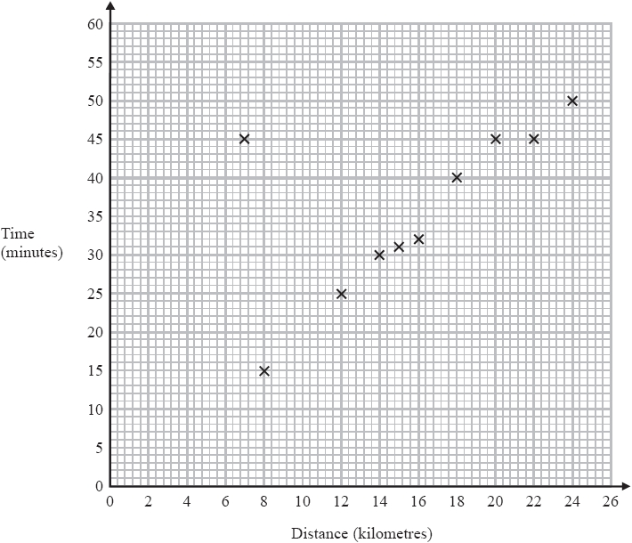
For another delivery he drives 22 kilometres and takes 50 minutes.
(a) Show this information on the scatter graph.
(1)
(b) What type of correlation does the scatter graph show?
...........................................................
(1)
The driver has to drive a distance of 10 km for his next delivery.
(c) Estimate the time taken for this delivery.
........................................................... minutes
(2)
During one of the deliveries, the driver was delayed by road works.
(d) Using the graph write down the time taken for this delivery.
........................................................... minutes
(1)
(Total for question = 5 marks)
Q8.
Oliver records the distance from London to each of eight cities in the USA.
He also records the time taken to fly from London to each of these cities.
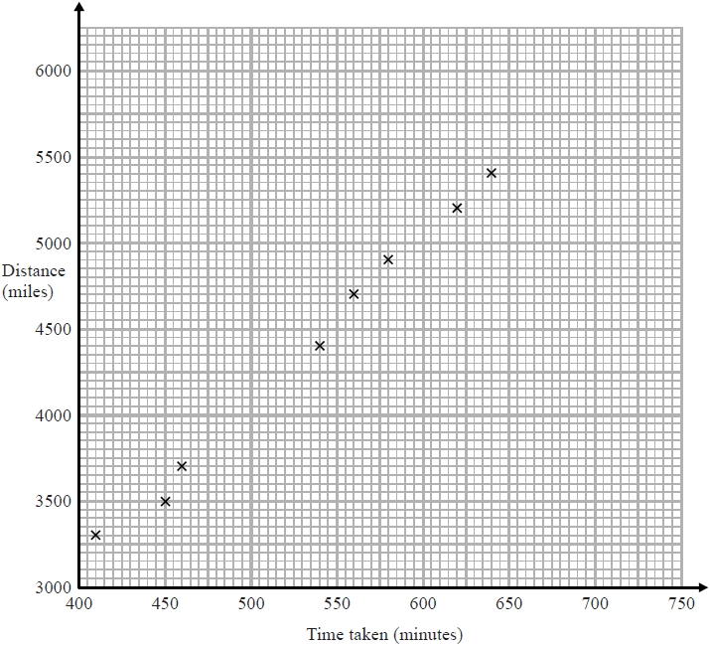
Chicago is a city in the USA. Chicago is 4000 miles from London.
(a) (i) By drawing a line of best fit, find an estimate for the time taken to fly from London to Chicago.
........................................................... minutes
(2)
(ii) Why is your answer to part (i) only an estimate?

(1)
(b) (i) Calculate the gradient of your line of best fit.

(2)
(ii) Give an interpretation of the gradient of your line of best fit.

(1)
(Total for question = 6 marks)
Mark Scheme
Q1.
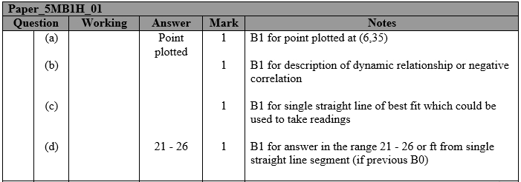
Q2.
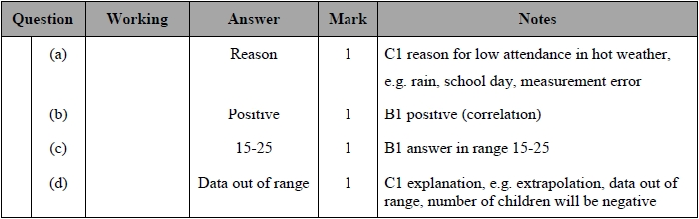
Q3.
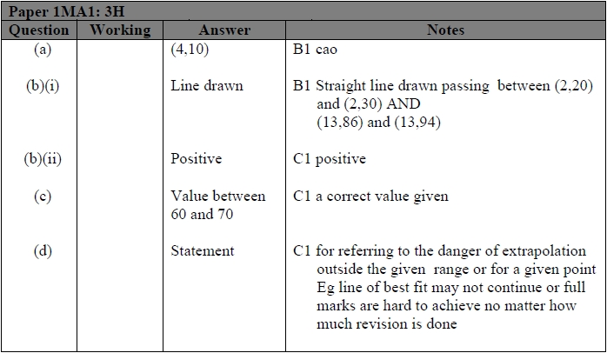

Q4.
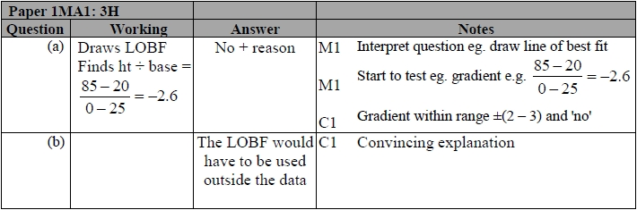
Q5.
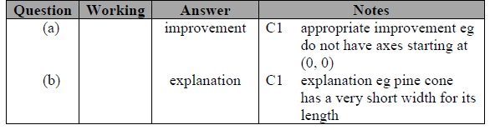
Q6.
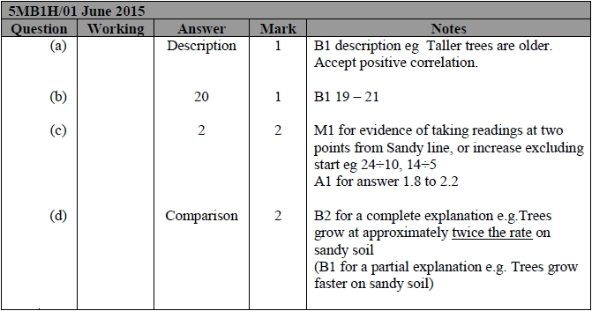

Q7.
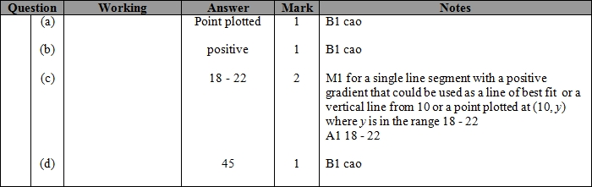
Q8.
