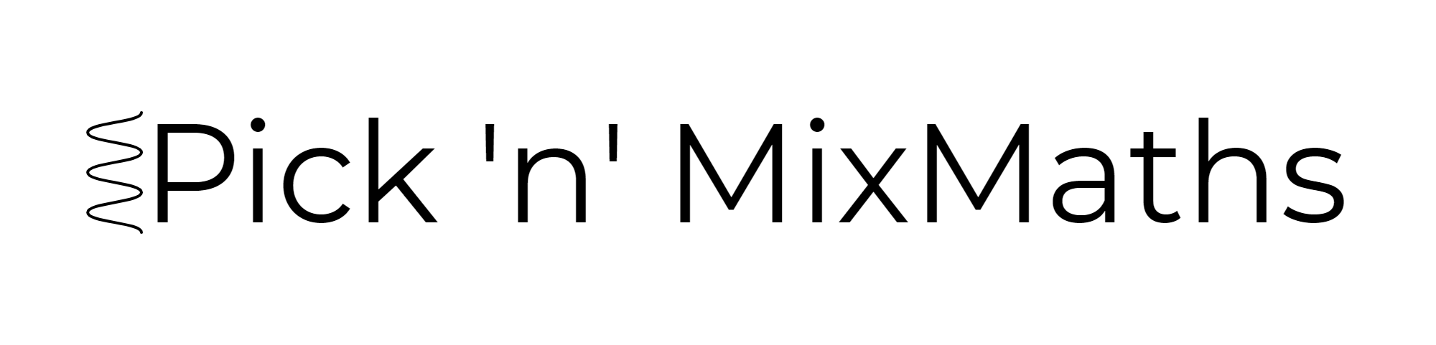  
HIGHER: FORMULAE – This is a selection of the types of question that you need to be able to solve.

**Q1.**

*S* = *π*2(*b*2 − *a*2)

*a* = 8, *b* = 10

Calculate the value of *S*.   
Give your answer correct to 3 significant figures.

...........................................................

**(Total for question = 2 marks)**

**Q2.** The body mass index, *B*, for a person of mass *m* kg and height *h* metres is given by the formula



Usman has a mass of 50 kg.   
He has a height of 1.57 m.

(a)  Work out Usman's body mass index.

Give your answer correct to one decimal place.

...........................................................

**(2)**

Tom's height is 1.80 m.   
He wants his body mass index to be 21

(b)  Work out the mass that will give Tom a body mass index of 21

........................................................... kg

**(2)**

**(Total for question = 4 marks)**

**Q3.**

You can use this formula to change a temperature *C*, in °C, to a temperature *F*, in °F.

*F* = 1.8*C* + 32

(a) Use the formula to change 20°C into °F.

. . . . . . . . . . . . . . . . . . . . . . °F

**(2)**

(b) On the grid opposite, draw a conversion graph that can be used to change between temperatures in °C and temperatures in °F.

**(3)**

(c) Use your graph to change 100 °F into °C.

. . . . . . . . . . . . . . . . . . . . . . °C

**(1)**

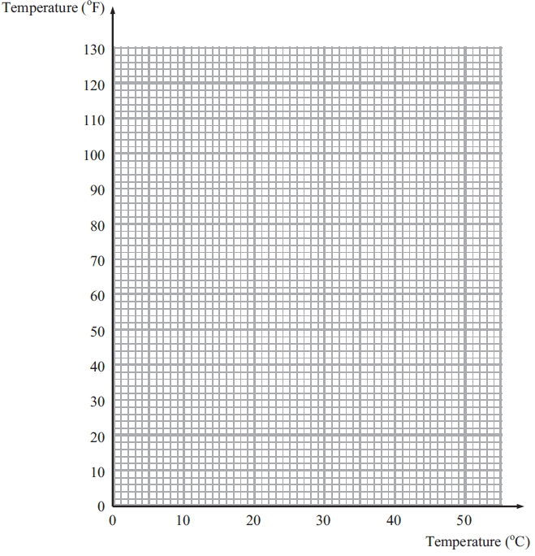

**(Total for Question is 6 marks)**

**Q4.**

You can change temperatures from °F to °C by using the formula

**

*F* is the temperature in °F.   
*C* is the temperature in °C.

The minimum temperature in an elderly person's home should be 20°C.

Mrs Smith is an elderly person.   
The temperature in Mrs Smith's home is 77°F.

(a) Decide whether or not the temperature in Mrs Smith's home is lower than the minimum temperature should be.

**(3)**

(b) Make *F* the subject of the formula   **

...........................................................

**(3)**  
**(Total for Question is 6 marks)**

**Q5.** 

Make *k* the subject of the formula.

...........................................................

**(Total for question is 3 marks)**

**Q6.**

Make *t* the subject of the formula 2(*d* – *t*) = 4*t* + 7

*t* =  . . . . . . . . . . . . . . . . . . . . . .

**(Total for Question is 3 marks)**

**Q7.**Make *a* the subject of     

...........................................................

**(Total for question = 3 marks)**

**Q8.** Make *a* the subject of the formula   

...........................................................

**(Total for question = 4 marks)**

**Q9.**

A shop sells packets of envelopes.

There are 5 envelopes in a small packet.   
There are 20 envelopes in a large packet.   
  
There is a total of *T* envelopes in *x* small packets and *y* large packets.

Write down a formula for *T* in terms of *x* and *y*.

...........................................................

**(Total for question = 3 marks)**

**Q10.**Steph's weight in kilograms is 2*x* + 9   
Kyle's weight in kilograms is 4*x* − 7

Write down an expression, in terms of *x*, for the mean of their weights.

........................................................... kilograms

**(Total for question = 2 marks)**

**Q11.**

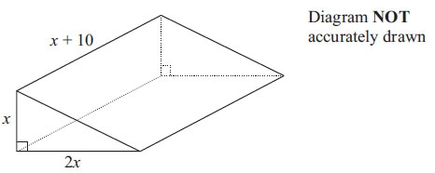

The diagram shows a solid triangular prism.  
 All the measurements are in centimetres.

The volume of the prism is *V* cm3.

Find a formula for *V* in terms of *x*.  
Give your answer in simplified form.

**(Total for Question is 3 marks)**

**Mark Scheme**  
Q1.

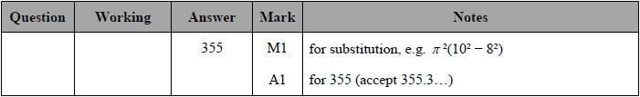

**Q2.**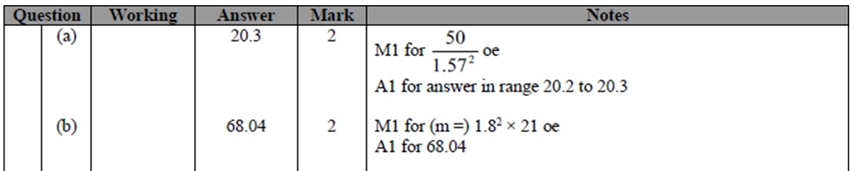

**Q3.**

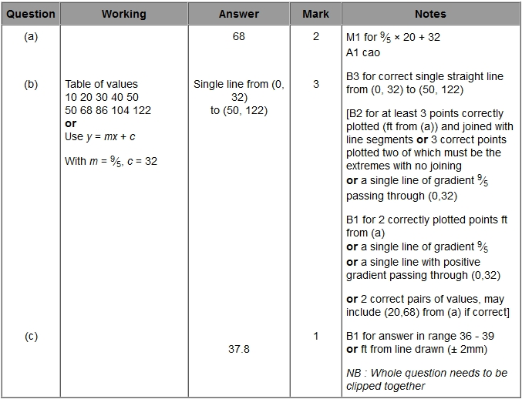

**Q4.**

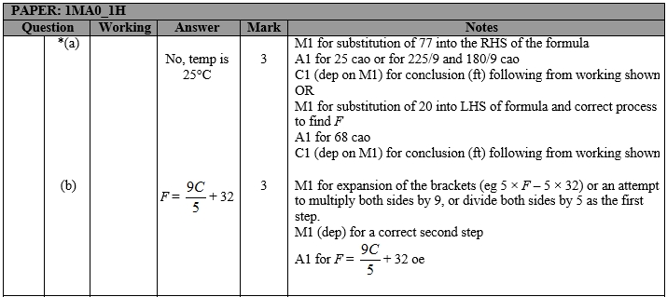

**Q5.**

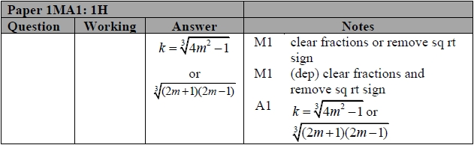

**Q6.**

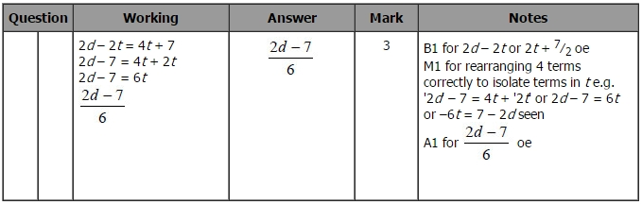

**Q7.**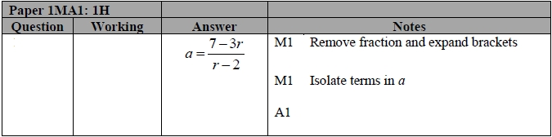

**Q8.**

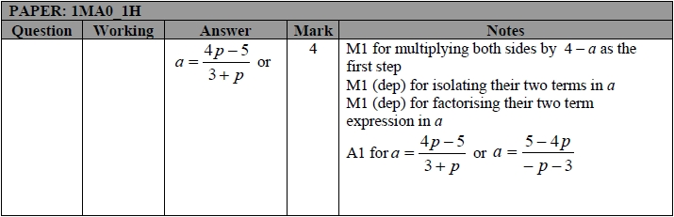

**Q9.**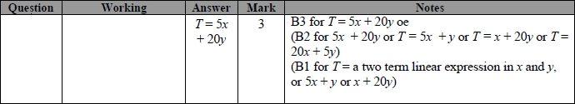

**Q10.**

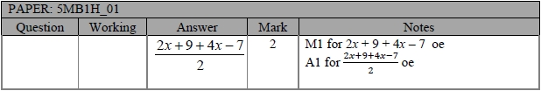

**Q11.**

