Maths Predicted Paper
Foundation Paper 2 Calculator
Q1. Work out 4 + 3 × 5 − 1
Circle your answer.
16 18 28 34
(Total 1 mark)
Q2. Circle the fraction that is equal to
(Total 1 mark)
Q3. What is the largest two-digit prime number?
Circle your answer.
93 95 97 99
(Total 1 mark)
Q4. Circle the decimal that is closest in value to
0.04 0.048 0.049 0.05
(Total 1 mark)
Q5. Work out of 900
_______________________________________________________________________
Answer _________________________________________
(Total 2 marks)

Q6. Here is a number line.
Which number is at A?
Circle your answer.
3.3 3.55 3.6 3.8
(Total 1 mark)
Q7. Saj wants to go to all 19 home games at a football club.
For each game, a ticket costs £28
A season ticket
costs £379
and
gives entry to all 19 home games.
In total, how much does Saj save by buying a season ticket?
_______________________________________________________________________
_______________________________________________________________________
_______________________________________________________________________
_______________________________________________________________________
_______________________________________________________________________
_______________________________________________________________________
_______________________________________________________________________
_______________________________________________________________________
_______________________________________________________________________
£ _________________________________________
(Total 3 marks)

Q8. Show that there are exactly five 3-digit cube numbers.
_______________________________________________________________________
_______________________________________________________________________
_______________________________________________________________________
_______________________________________________________________________
_______________________________________________________________________
_______________________________________________________________________
_______________________________________________________________________
_______________________________________________________________________
(Total 3 marks)
Q9. 9(a) Use your calculator to work out as a decimal.
Write down your full calculator display.
Answer _________________________________________
(1)
(b) Give your answer to part (a) to 1 decimal place.
Answer _________________________________________(1)
(Total 2 marks)
Q10. Solve the equations.
(a) x − 19 = 43
___________________________________________________________________
x = ___________________________________
(1)
(b) 9y = 72
___________________________________________________________________
y = ___________________________________
(1)
(c) = 10
___________________________________________________________________
w = ___________________________________(1)
(Total 3 marks)
Q11. Joe and Kyle share an amount of money in the ratio 7 : n
Joe gets 35% of the money.
Work out the value of n
______________________________________________________________________
_______________________________________________________________________
_______________________________________________________________________
_______________________________________________________________________
_______________________________________________________________________
_______________________________________________________________________
Answer _______________________________________
(Total 2 marks)
Q12. Line AB is shown on the grid.
A is the point (0, 2)
B is the point (6, 5)
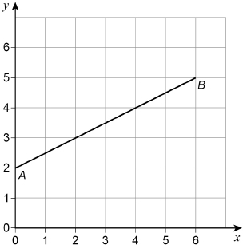
(a) Work out the coordinates of the midpoint of the line AB.
Answer ( ________ , ________ )
(1)
(b) C is another point on AB.
C is closer to B than to A.
The coordinates of C are whole numbers.
Work out the coordinates of C.
Answer ( ________ , ________ ) (1)
(c) On the grid, draw a line from point (0, 0) that is
parallel to AB
and
two thirds as long as AB.
(2)
(Total 4 marks)
Q13. On a map the distance between two towns is 6 cm.
The actual distance is 1.2 km
Work out the scale of the map as a ratio in its simplest form.
_______________________________________________________________________
_______________________________________________________________________
_______________________________________________________________________
_______________________________________________________________________
_______________________________________________________________________
_______________________________________________________________________
_______________________________________________________________________
Answer ___________ : ___________
(Total 3 marks)
Q14. How many minutes are there in hours?
Circle your answer.
315 325 515 525
(Total 1 mark)
Q15. (a) Divide 120 in the ratio 1 : 4
___________________________________________________________________
___________________________________________________________________
___________________________________________________________________
___________________________________________________________________
___________________________________________________________________
Answer ___________ : ___________
(2)
(b) Write the ratio 7 : 4 in the form n : 1
___________________________________________________________________
___________________________________________________________________
___________________________________________________________________
___________________________________________________________________
___________________________________________________________________
Answer ___________ : ___________
(1)
(Total 3 marks)
Q16. The population of England in 2013 is approximately 53 million.
It is predicted that
the population in 2018 will be 4% more than the population in 2013
and the population in 2023 will be 4% more than the population in 2018.
Work out the predicted population of England in 2023.
_______________________________________________________________________
_______________________________________________________________________
_______________________________________________________________________
_______________________________________________________________________
_______________________________________________________________________
_______________________________________________________________________
Answer _________________________________________
(Total 3 marks)

Q17. Oil is sold in two sizes.
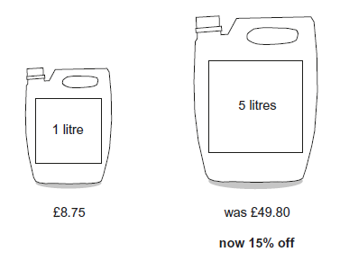
Which size is better value for money?
You must show your working.
_______________________________________________________________________
_______________________________________________________________________
_______________________________________________________________________
_______________________________________________________________________
_______________________________________________________________________
_______________________________________________________________________
_______________________________________________________________________
_______________________________________________________________________
Answer _________________________________________
(Total 4 marks)
Q18. Here are seven numbers.

13 6 12 7 6 4 8
(a) Work out the range of the seven numbers.
Circle your answer.

5 6 7 8 9
(1)

(b) What is the mode of the seven numbers?
Circle your answer.

5 6 7 8 9
(1)
(Total 2 marks)
Q19. There are 240 cows on a farm.
(a) On the farm,
number of bulls : number of cows = 1 : 30
How many bulls are there?
___________________________________________________________________
___________________________________________________________________
Answer _________________________________________
(1)
(b) Assume
the 240 cows produce milk for 10 months each year
each cow produces an average of 25 litres of milk per day.
Estimate the total milk production, in litres, of the 240 cows in one year.
You must show your working.
___________________________________________________________________
___________________________________________________________________
___________________________________________________________________
___________________________________________________________________
___________________________________________________________________
___________________________________________________________________
___________________________________________________________________
___________________________________________________________________
Answer _________________________________________ lires
(4)
(Total 5 marks)

Q20. The diagram shows a quarter-circle with radius 6.5 cm.
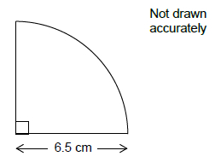
Work out the area of the quarter-circle.
_______________________________________________________________________
_______________________________________________________________________
_______________________________________________________________________
Answer _____________________________________ cm²
(Total 3 marks)
Q21. A play area has thousands of coloured balls.
They are white, pink or yellow.
Sam picks 10 balls at random.
The table shows some of her results.

 | white | pink | yellow
Frequency | 4
Relative frequency |  | 0.1
(a) Complete the table.

(3)
(b) Sam uses her results to estimate the proportion of white balls in the play area.
How could she make her estimate more reliable?
___________________________________________________________________
_________________________________________________________________(1)
(Total 4 marks)
Q22. Here are the marks of a student in four exams.
65 80 76 69
The student takes a fifth exam.
His mean mark for the five exams is 70
Work out his mark in the fifth exam.
_______________________________________________________________________
_______________________________________________________________________
_______________________________________________________________________
Answer _________________________________________
(Total 3 marks)
Q23. Points A and B are shown on the centimetre grid.
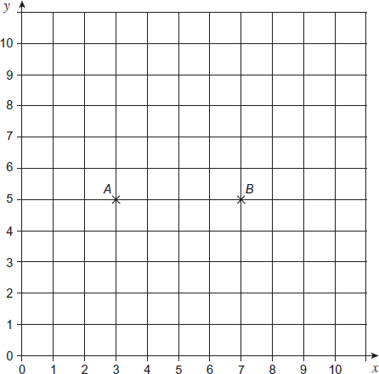
(a) Draw a rectangle ABCD on the grid with area 12 cm².
(2)
(b) Write down the coordinates of point C and point D.
Answer C ( _____ , _____ ) and D ( _____ , _____ )
(2)
(Total 4 marks)
Q24. The pie chart shows information about how people voted in an election.
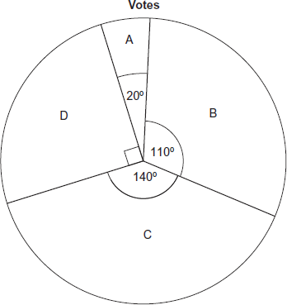
1800 people voted for D.
How many more people voted for C than B?
_______________________________________________________________________
_______________________________________________________________________
_______________________________________________________________________
_______________________________________________________________________
_______________________________________________________________________
Answer _________________________________________
(Total 3 marks)

Q25. Work out the area of this pentagon.
Not drawn accurately
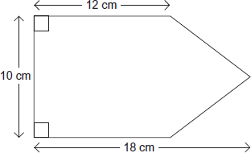
__ _____________________________________________________________________
_______________________________________________________________________
_______________________________________________________________________
_______________________________________________________________________
_______________________________________________________________________
_______________________________________________________________________
Answer _______________________________ cm²
(Total 3 marks)
Q26. Solve 4(3x − 2) = 2x − 5
_______________________________________________________________________
_______________________________________________________________________
_______________________________________________________________________
_______________________________________________________________________
x = _________________________________________
(Total 3 marks)
Q27. Amy has x beads.
Billy has three more beads than Amy.
Carly has four times as many beads as Billy.
Circle the expression for the number of beads that Carly has.
4x + 3 3x + 4 4(x + 3) x + 12
(Total 1 mark)
Q28. Circle the expression that is equivalent to 2a + 5a × 4a – a
a + 20a² 21a² 28a² – a 2a + 15a²
(Total 1 mark)
Q29. Expand and simplify (2x + 5y)(3x − 8y)
_______________________________________________________________________
_______________________________________________________________________
_______________________________________________________________________
Answer _________________________________________
(Total 3 marks)
Q30. (a) Factorise fully 9a² − 6a
___________________________________________________________________
___________________________________________________________________
Answer _________________________________________
(2)
(b) Solve x² − 12x + 20 = 0
___________________________________________________________________
___________________________________________________________________
Answer _________________________________________
(3)
(Total 5 marks)

Q31. A straight line
has gradient 4
and
passes through the point (5, 23)
Work out the equation of the line.
Give your answer in the form y = mx + c
_______________________________________________________________________
_______________________________________________________________________
_______________________________________________________________________
_______________________________________________________________________
_______________________________________________________________________
_______________________________________________________________________
_______________________________________________________________________
_______________________________________________________________________
Answer _________________________________________
(Total 3 marks)
Q32. x is an integer.
–4 < x ≤ 2 and 2 ≤ x + 3 < 9
Work out all the possible values of x.
_______________________________________________________________________
_______________________________________________________________________
_______________________________________________________________________
_______________________________________________________________________
_______________________________________________________________________
_______________________________________________________________________
_______________________________________________________________________
_______________________________________________________________________
Answer _________________________________________
(Total 3 marks)
Q33. Here is a right-angled triangle.
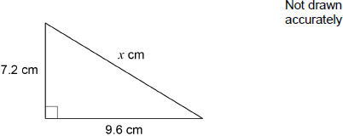
Show that x = 12
_______________________________________________________________________
_______________________________________________________________________
_______________________________________________________________________
_______________________________________________________________________
_______________________________________________________________________
_______________________________________________________________________
_______________________________________________________________________
_______________________________________________________________________
_______________________________________________________________________
(Total 2 marks)

Q34. Here is an advert.

Hair Salon
Trim and Colour | £65.50
Wash and Dry | £15.50
Perm | £68.00
Special Offer
10% off
Jen has a Trim and Colour.
She uses the special offer.
How much does she pay?
_______________________________________________________________________
_______________________________________________________________________
_______________________________________________________________________
_______________________________________________________________________
_______________________________________________________________________
Answer £ _________________________________
(Total 2 marks)

Q35. The probability of a biased coin landing on heads is
The coin is tossed twice.
Complete the tree diagram.
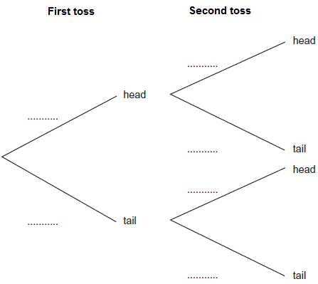
(Total 3 marks)

